**WebsiteUrl:-** <https://wpbitcot.com/jayjinshasan/>

I have implemented Google Analytics and Google tag manager on this website

<https://wpbitcot.com/jayjinshasan/> using my mail [arpitajain@bitcot.com](mailto:arpitajain@bitcot.com)

---------------------------------------------------------------------------------------------------------------------------------------------

# Google Analytics :-

Google Analytics **includes** **capabilities** **that can** **help** **users** **identify** **developments** and **patterns** in how **traffic** **interacts** with their **websites**. These **capabilities** **allow** for **facts** **series**, **analysis**, **monitoring**, visualization, reporting and integration with **different** **programs**.

**It will** **assist you to** **analyze** the **traffic** of your **website** and the **behavior** of your **traffic**.

**The important functions** of Google Analytics are revolve **around**:

* **Your Target market**: - **understand** **who are** your **internet site** **visitors**
* Acquisition: From **where** the visits are coming
* **Behavior**: How do the **visitors** behave **to your** **internet site**, how is their **go with the flow** **via** the pages
* Conversion: The **degree** of **effect** of your **moves**

## **Setup Google Analytics:-**

This is a URL to create a Google Analytics Account. We are required with a gmail id to sign in the below mentioned URL.

<https://analytics.google.com/analytics/web/provision/#/provision>

* Sign in account with your gmail
* Create new account
* Added account name

The following settings are required to access your account:-

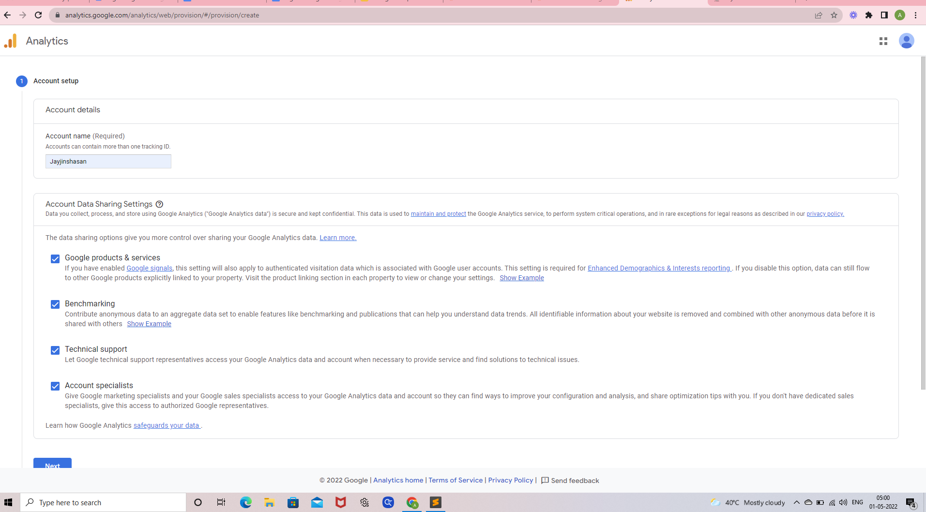

**To set up a Universal Analytics property :-**

Click the Setting icon in the **Admin** area

Property created

Property Setup

* Set Up **Reporting time zone**
* Set Up **Currency**
* Click **Show advanced options** link

### Enable this **Create a Universal Analytics property**

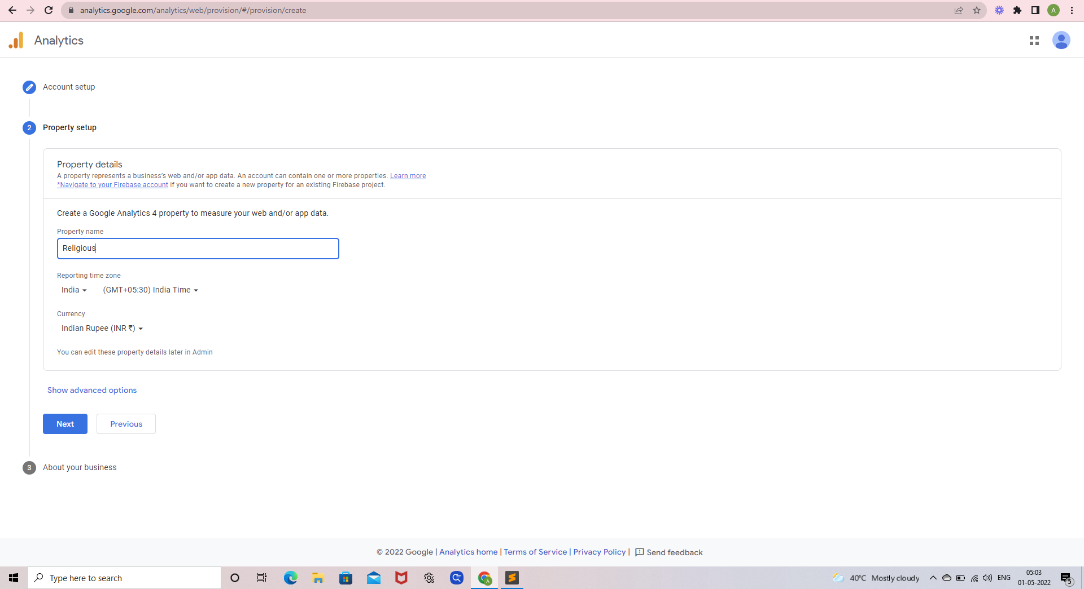

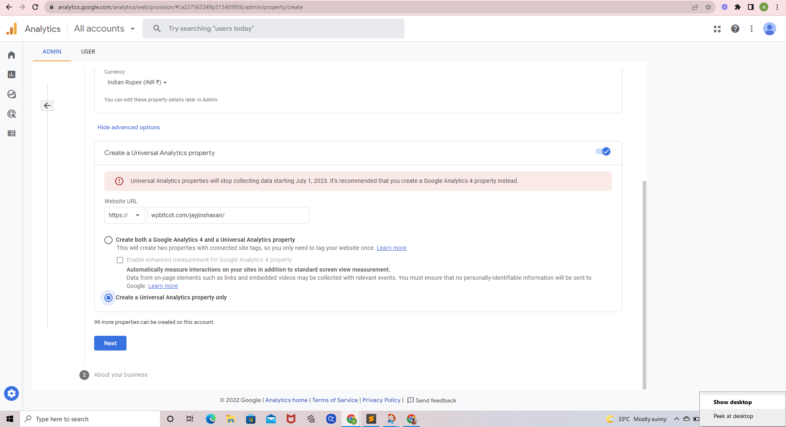

**About Your Business**

Added these details

* Select Industry category
* Select Business Size
* There are multple options we can select according to our business requrement.

**How do you intend to use Google Analytics with your Business?**

* After **Create**

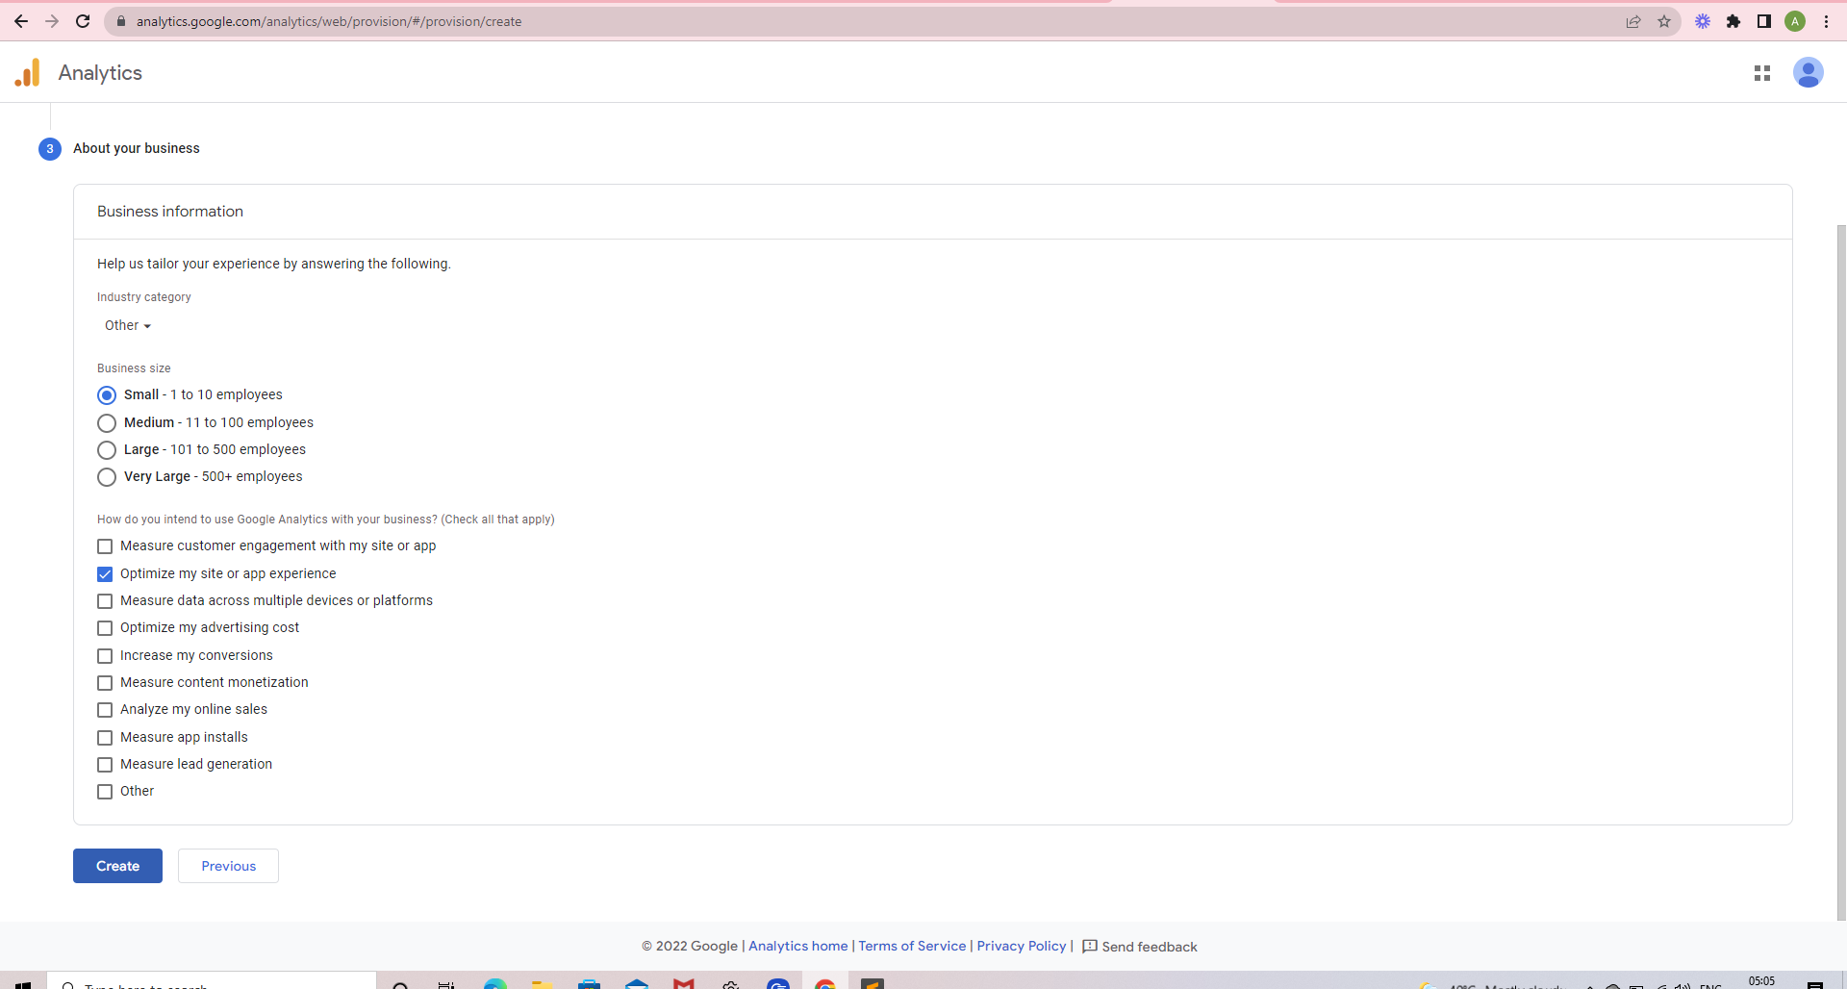

After Click Terms of Services

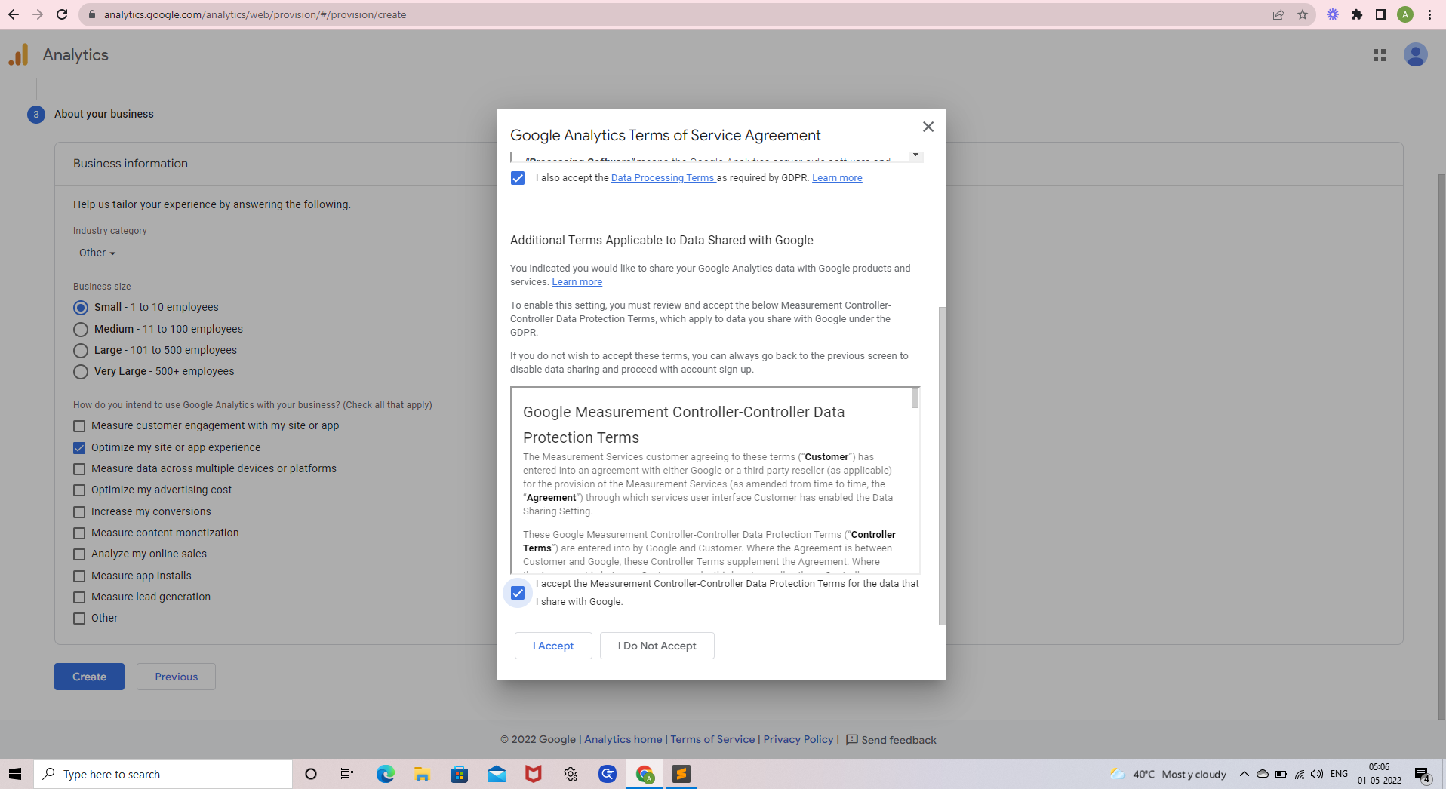

**Next step is creating Data Streams:-**

This traffic analysis tool can be implemented in the three platforms as mentioned in the enclosed image.

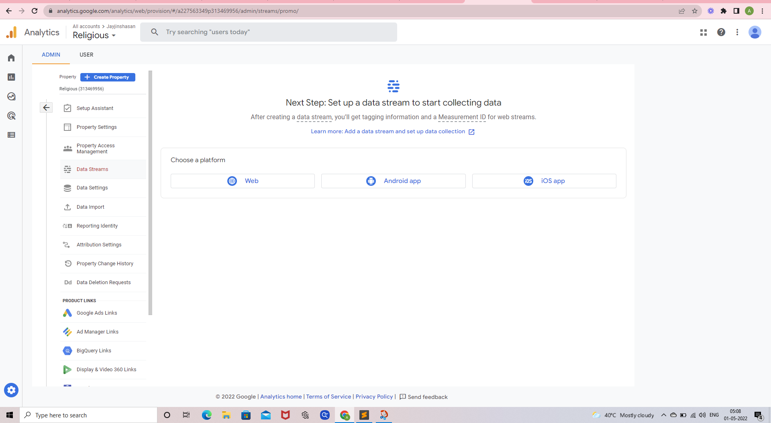

* Select the Web

**Web** can be selected by the users in the **WordPress** and can also edit website URL as in the image attached below

Set up your web stream like this

* To fill in your website’s URL and name
* After enable Enhanced Measurement

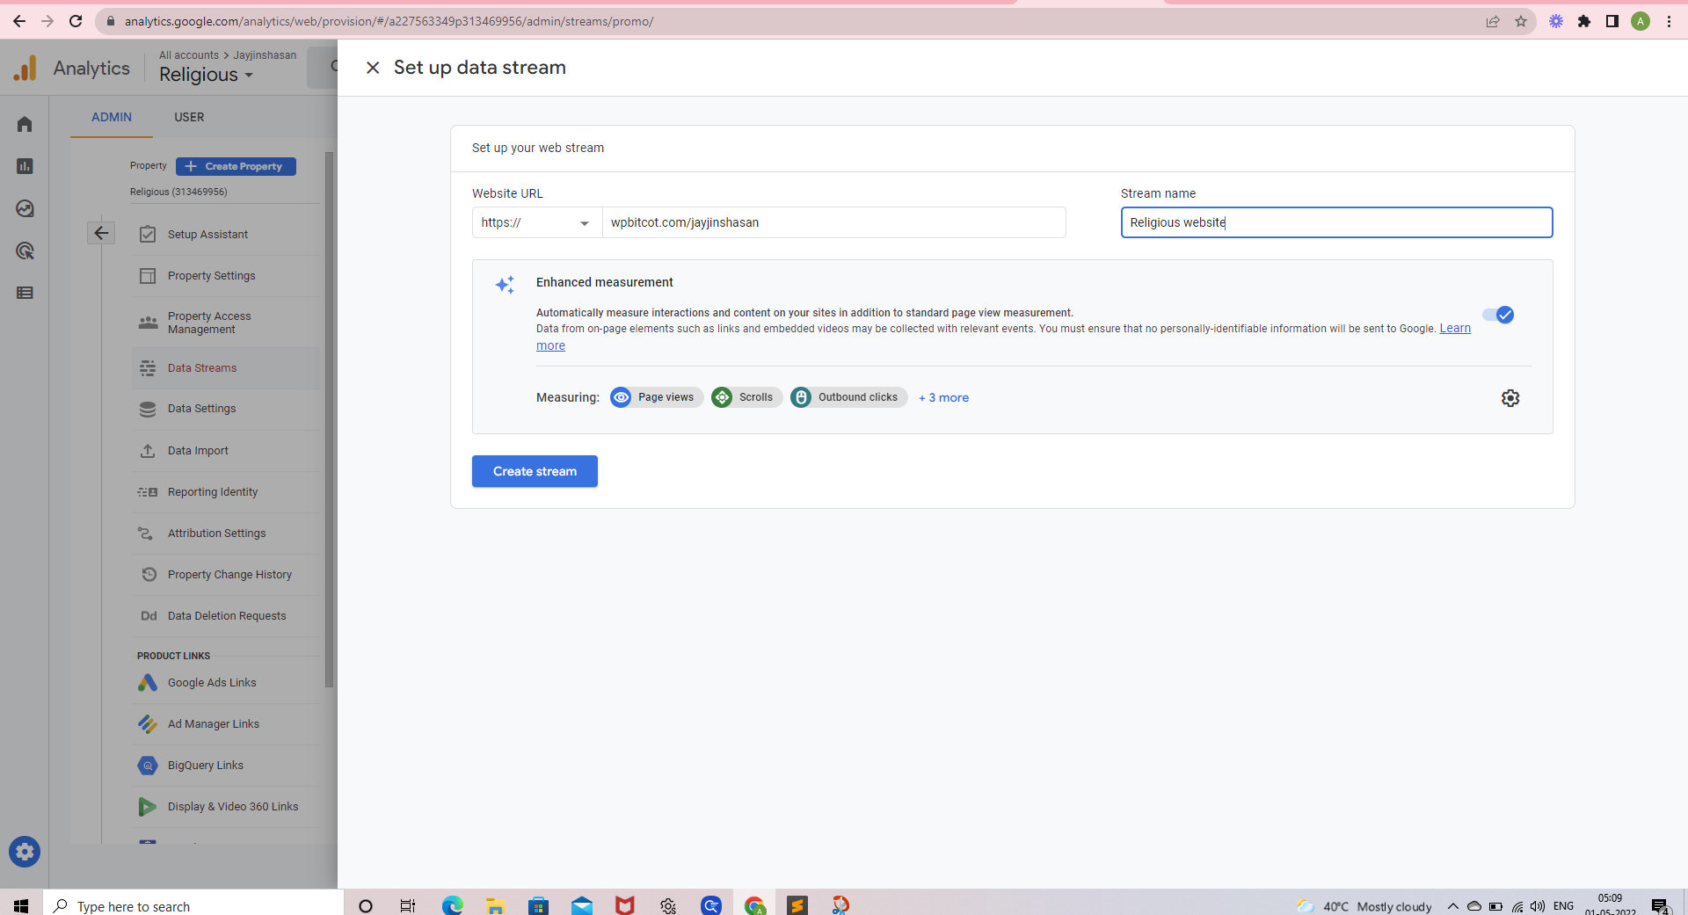

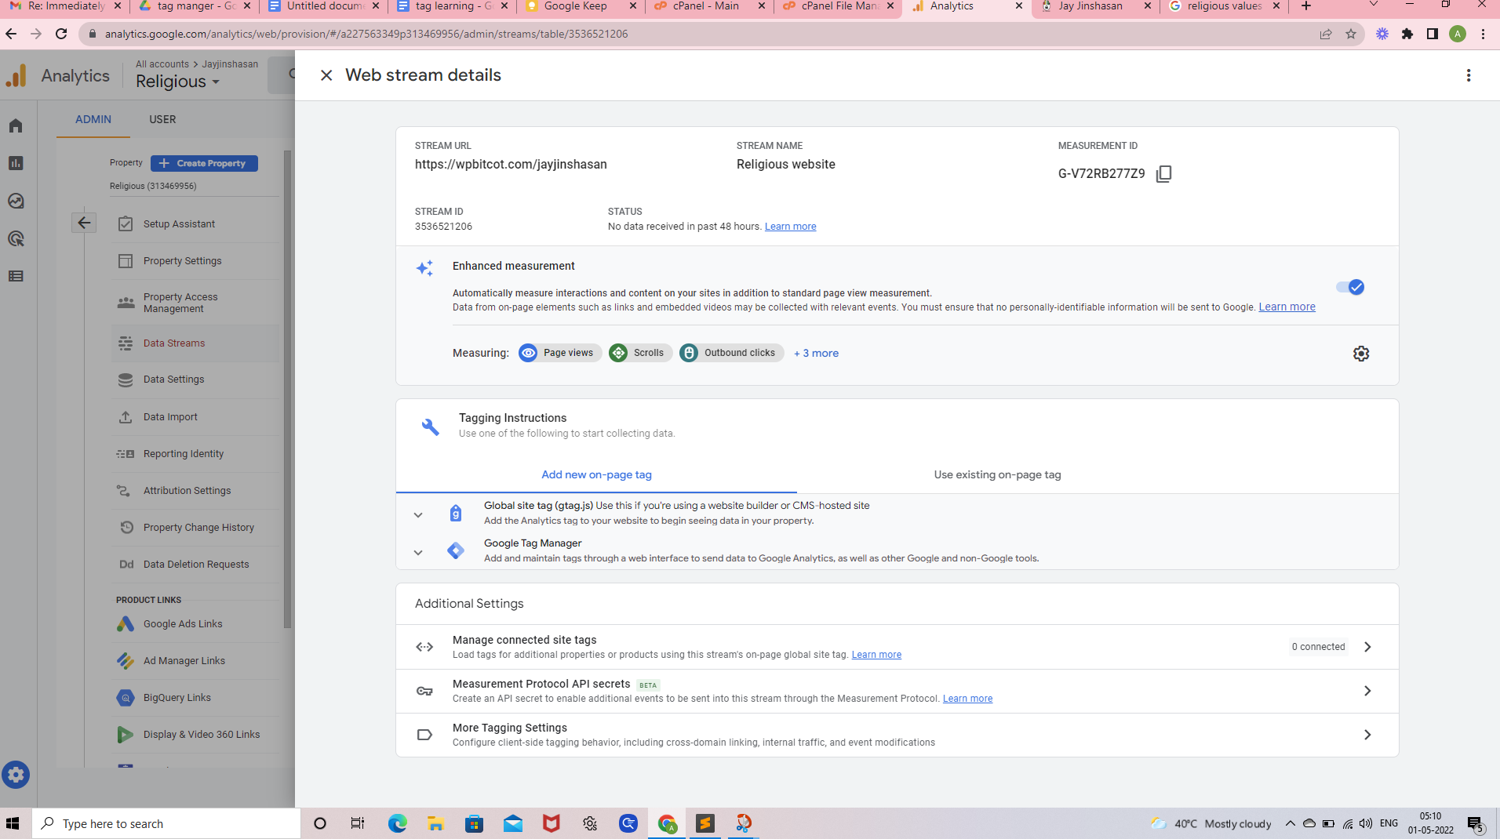

**After that, the tracking code or Id is provided to us.**

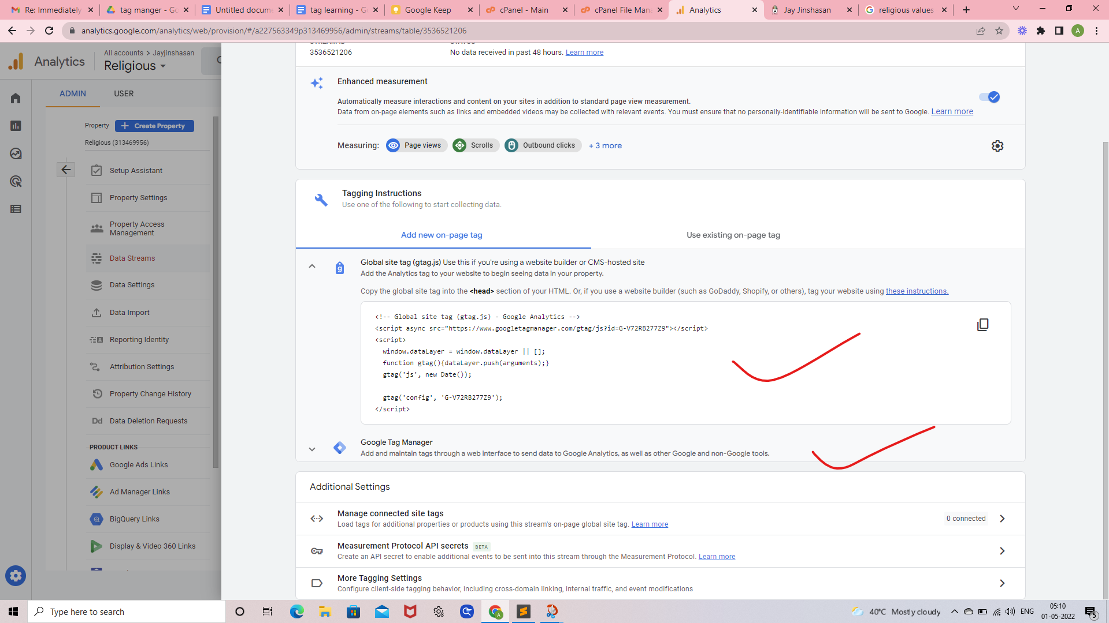

Add the Analytics tag to your website to begin seeing data in your property.

Copy the global site tag into the **<head>** section of your HTML.

However, if you use a website builder (such as GoDaddy, Shopify, or others), tag your website using

------------------------------------------------------------------------------------------------------------

<!-- Global site tag (gtag.js) - Google Analytics -->

<script async src="https://www.googletagmanager.com/gtag/js?id=G-V72RB277Z9"></script>

<script>

window.dataLayer = window.dataLayer || [];

function gtag(){dataLayer.push(arguments);}

gtag('js', new Date());

gtag('config', 'G-V72RB277Z9');

</script>

------------------------------------------------------------------------------------------------------------

GA Id:- **G-V72RB277Z9**

Tracking info-> Tracking Code Tracking ID UA-227563349-1

Below image dispaly this

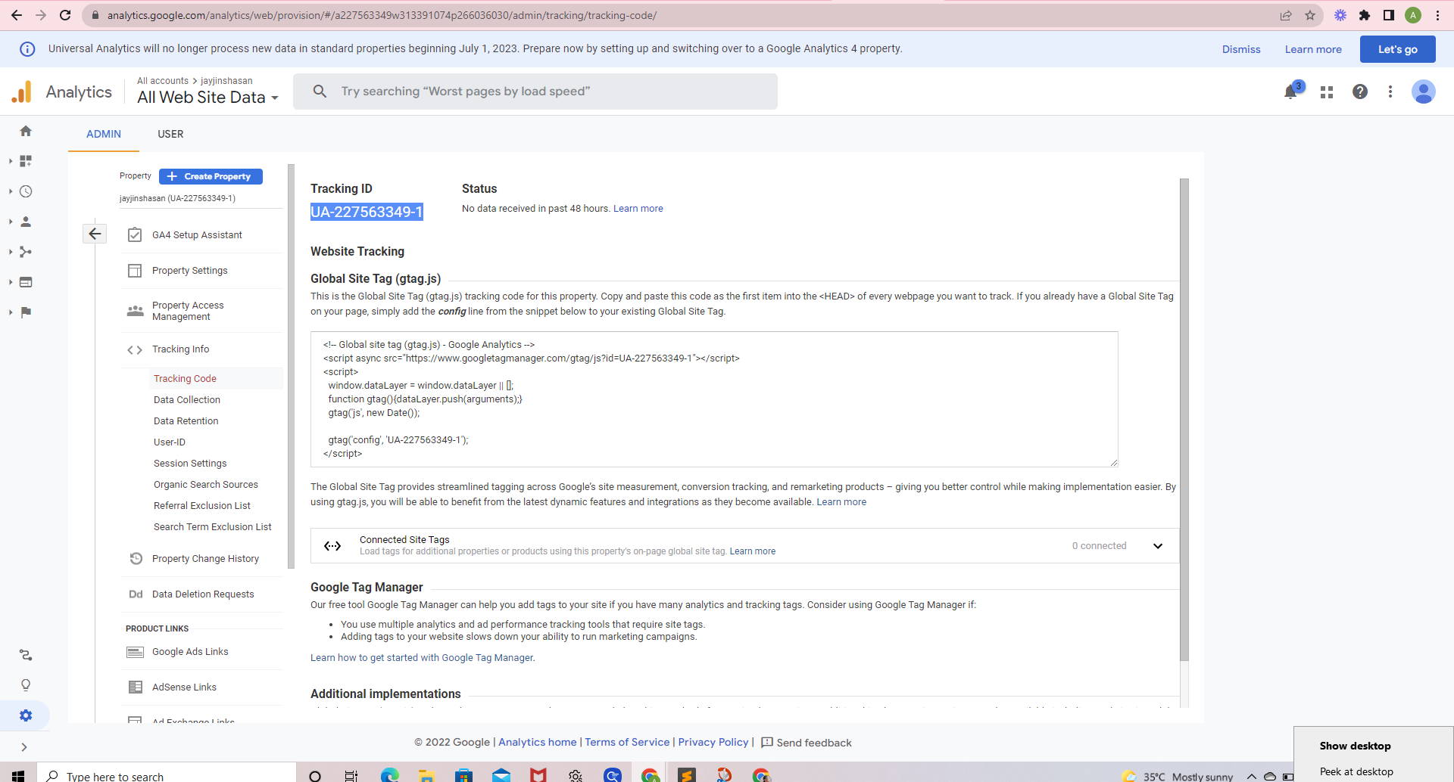

The Below enclosed image shows that the code is Implemented in head section in the website

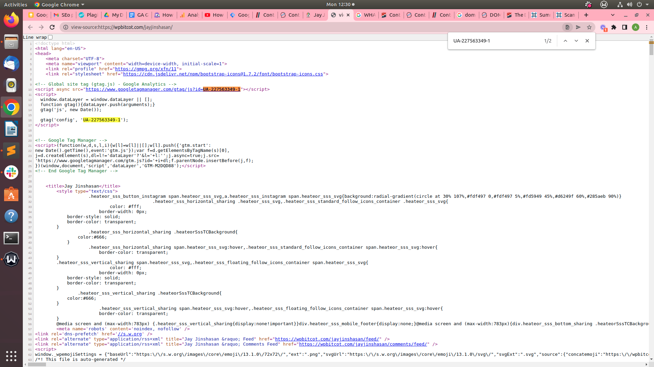

Setup done after open Account

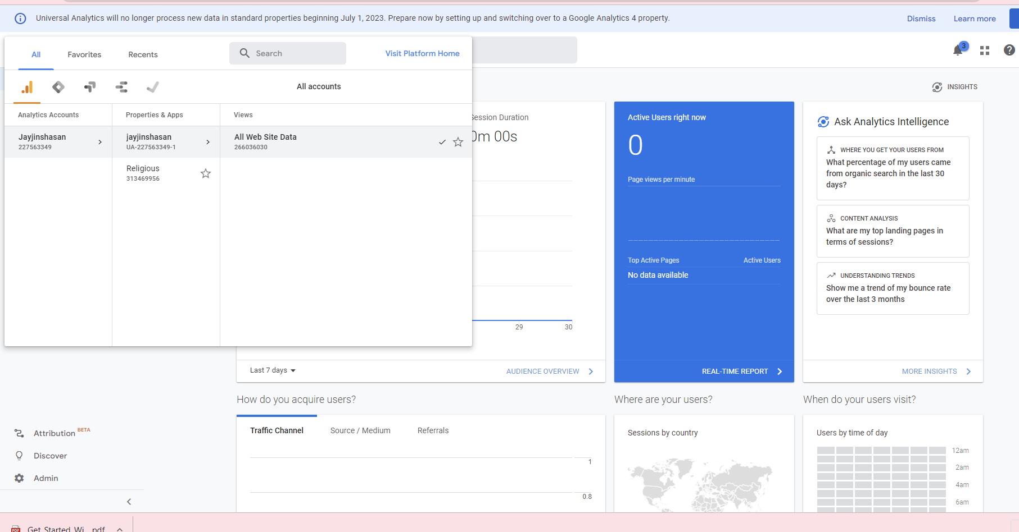

---------------------------------------------------------------------------------------------------------------------------------------------

# Google Tag Manager

Google Tag **supervisor** is a tag **control** **system** (TMS) that **permits** you to **easily** **update** **measurement** codes and **related** code fragments **together** **referred to as** tags **to your** **website** or **mobile** app.

Google Tag **supervisor** **gives** **powerful** **features** **such as:**

* Tag: Create any **advertising** Tag and use the **various** integrations already **current**.
* **Trigger**: **define** **when** your tag **ought to** get **completed**.
* **Versions**: **define** **numerous** **variations** and **deploy** them to **special** **websites**.

## **Setup Google Tag Manager:-**

1. Create a new Account <https://tagmanager.google.com/>
2. Enter an **Account Name** “ **Bitcot**”
3. Set Up **Country** “**United States”**
4. After Container Setup   
   We used our website url which we want to track   
   <https://wpbitcot.com/jayjinshasan/>
5. Select Target Platform “ **Web”**
6. Click on Create

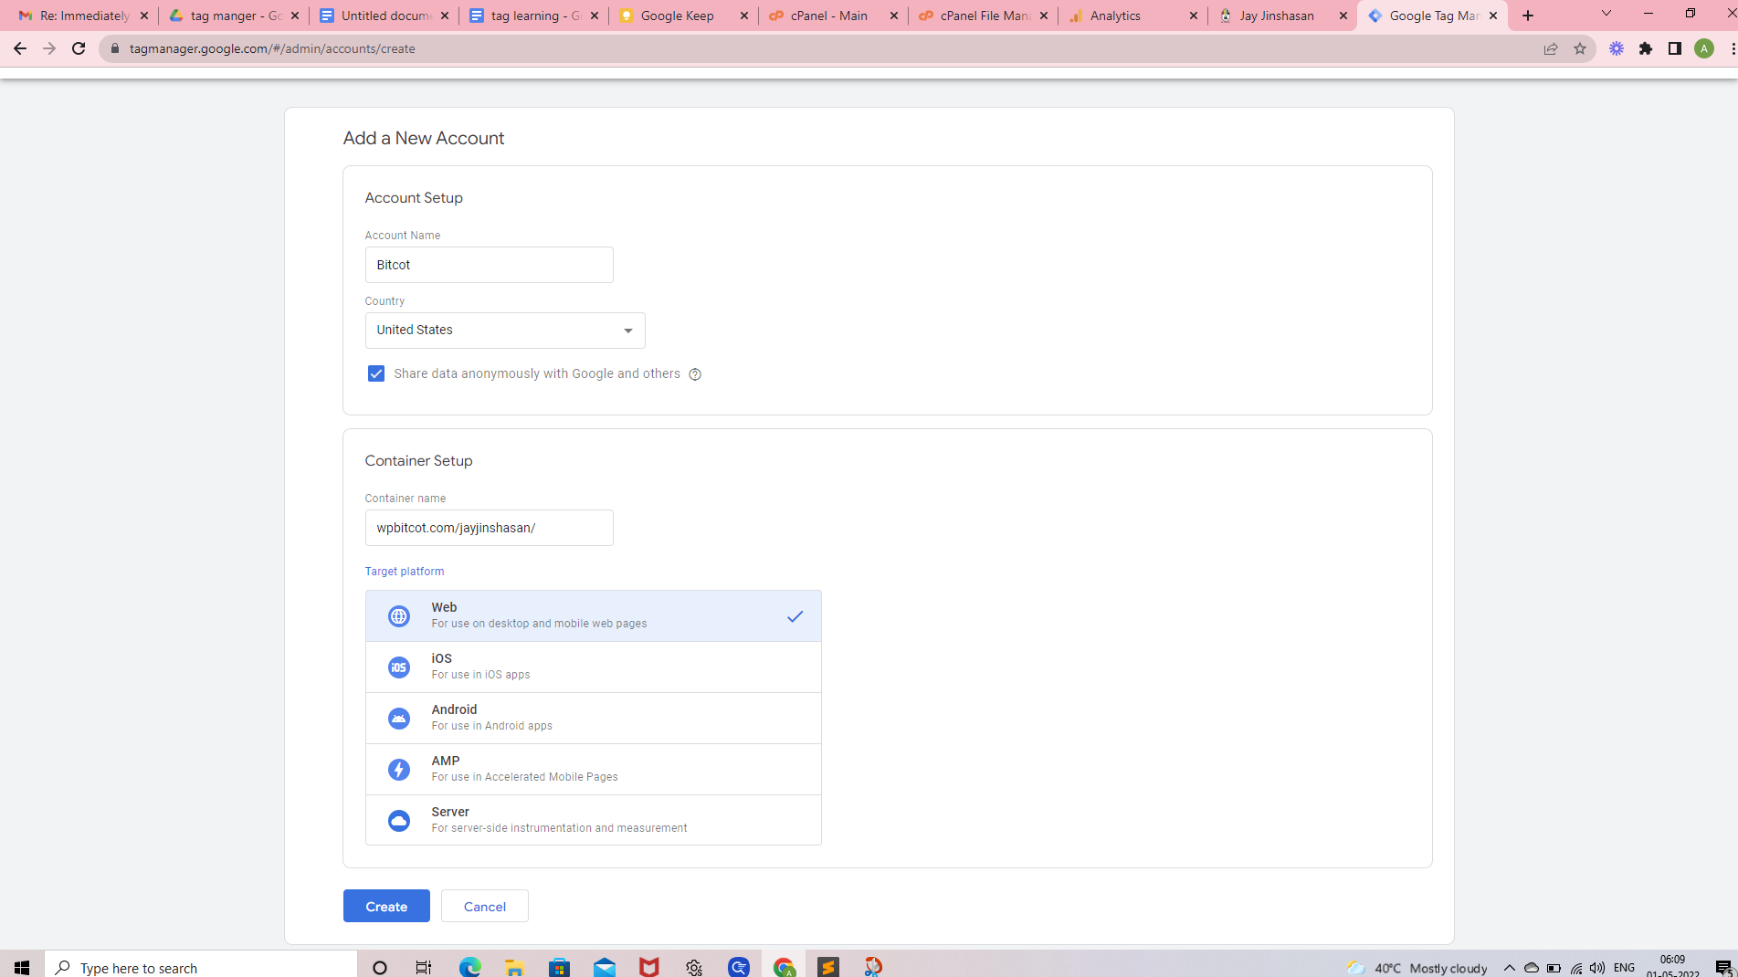

* After that Popup Open
* Google Tag Manager Terms of Services Agreement
* Scroll down checked checkbox
* After click yes

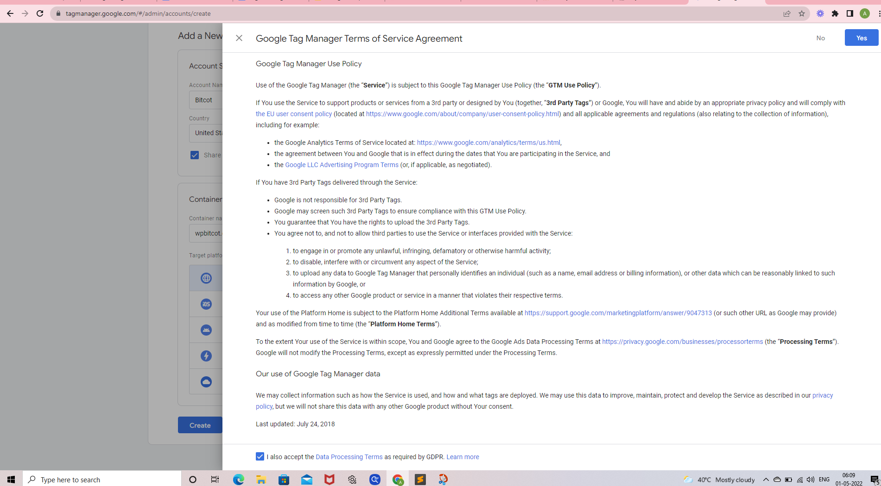

Copy exactly the two pieces of code on the Header file in the <HEAD> section and in the Body <BODY> section in your website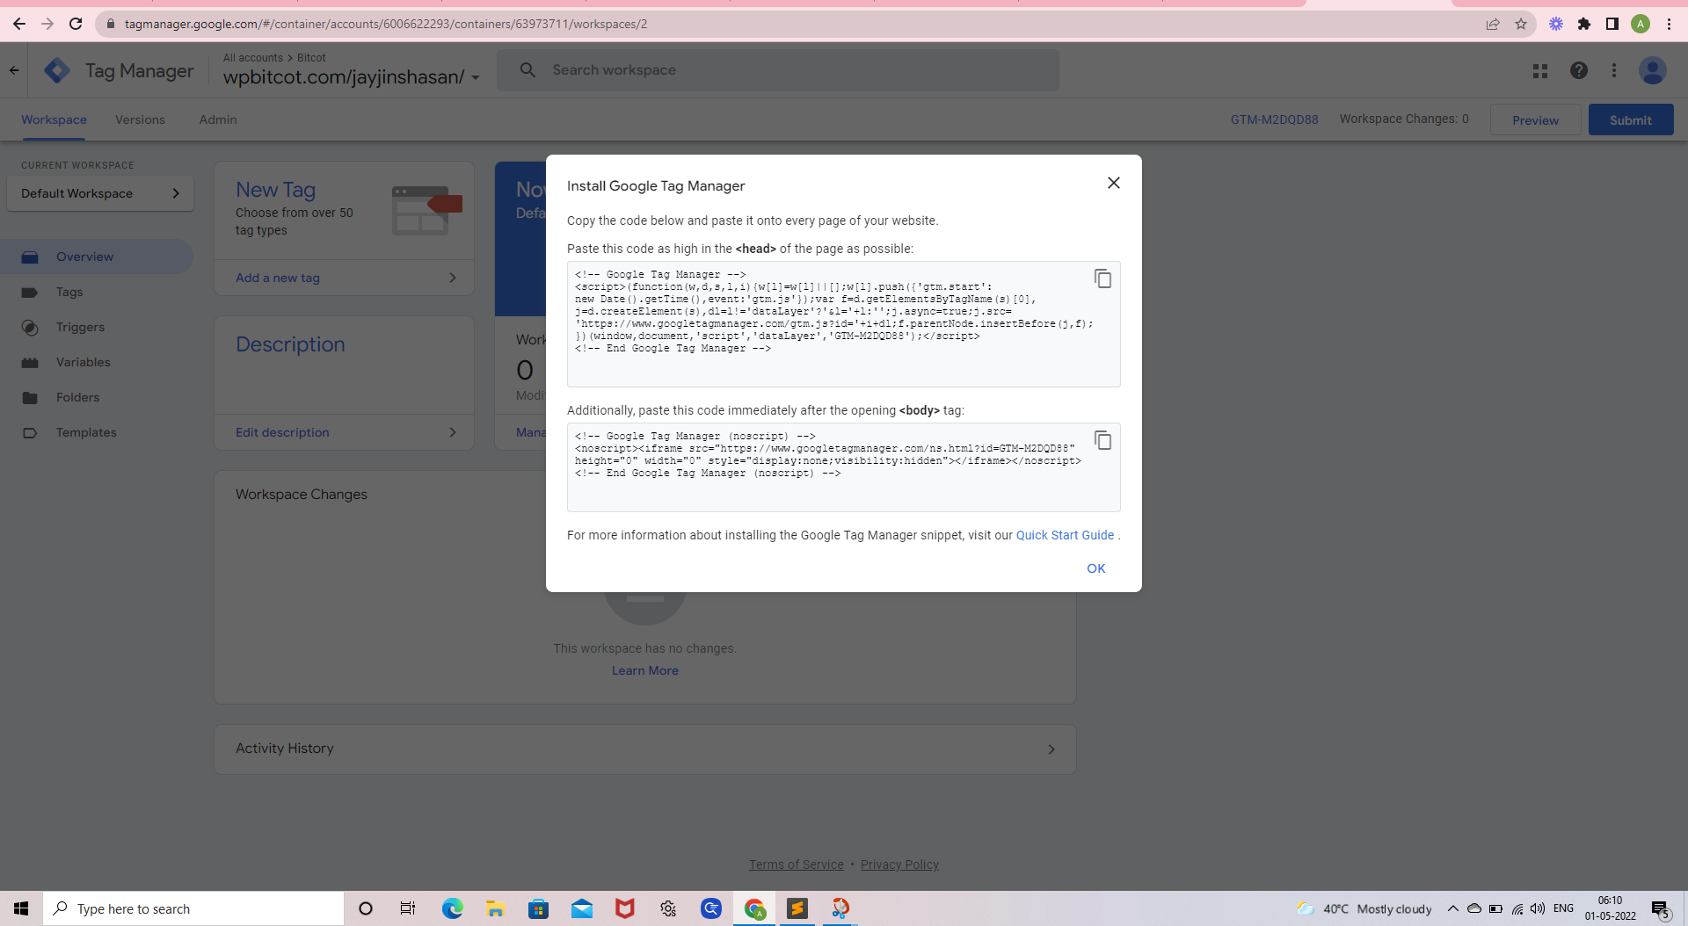

----------------------------------------------------------------------------------------------------------------------------

**Paste this code as high in the <head> of the page as possible:**

<!-- Google Tag Manager -->

<script>(function(w,d,s,l,i){w[l]=w[l]||[];w[l].push({'gtm.start':

new Date().getTime(),event:'gtm.js'});var f=d.getElementsByTagName(s)[0],

j=d.createElement(s),dl=l!='dataLayer'?'&l='+l:'';j.async=true;j.src=

'https://www.googletagmanager.com/gtm.js?id='+i+dl;f.parentNode.insertBefore(j,f);

})(window,document,'script','dataLayer','GTM-M2DQD88');</script>

<!-- End Google Tag Manager →

----------------------------------------------------------------------------------------------------------------------------

**Additionally, paste this code immediately after the opening <body> tag:**

<!-- Google Tag Manager (noscript) -->

<noscript><iframe src="https://www.googletagmanager.com/ns.html?id=GTM-M2DQD88"

height="0" width="0" style="display:none;visibility:hidden"></iframe></noscript>

<!-- End Google Tag Manager (noscript) →

----------------------------------------------------------------------------------------------------------------------------

* Right click on website
* Open View Page Source
* Like below image and Url **view-source:https://wpbitcot.com/jayjinshasan/**
* Search this GTM Id :- **GTM-M2DQD88**

The Below enclosed image shows that the code is Implemented in **Head Section** in the website

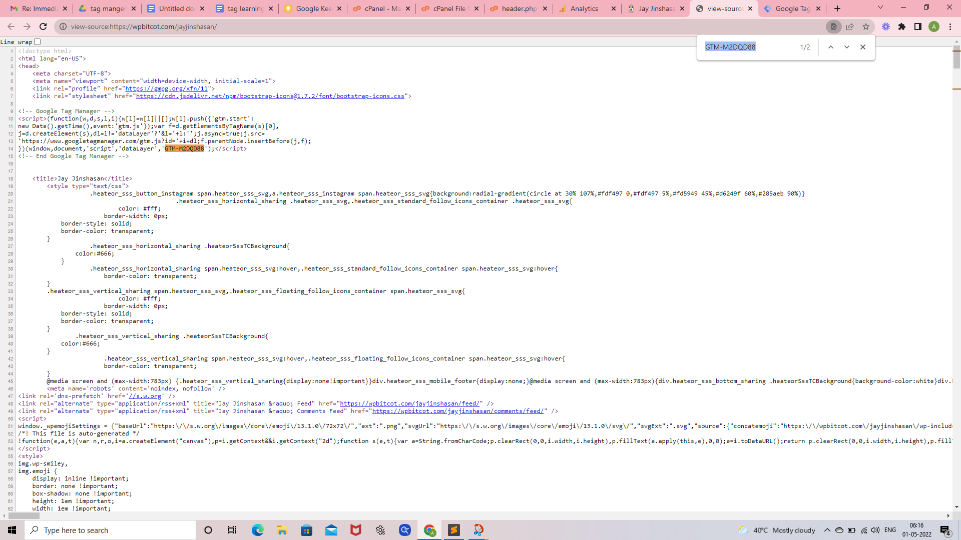

The Below enclosed image shows that the code is Implemented in **Body Section** in the website

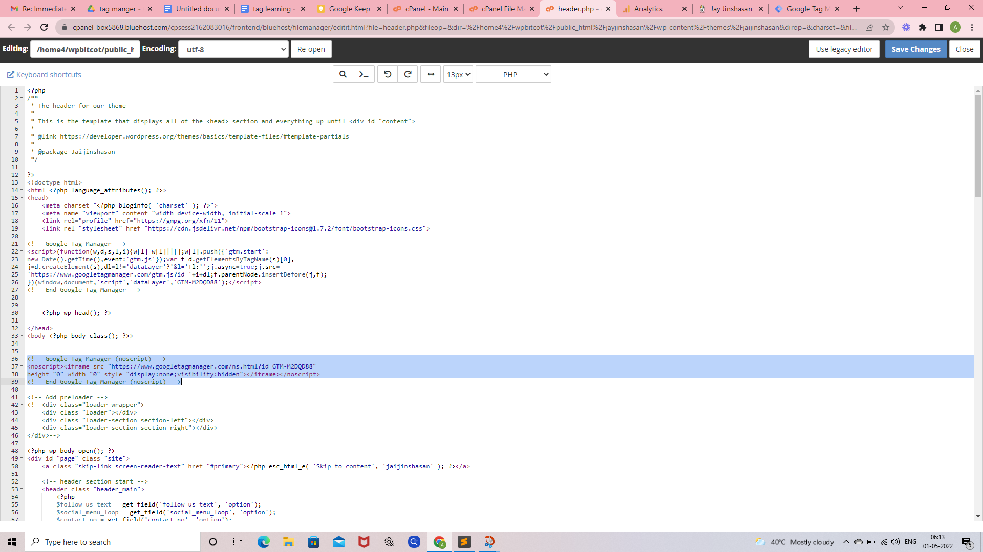

Setup done after open Account

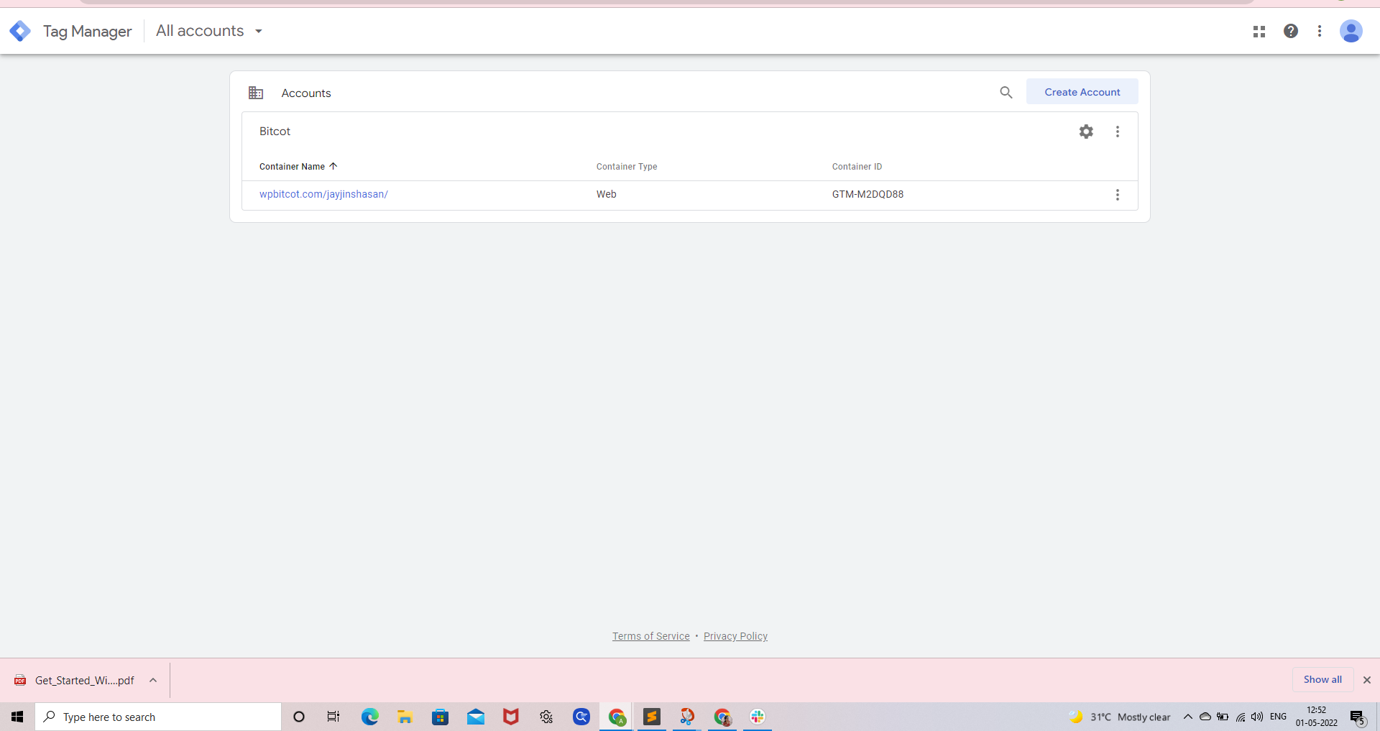

---------------------------------------------------------------------------------------------------------------------------------------------

# 

# 

# 

# 

# Install and set up Google Analytics with Google Tag Manager :-

1. Open Google Tag Manager

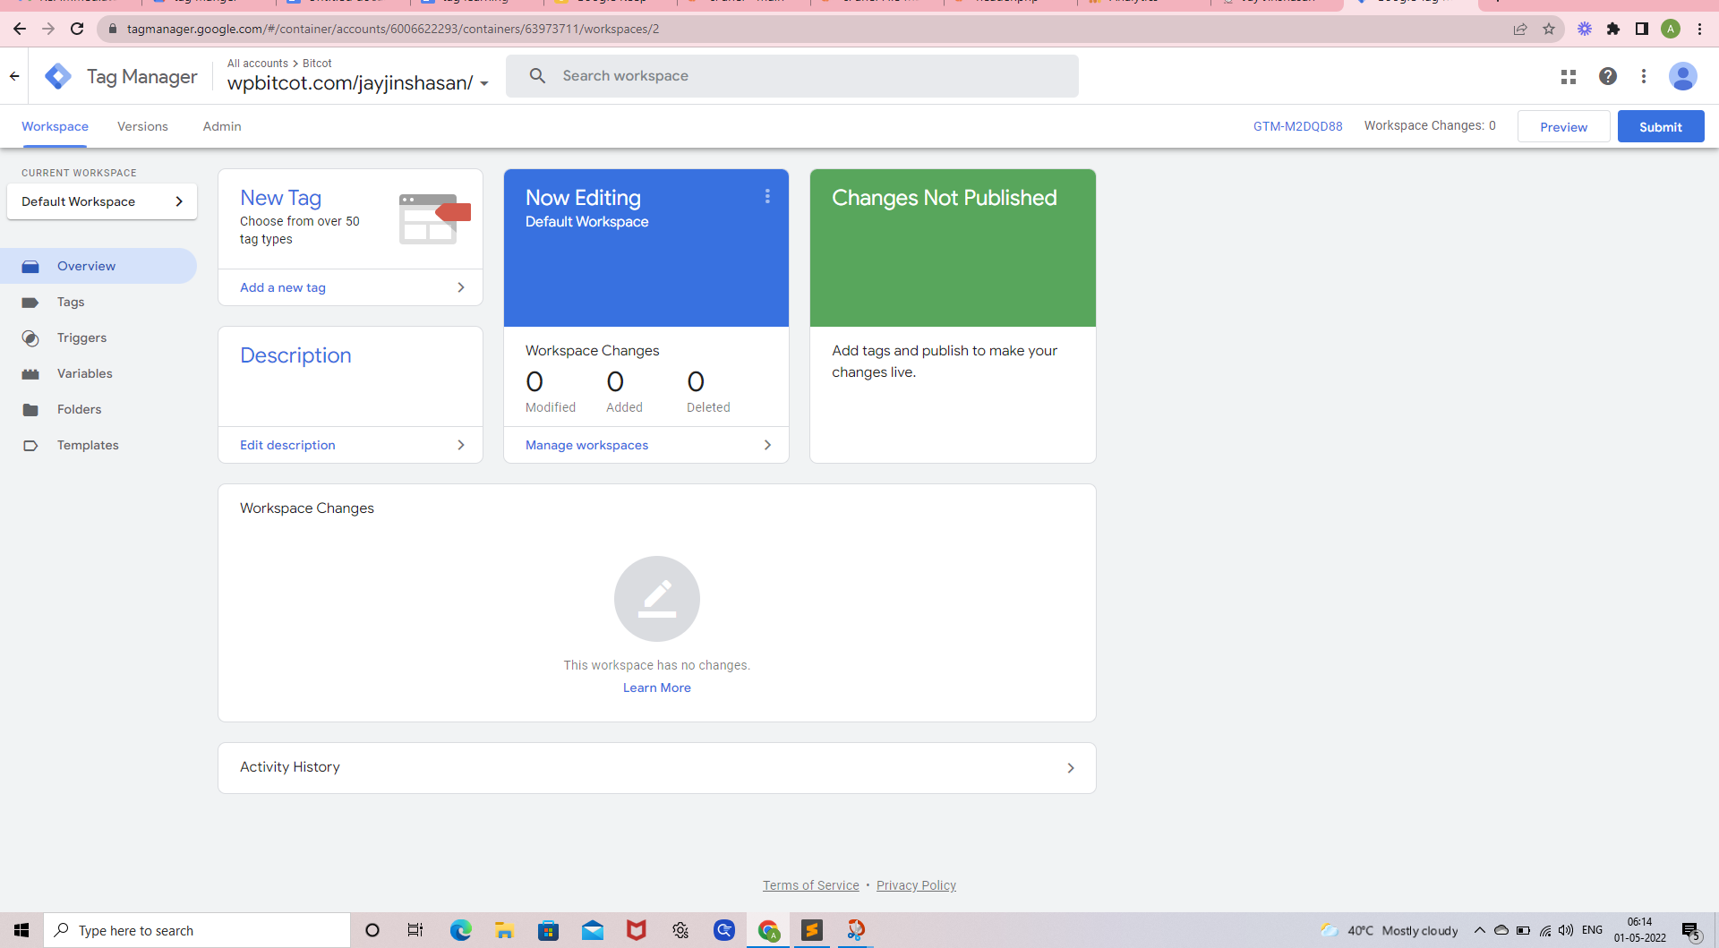

1. Click on Add new a tag, and a new window will popup

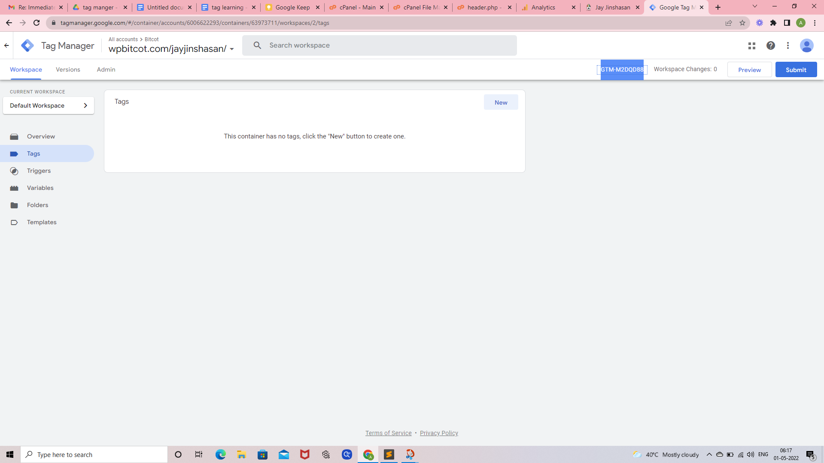

3 . Fill a name, as an example “**GA all pages**”

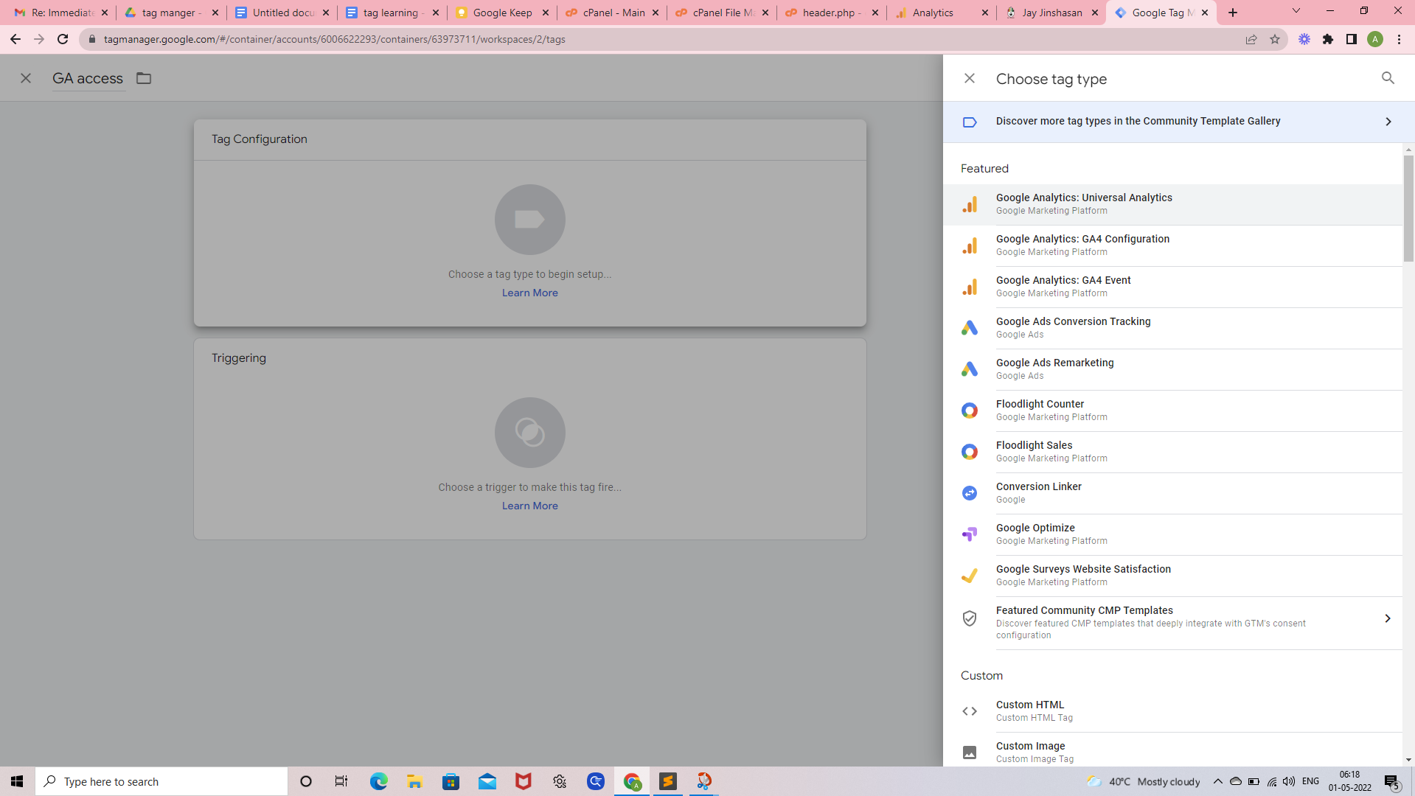

4. Click on the tag configuration area, and chose the type of Tag **Google Analytics Universal Analytics**

5. Leave the **Track type** on **Page view**

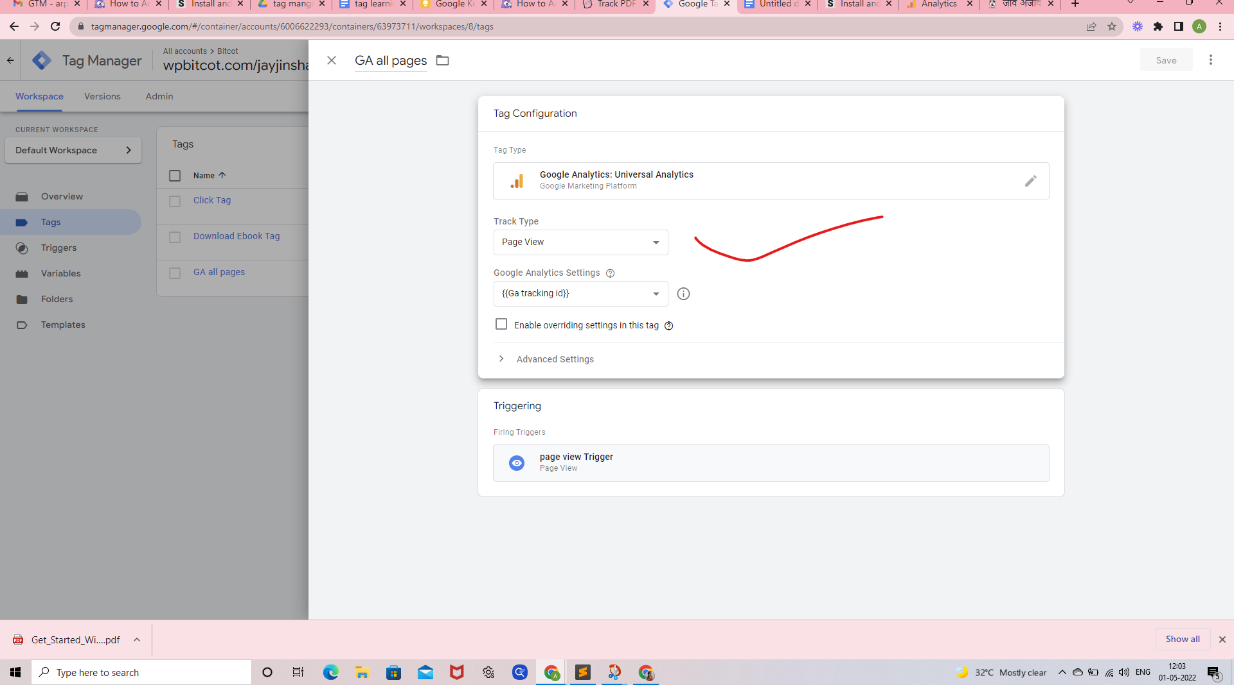

6. Then added a setting Variable. (If it is a brand new container, you should have no variable. )  
  
 **Google Analytics Settings** Click (Rightside **i** icon)  
 Create a new **Variable** and name it “**Ga tracking id**“  
 Click Variable Configuration select “**Google Analytics Settings”**  
 Enter the **Tracking ID** of Google Analytics (**UA-227563349-1**)  
 Select **Cookie Domain {{Page URL}}**

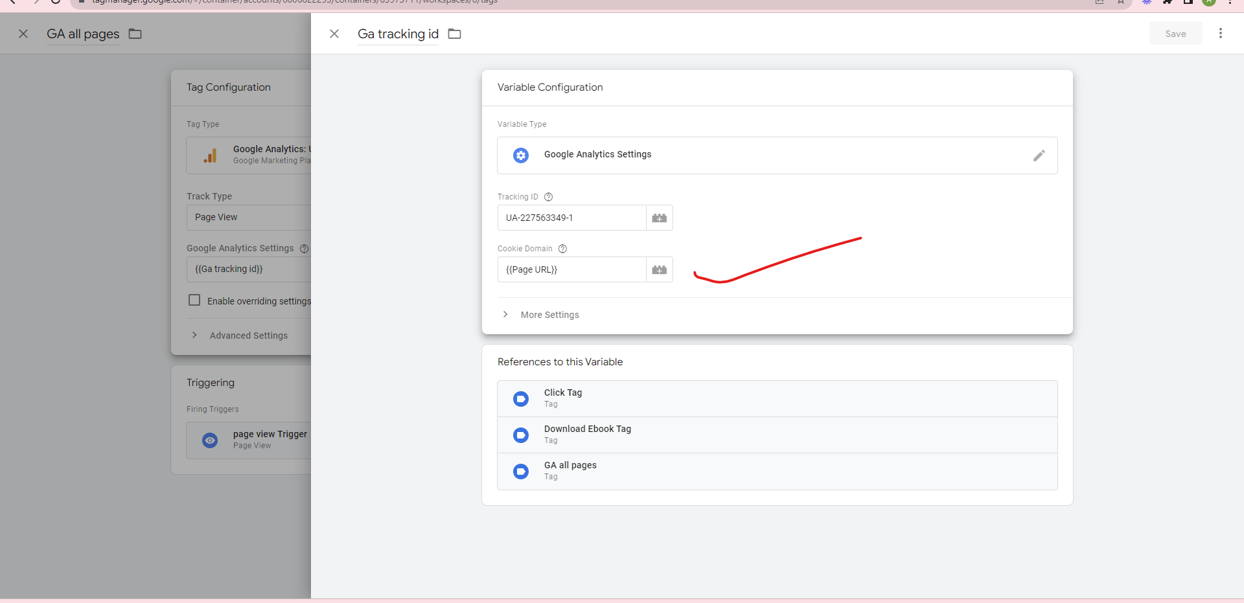

7. Leave the rest as it is and save

8. After that Trigger Created Click this new

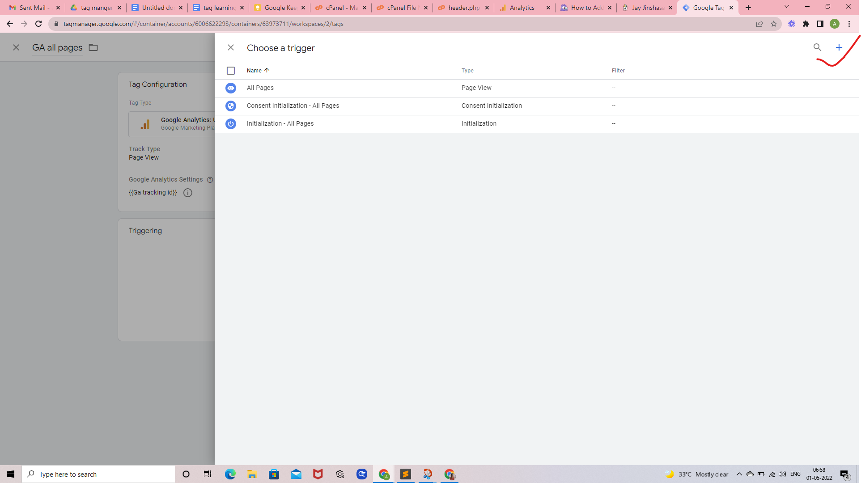

Choose trigger type ->Page view

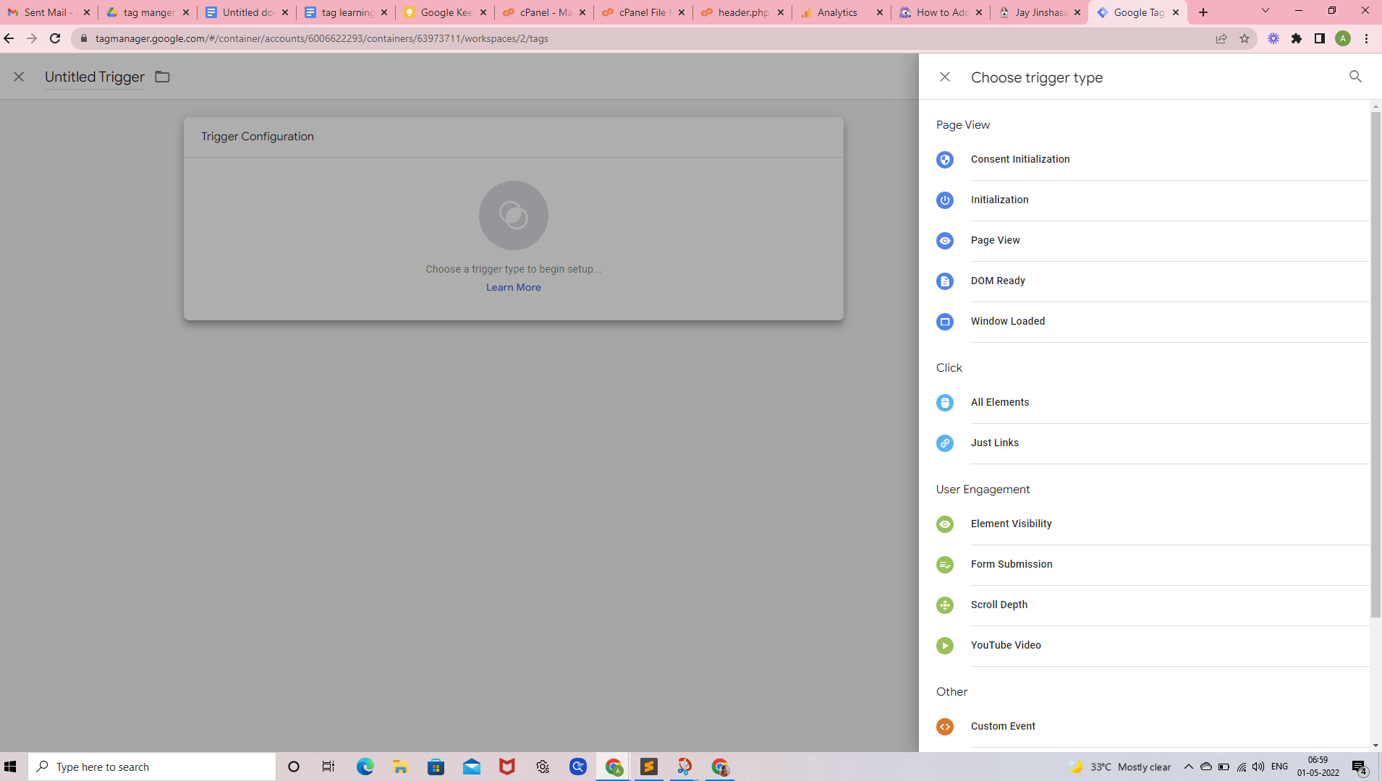

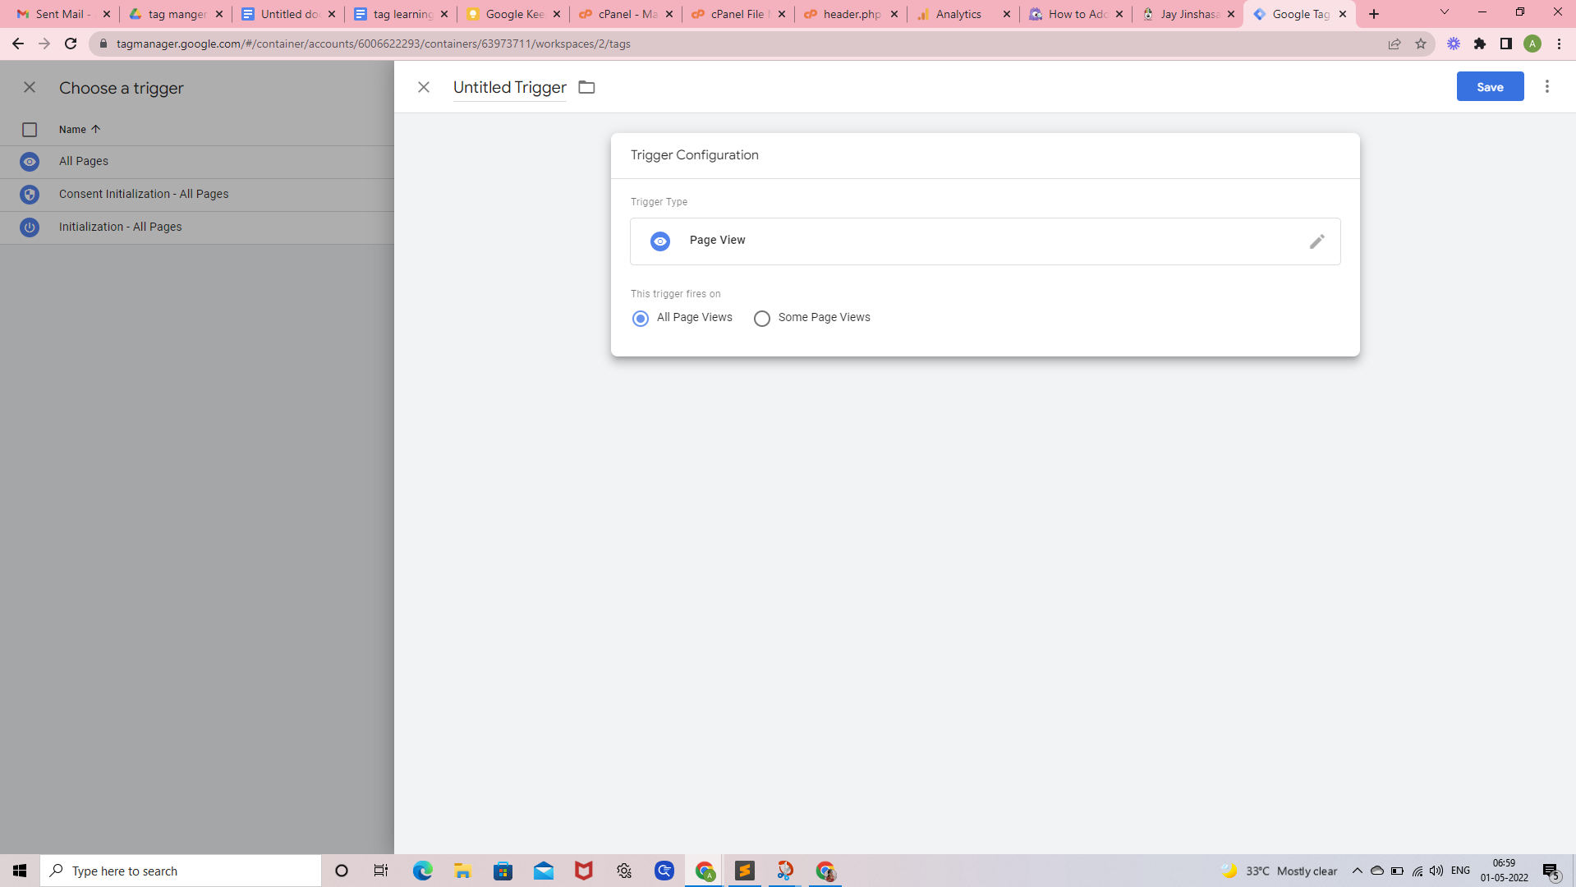

In this screen select the page view tigger inside this GA all pages

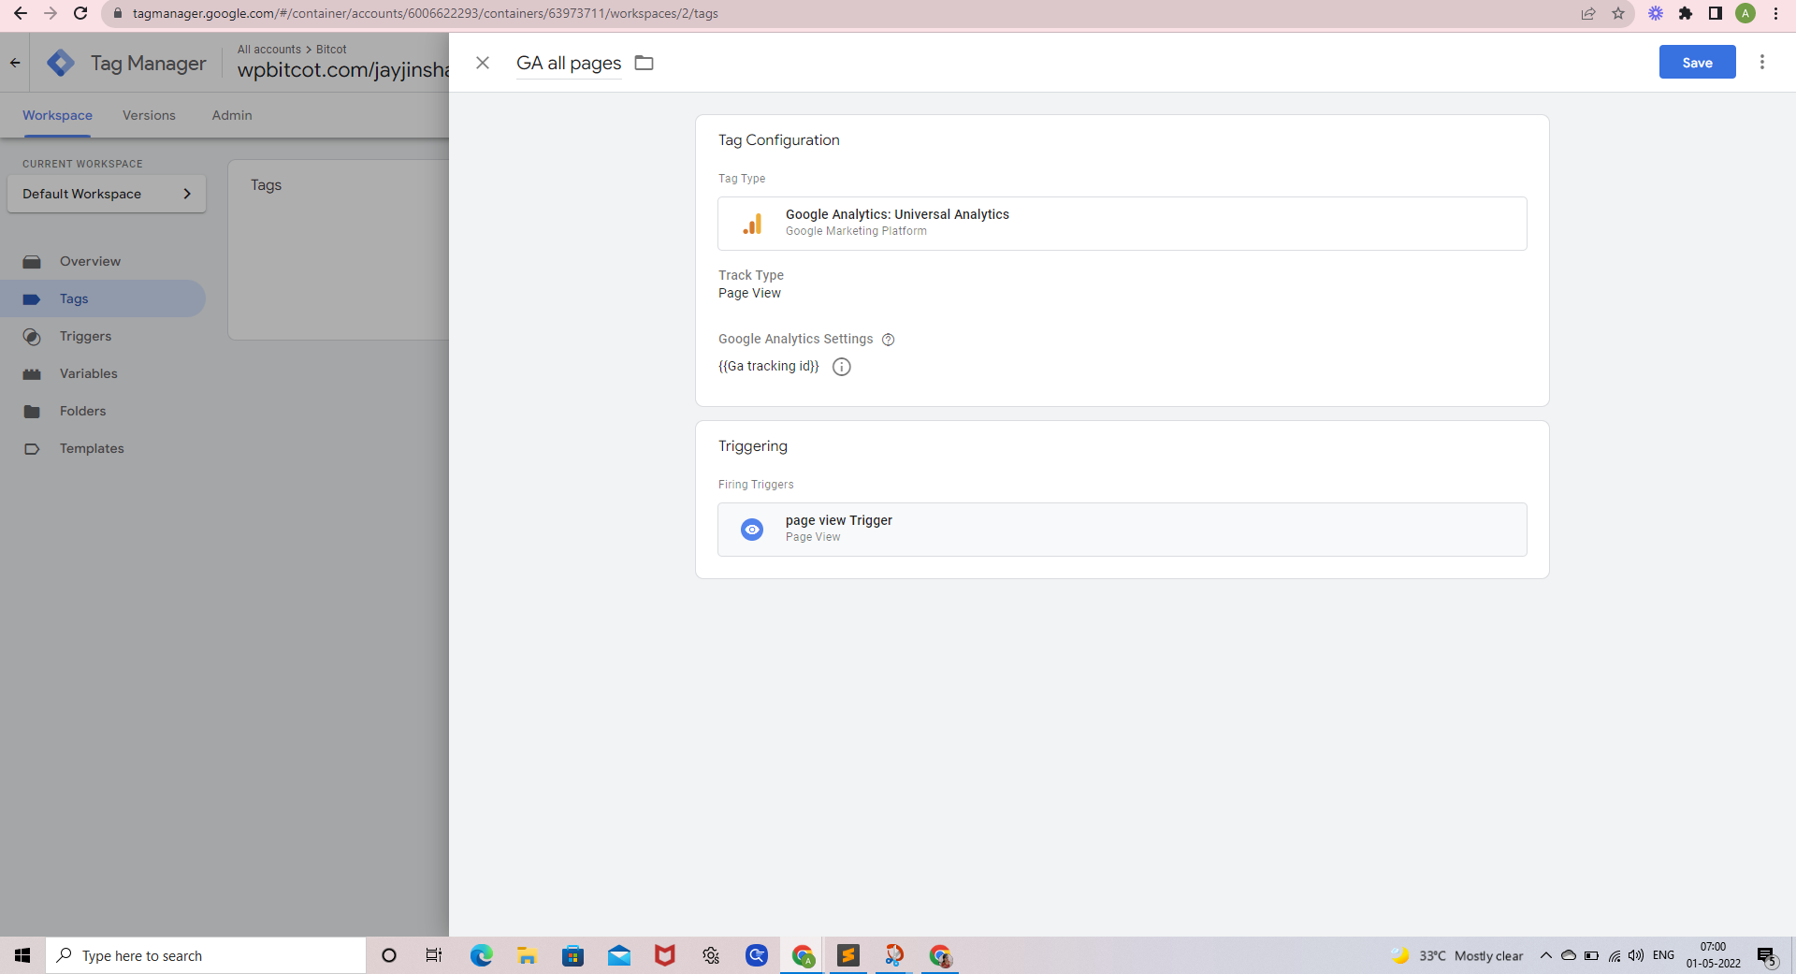

After that click submit

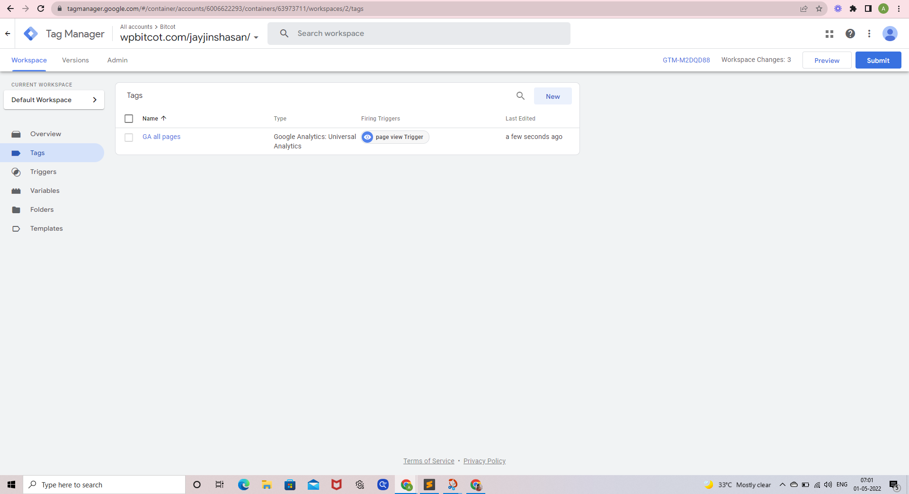

Then publish 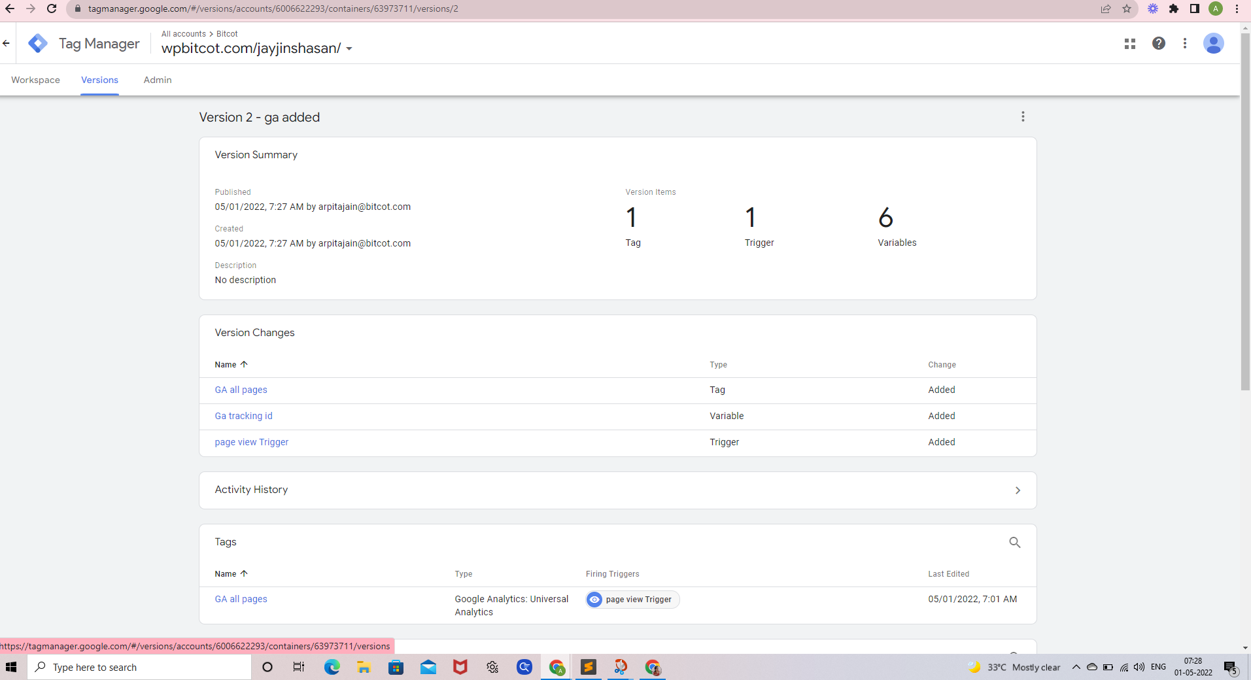

---------------------------------------------------------------------------------------------------------------------------------------------

# Test Google Tag Manager installation

To **test** **Google Analytics** and **Google Tag Manage**r installation in website

We need to install this **Chrome Extension:-**

**Tag Assistant Legacy (by Google) Extension**

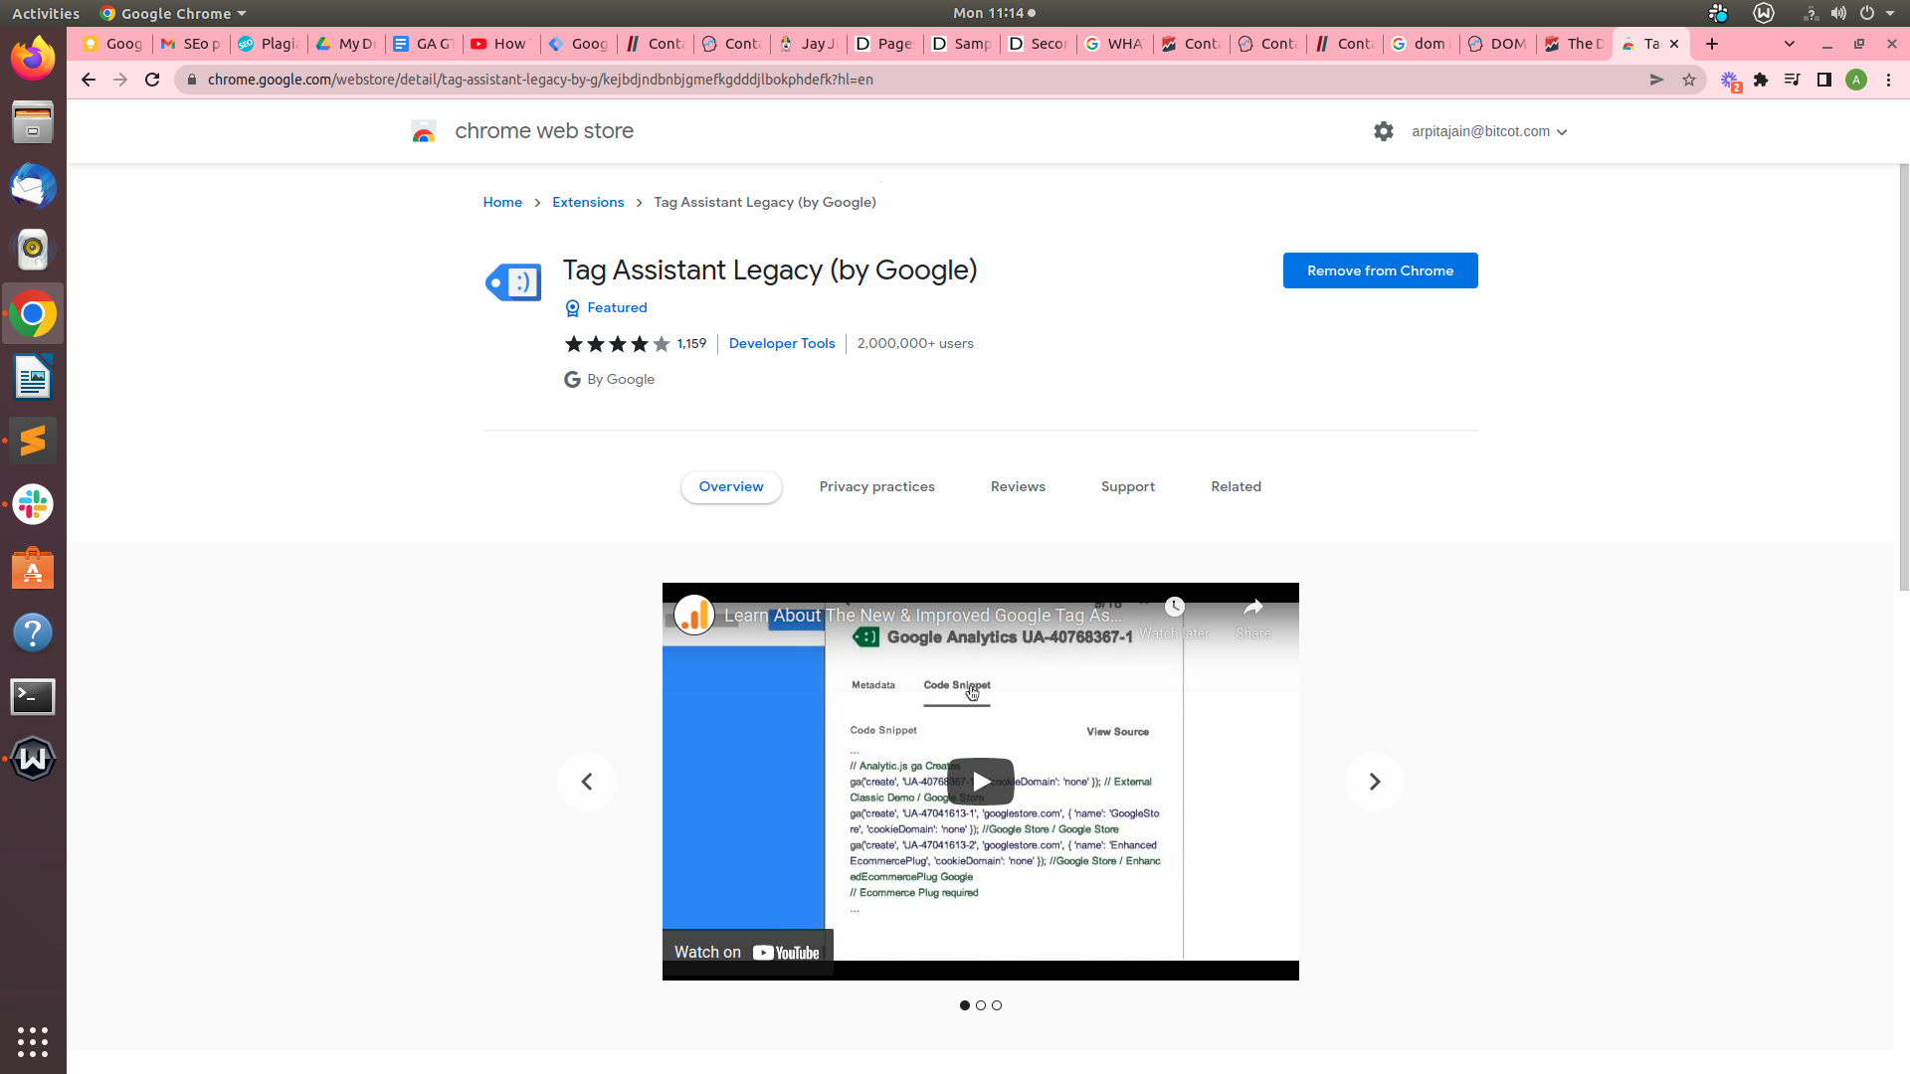

After Refresh website URL to enable this Chrome Extension

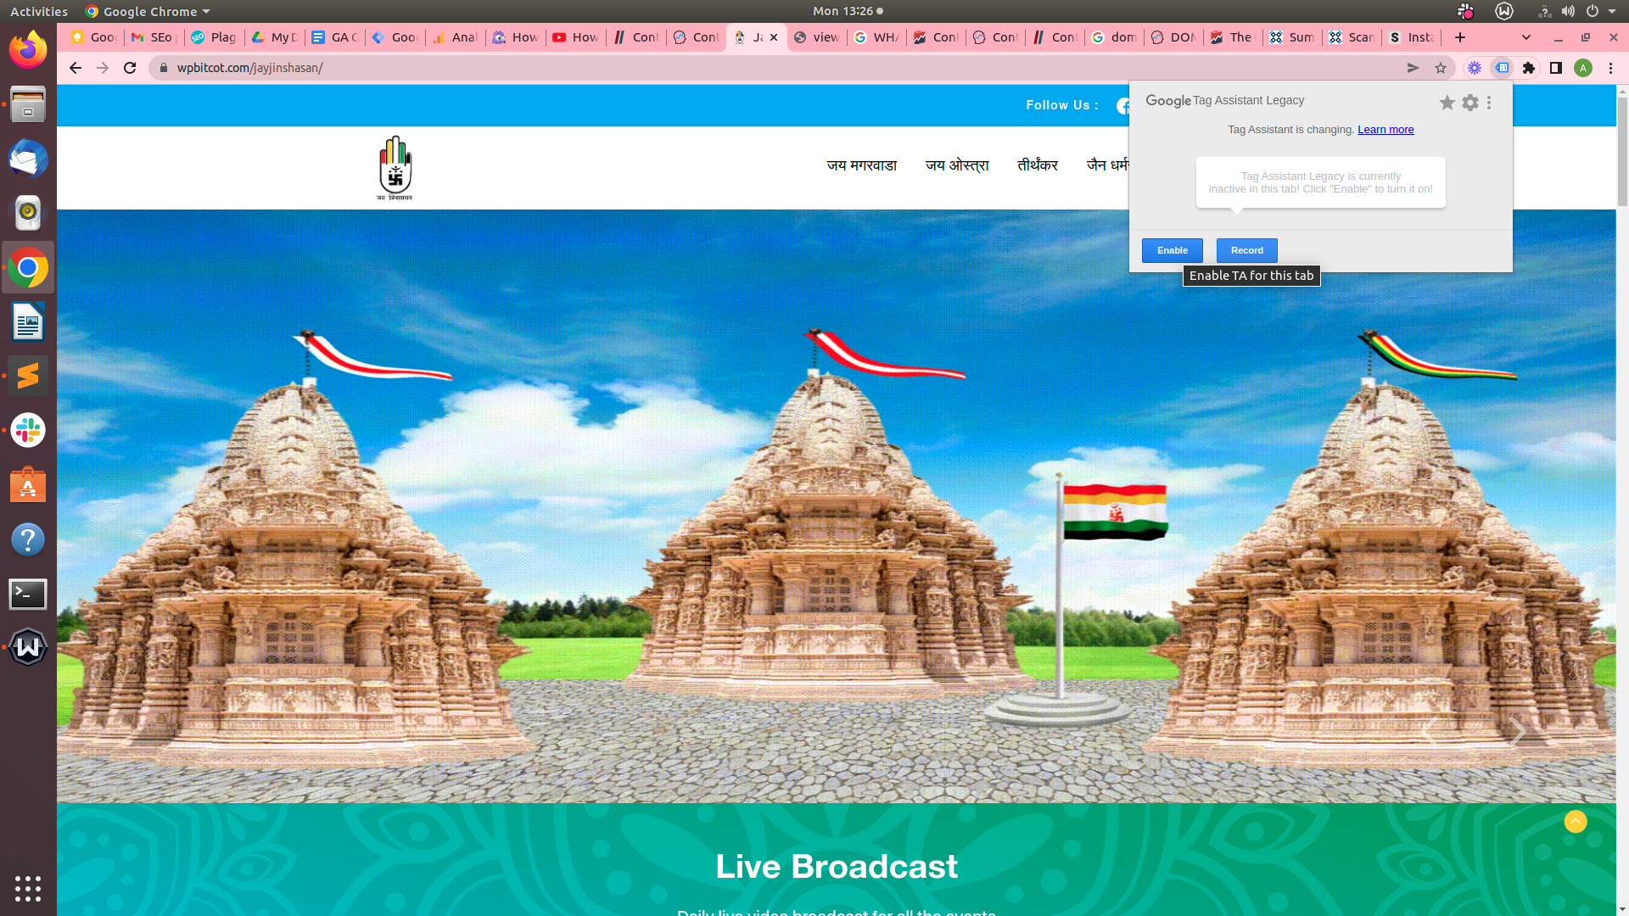

After successful implementation of this extension the below mentioned result will be displayed on the screen

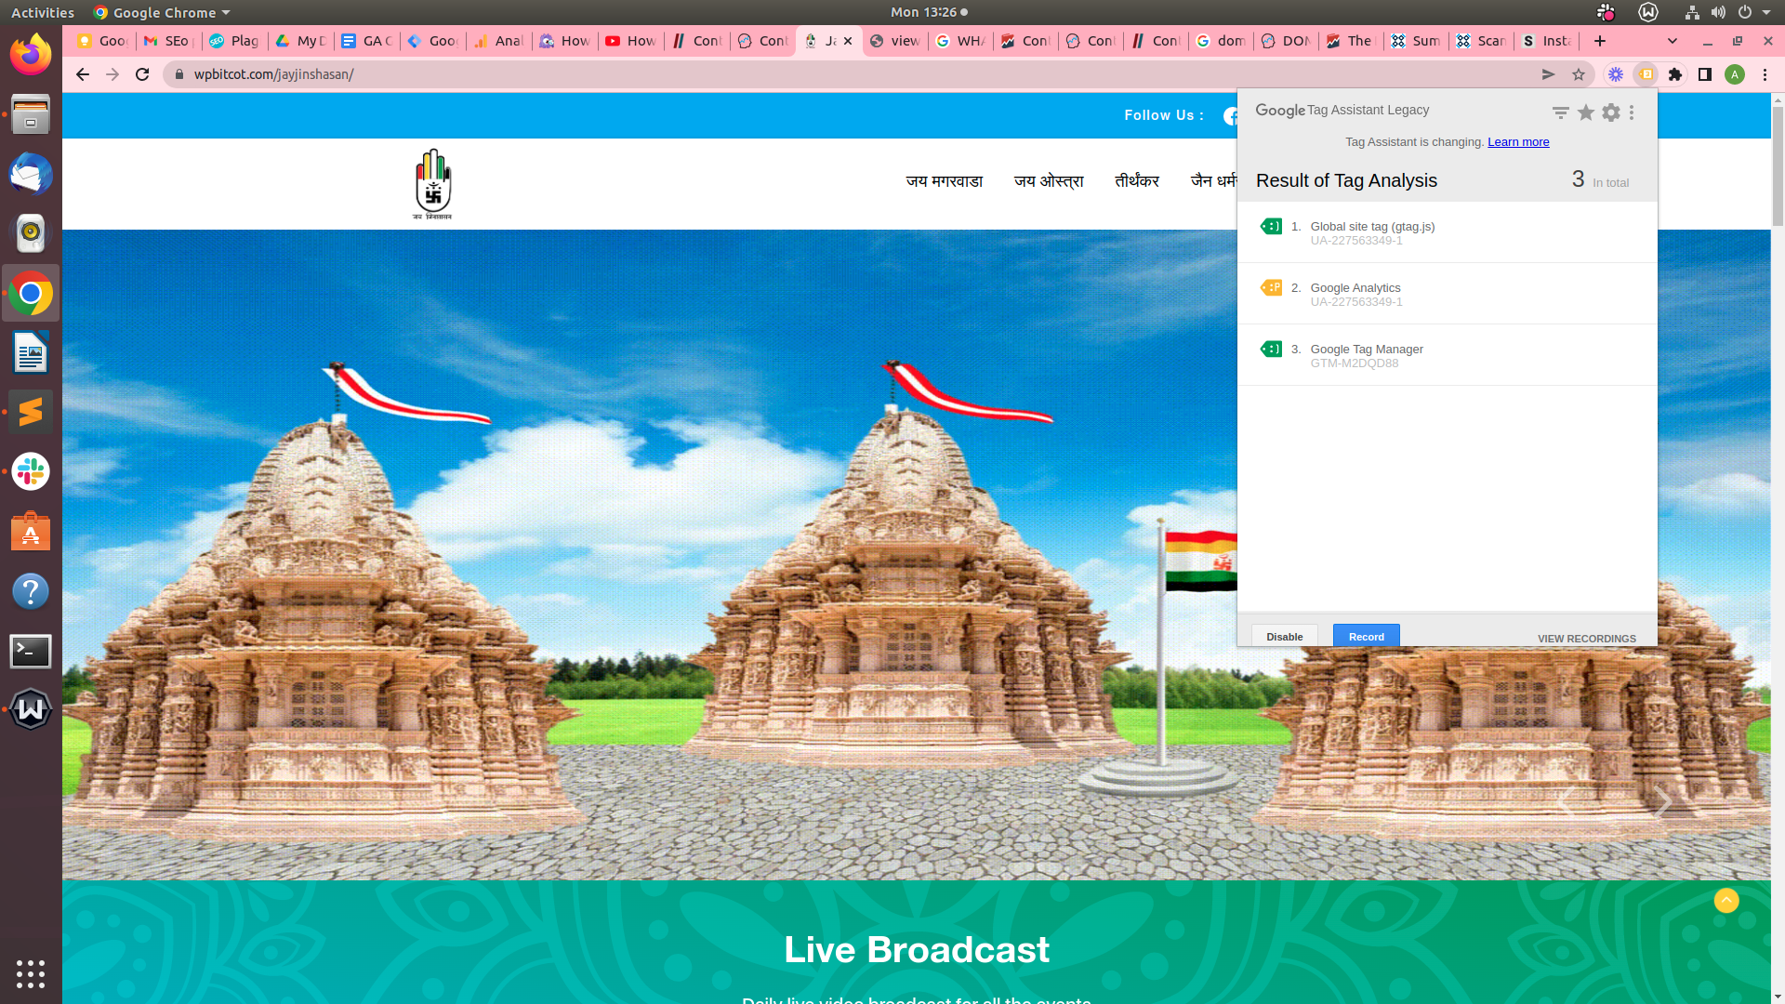

---------------------------------------------------------------------------------------------------------------------------------------------

# Tracking display in Google Analytics

After running this URL <https://wpbitcot.com/jayjinshasan/jain-dharam-swarup/>

Below mentioned result will be displayed on the screen

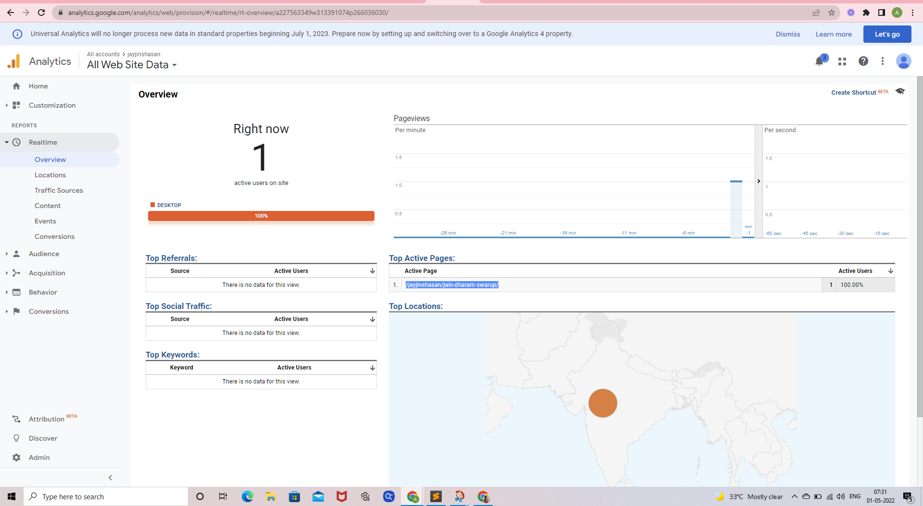

And below image will be showing user location

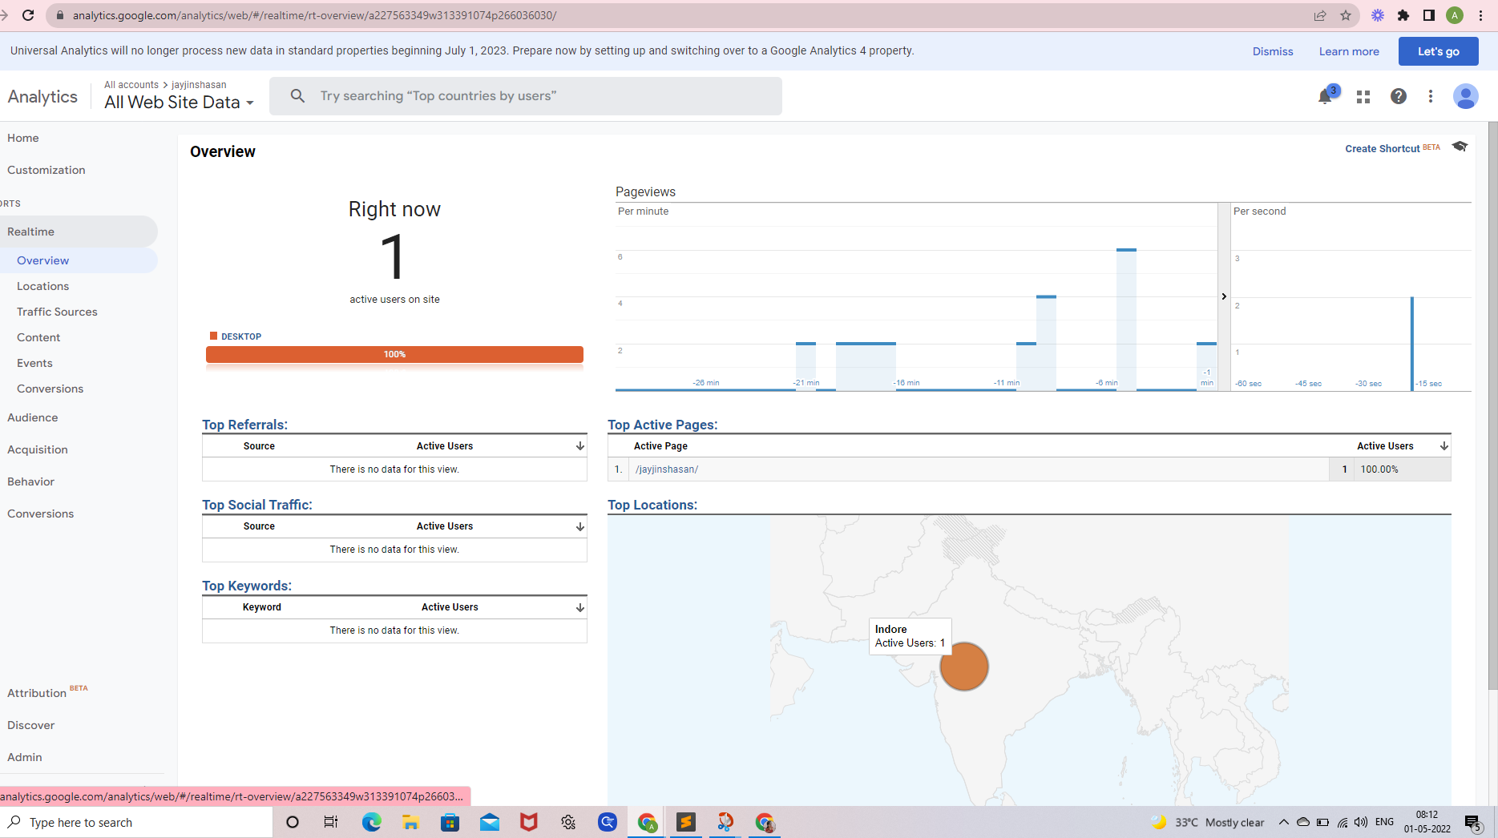

In this screen displayed no event Trigger in GA(**Google Analytics**)

Because I haven’t added any event tracking inside Google Tag manager

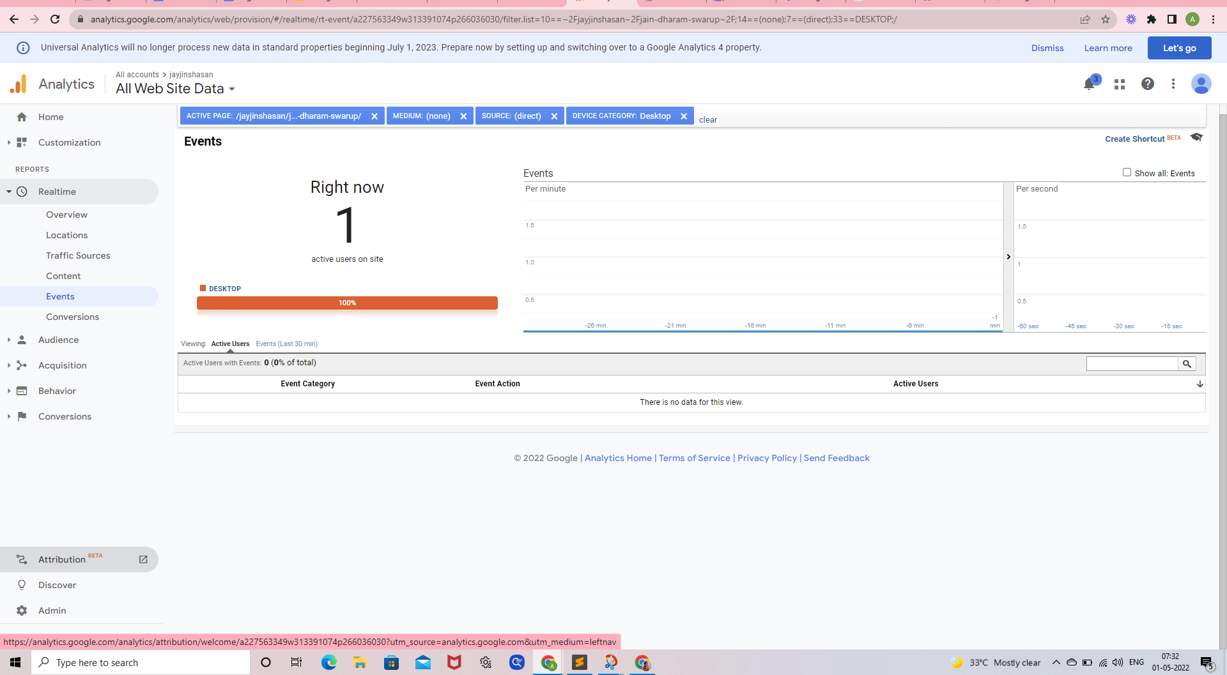

---------------------------------------------------------------------------------------------------------------------------------------------

# Track click event with GTM:-

Select "Click Variables" in Google Tag Manager

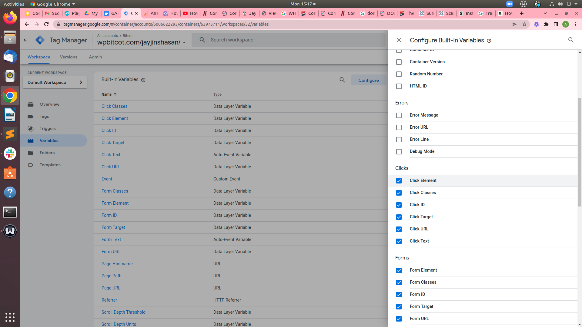

Tag Name :- Click Tag

* Google Analytics Tag
* Go to Tags and click New
* Add tag name click tag
* Track Type – Event
* Category – Click
* Action – Click
* Label – Click
* In the **Google Analytics Settings** field select the GA Settings Variable
* GA tracking id

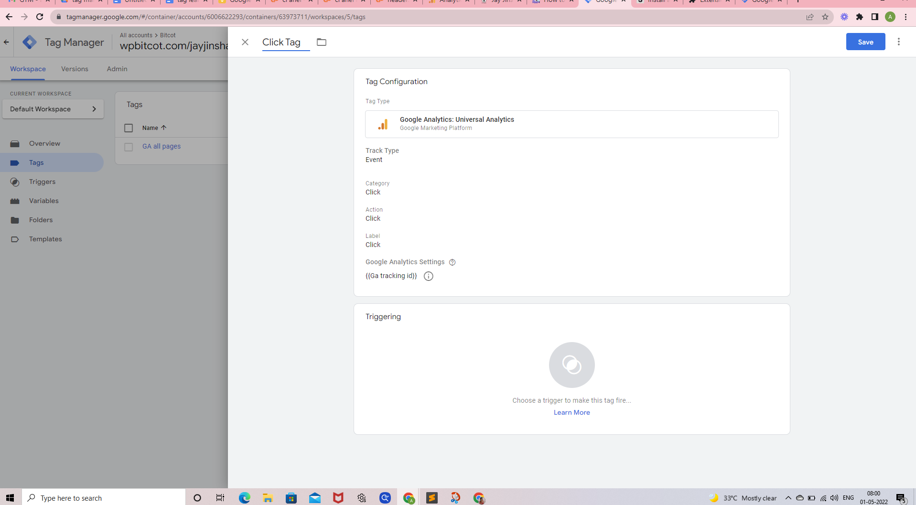

* In the Triggering section, Click trigger after click + icon
* Define tigger name

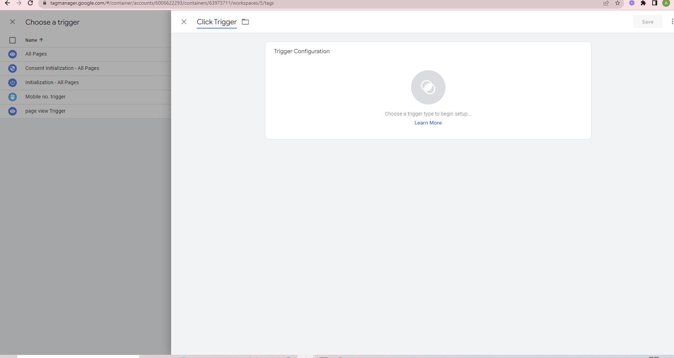

A trigger is a condition. When it is met, we will send the click data to GA (via tag).

* In GTM, go to Triggers > New
* Click Trigger Configuration
* Choose Click URL

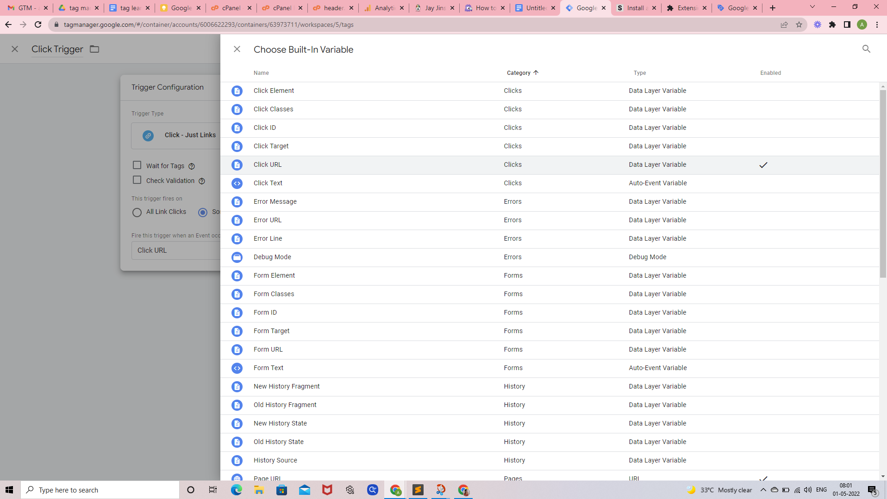

* Select Some Link Clicks

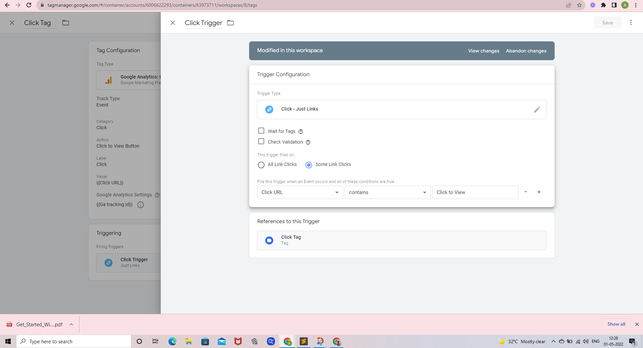

* And enter the following condition:  
  Click URL **contains** Click to View
* Save
* Publish

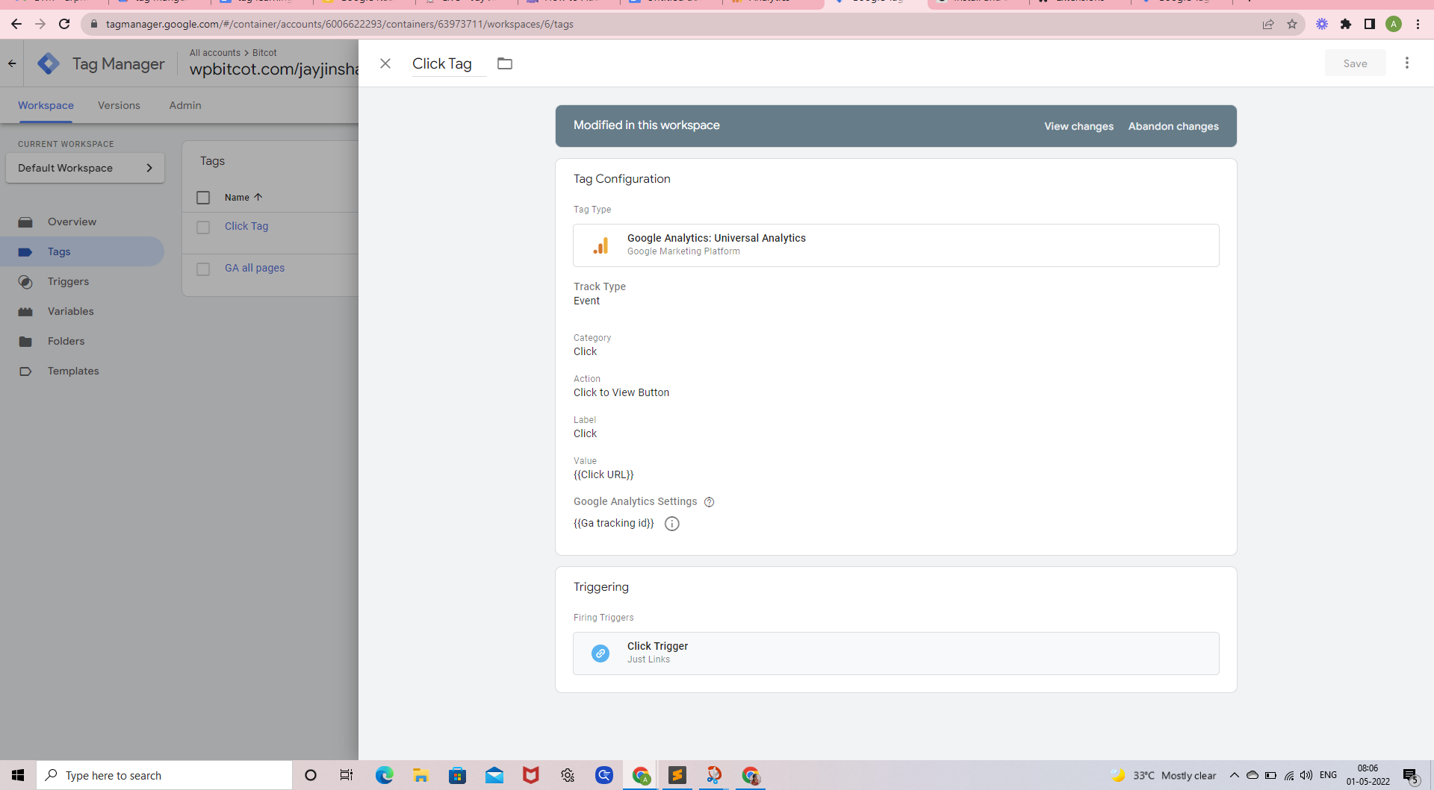

In this screen displayed event Trigger in GA(Google Analytics)

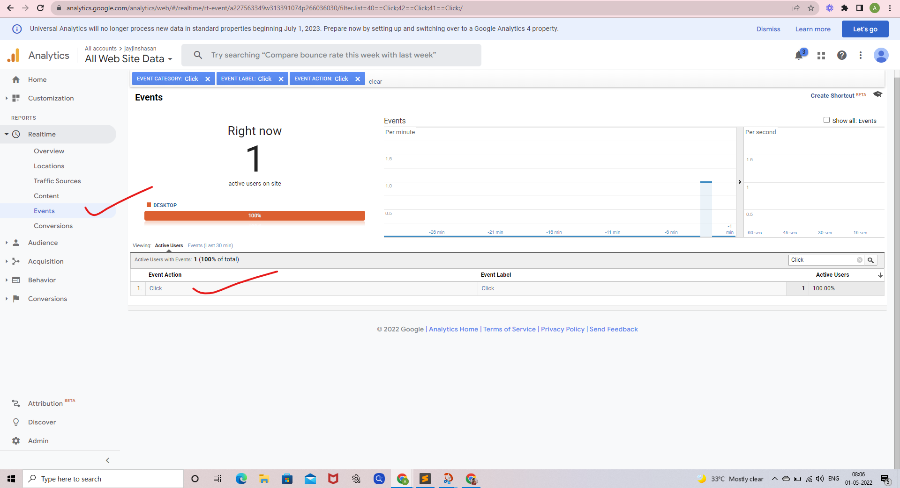

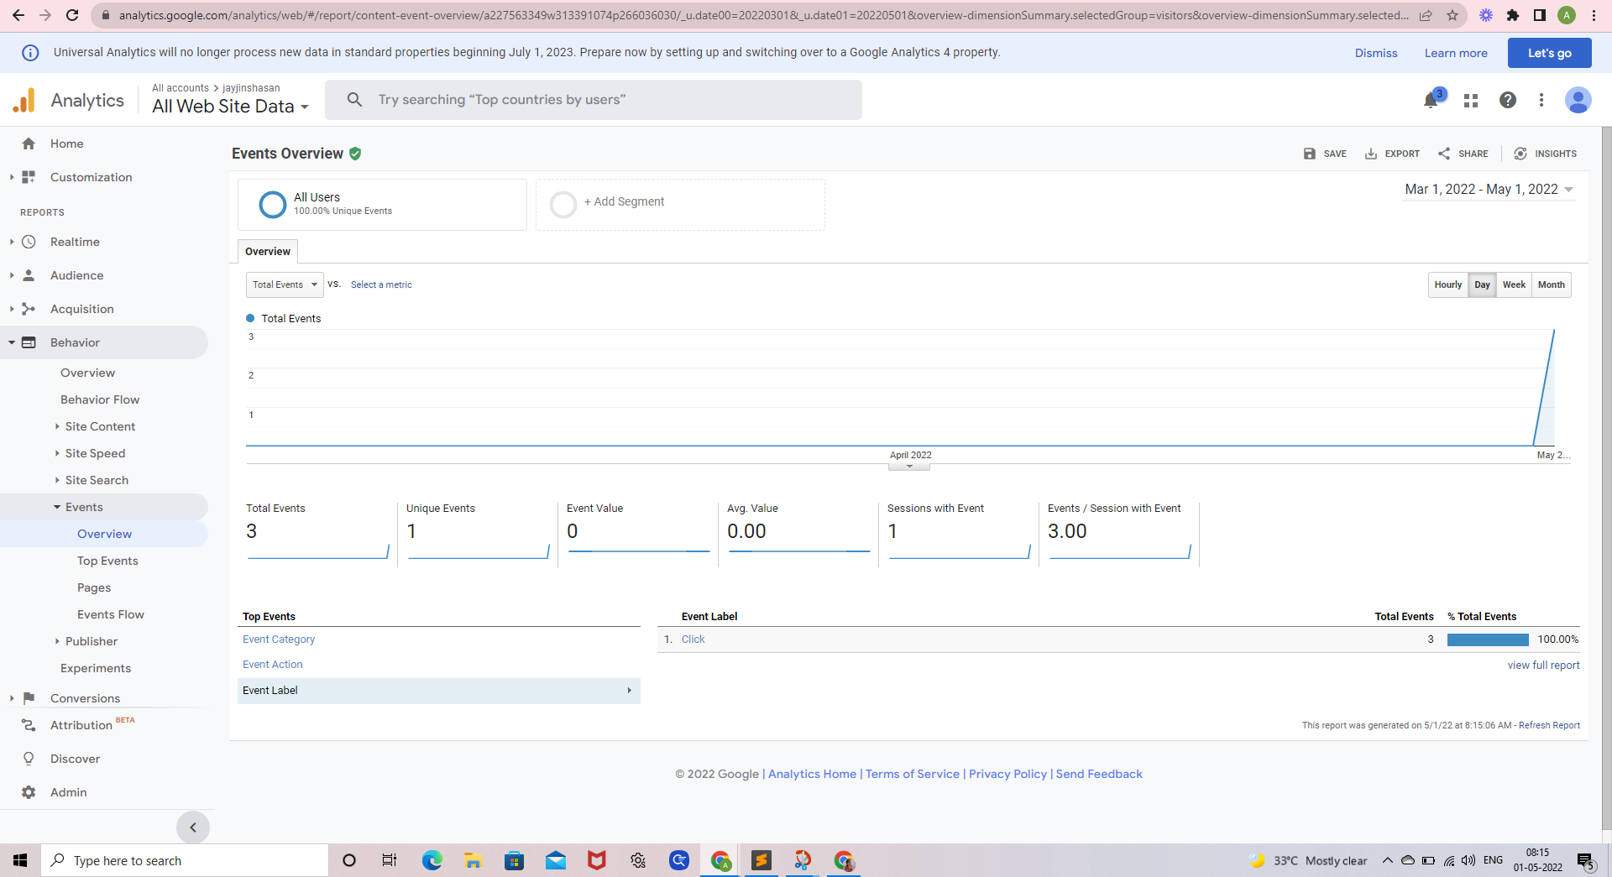

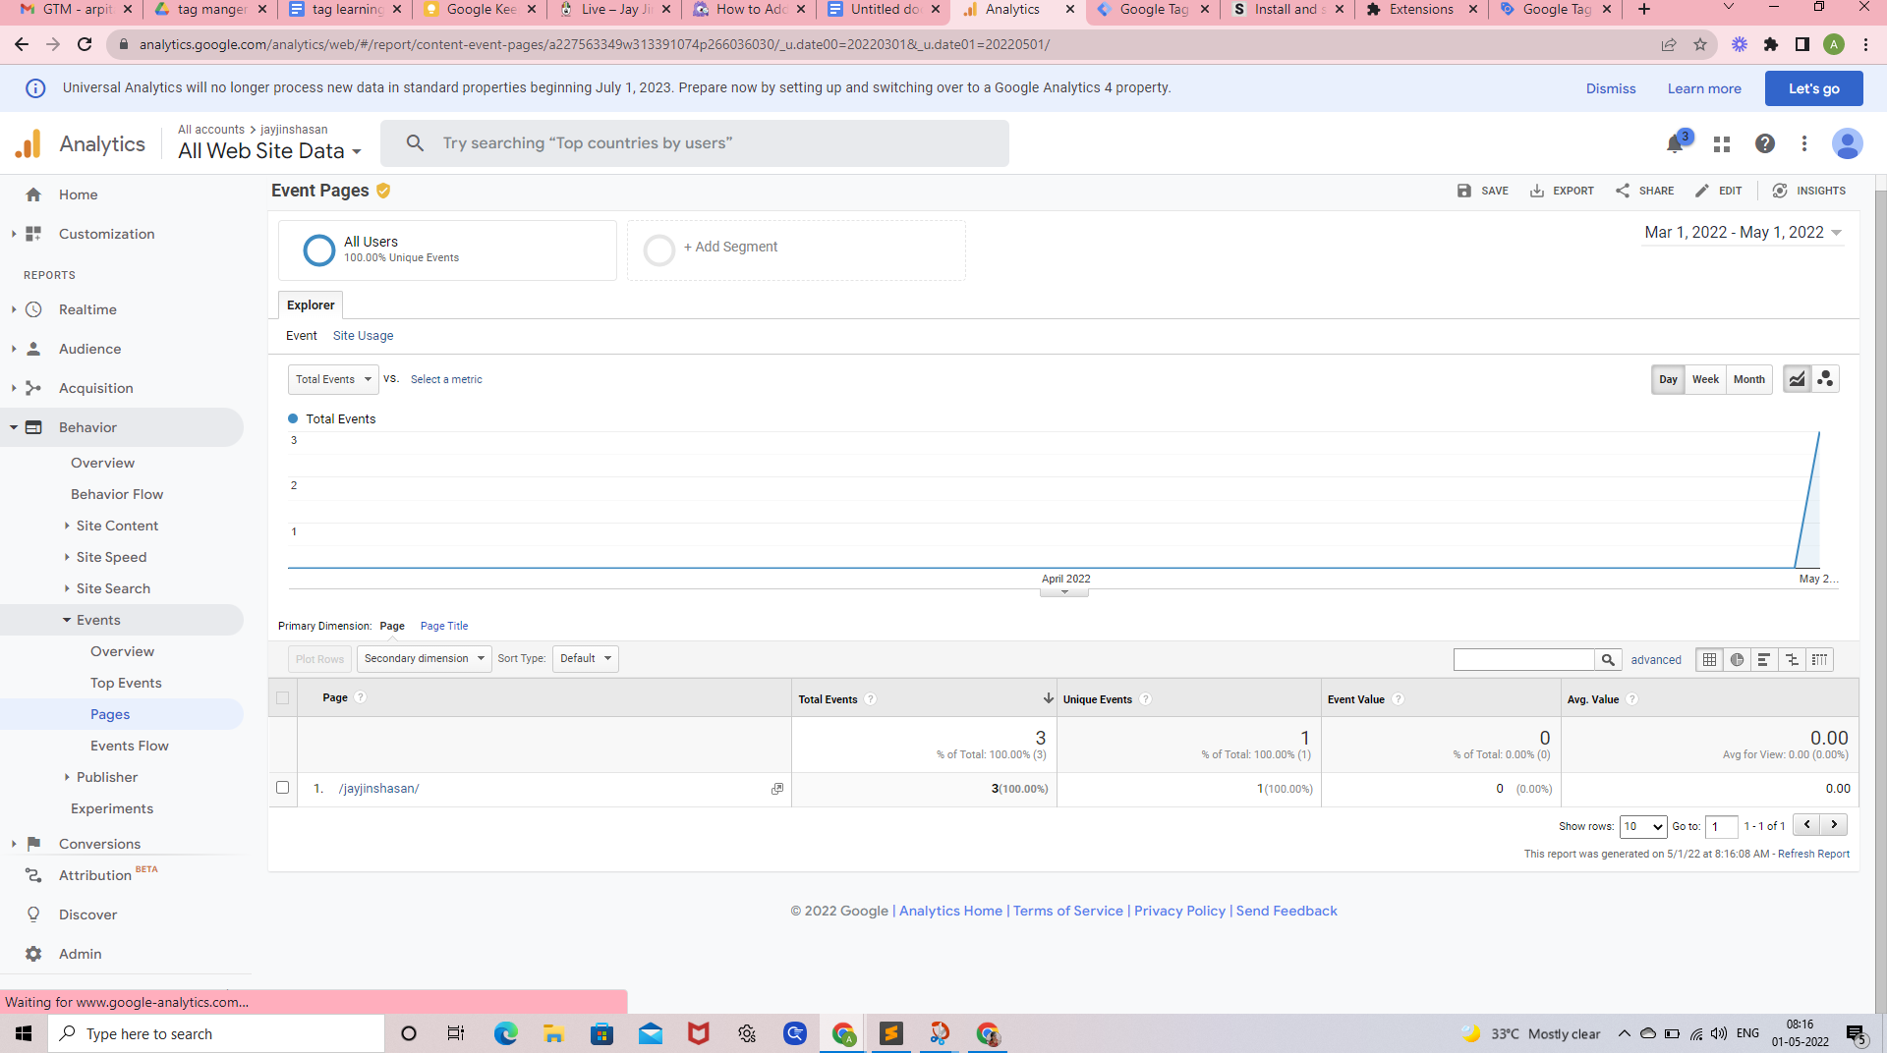

------------------------------------------------------------------------------------------------------------------------------------------

# Track PDF Downloads with GTM

* Google Analytics Tag
* Go to Tags and click New

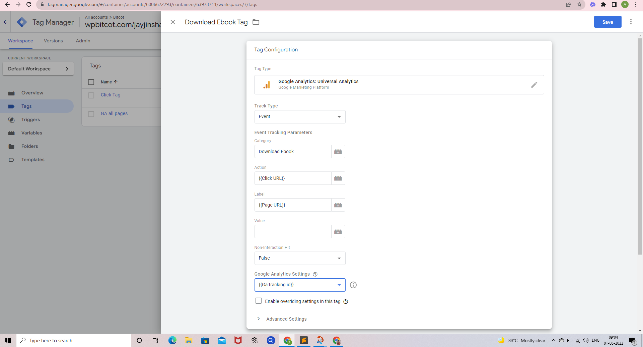

* Track Type – Event
* Category – Download Ebook
* Action – {{Click URL}}
* Label – leave it empty or {{Page URL}}
* In the **Google Analytics Settings** field select the GA Settings Variable
* GA tracking id
* Save the tag

## **Trigger**

A trigger is a condition. When it is met, we will send the click data to GA (via tag).

* In GTM, go to *Triggers > New*
* Click *Trigger Configuration*
* Choose *Just Link Clicks*.
* Select *Some Link Clicks*
* And enter the following condition:  
  *Click Element* **contains** *.pdf*
* Save
* Publish

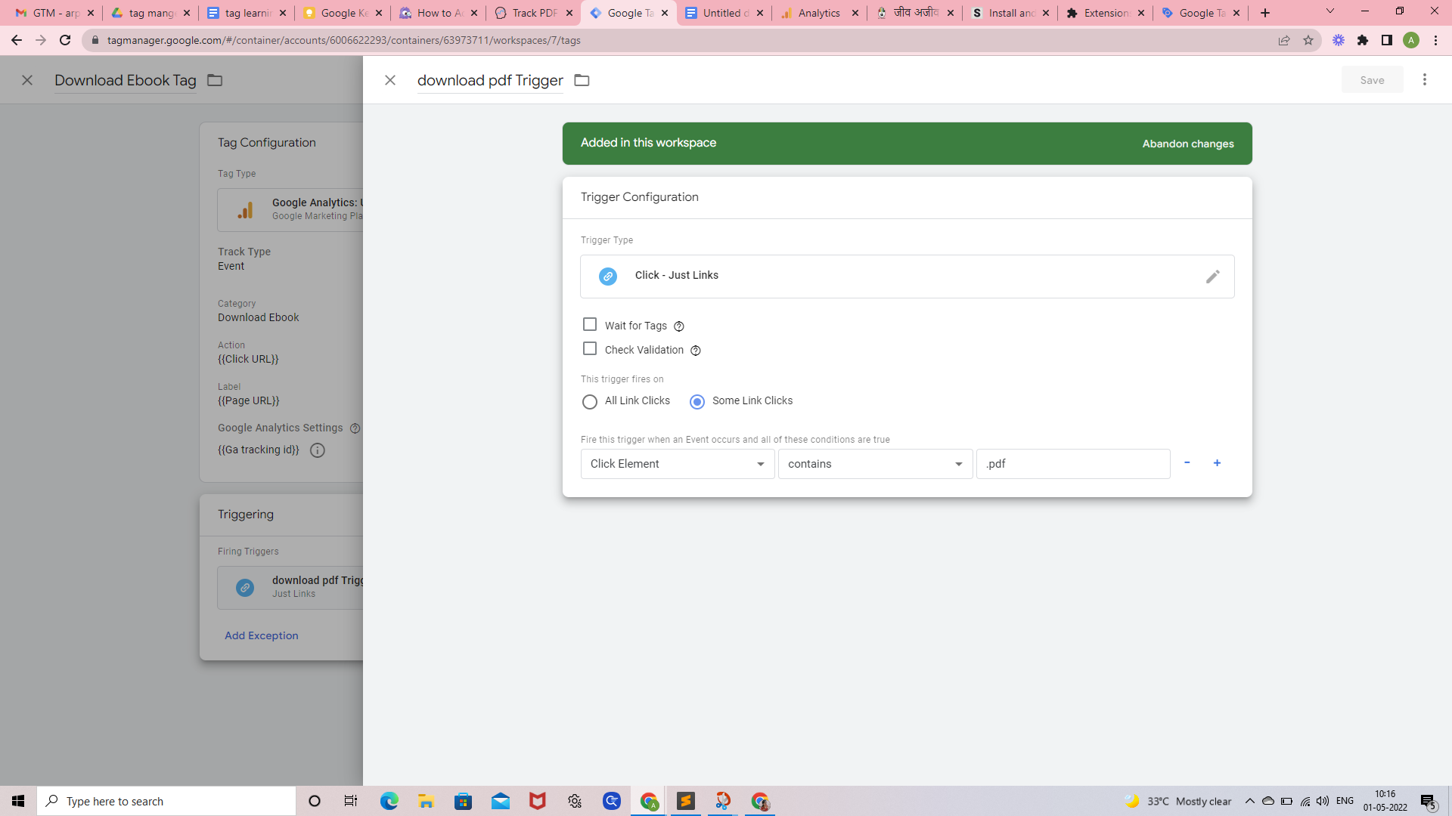

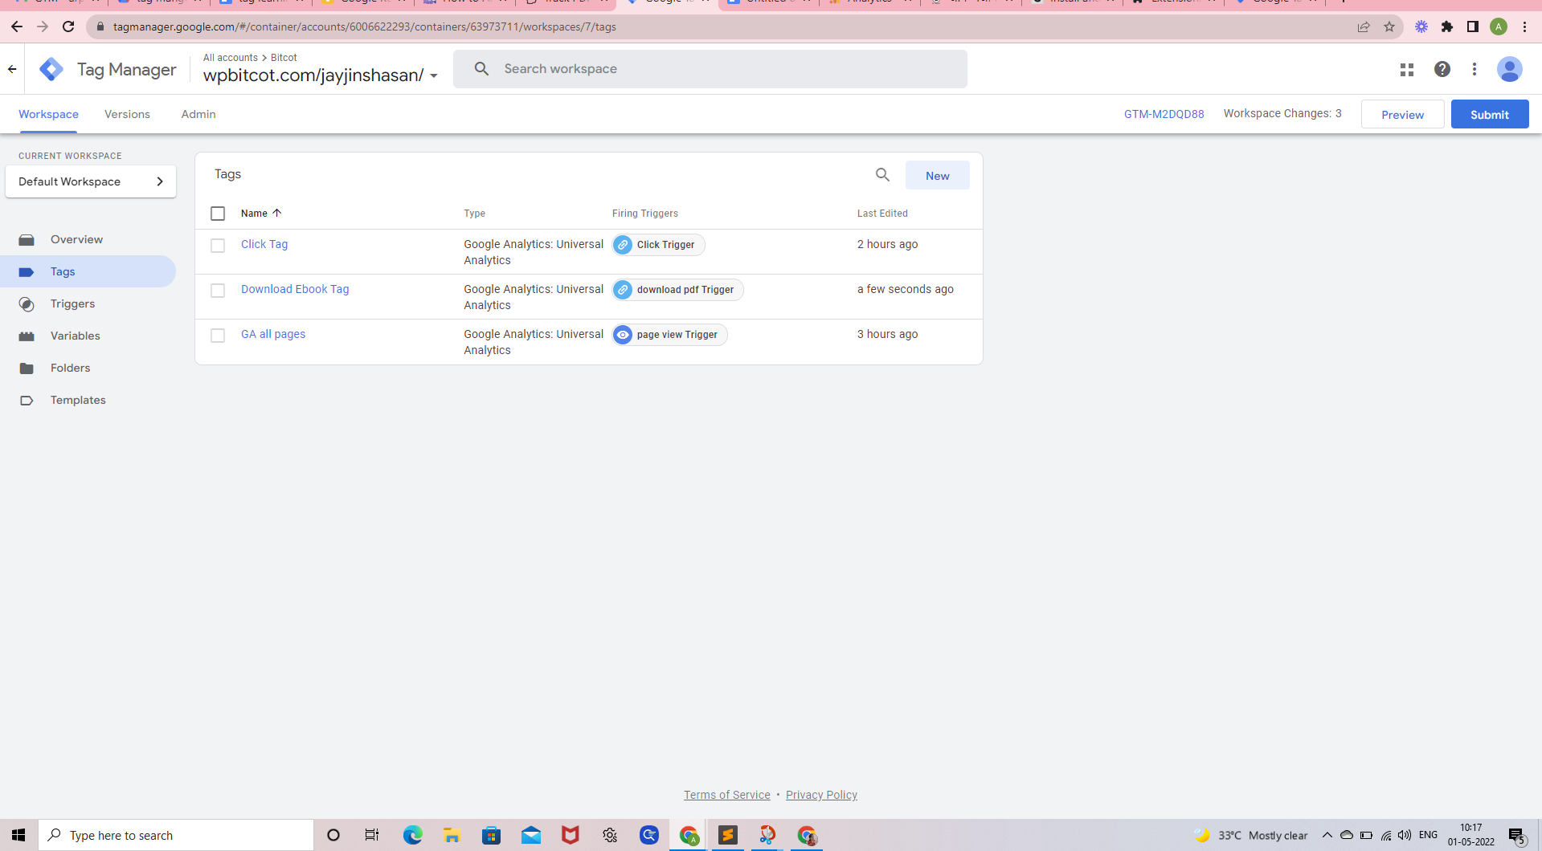

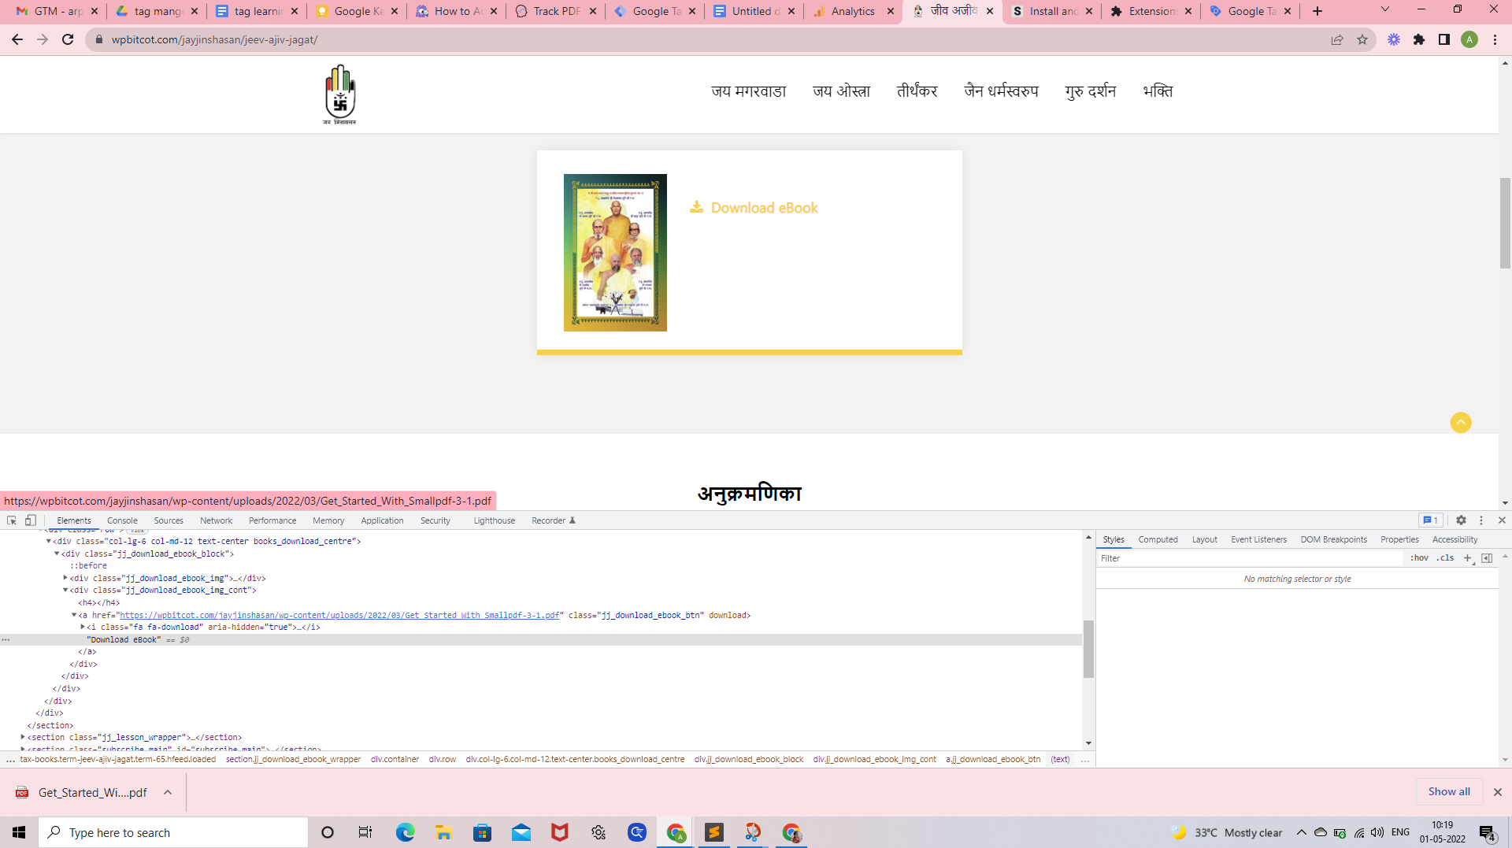

After click pdf link in website

below mentioned result will be displayed on Google Analytics the screen

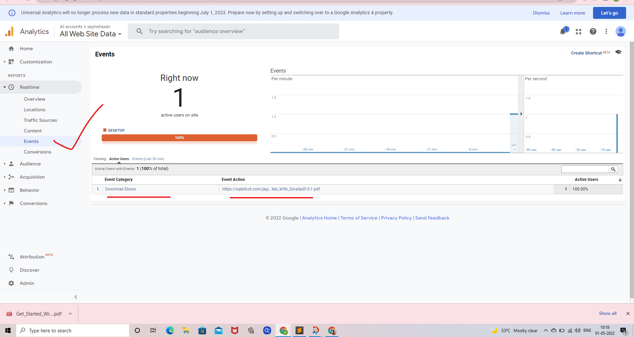

---------------------------------------------------------------------------------------------------------------------------------------------

## Useful Plugin

<https://wordpress.org/plugins/duracelltomi-google-tag-manager/>

## Useful link for tracking event :-

**Iframe- Tracking event with GTM** <https://measureschool.com/iframe-tracking/>

Using Facebook pixel with Google Tag Manager :-<https://en-gb.facebook.com/business/help/1021909254506499>

https://en-gb.facebook.com/business/help/1021909254506499

---------------------------------------------------------------------------------------------------------------------------------------------

# Track Youtube videos with Google Tag Manager

Tracking page-views is a way to recognize what website visitors are doing on your web page. You have to additionally not forget different interactions, inclusive of clicks, perspectives of unique factors, video interactions, and so on.

**Create a Youtube Video trigger**

Go to Triggers > New > trigger Configuration and select Youtube Video

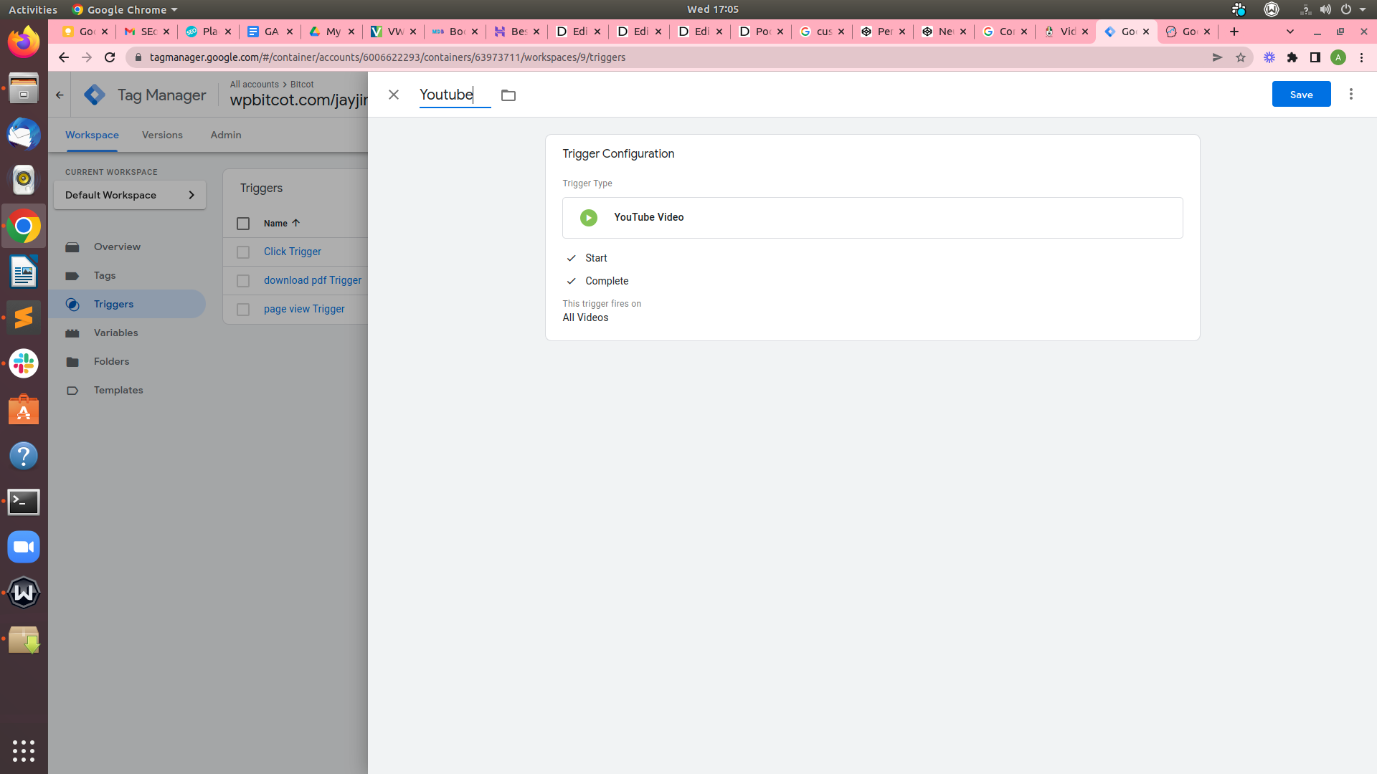

**You could** **alternatively** **share the** threshold to **anything** **you like**, **simply** separate them with a comma. **Also**, **you can** **allow** Pause, **seeking**, and Buffering **tracking**. **individually**, I **pick** **monitoring** **start**, **entire**, and **progress** (e.g. 25% of the video **turned into** watched).

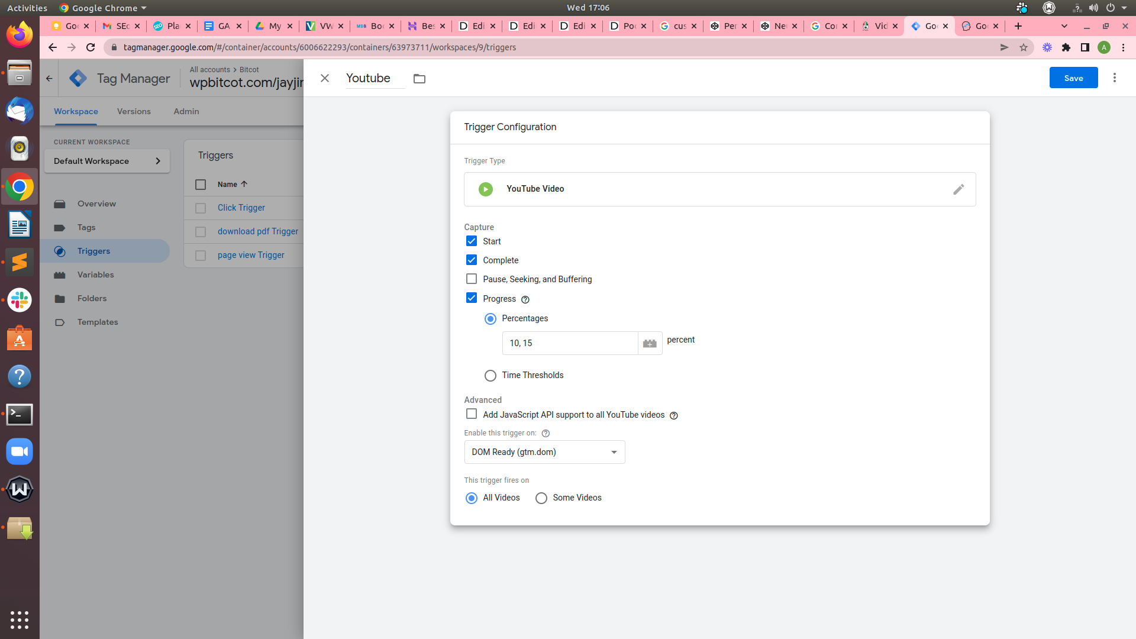

### **Enable built-in Youtube video variables**

**Go** Variables > Configure and **allow** all video-**associated** variables.

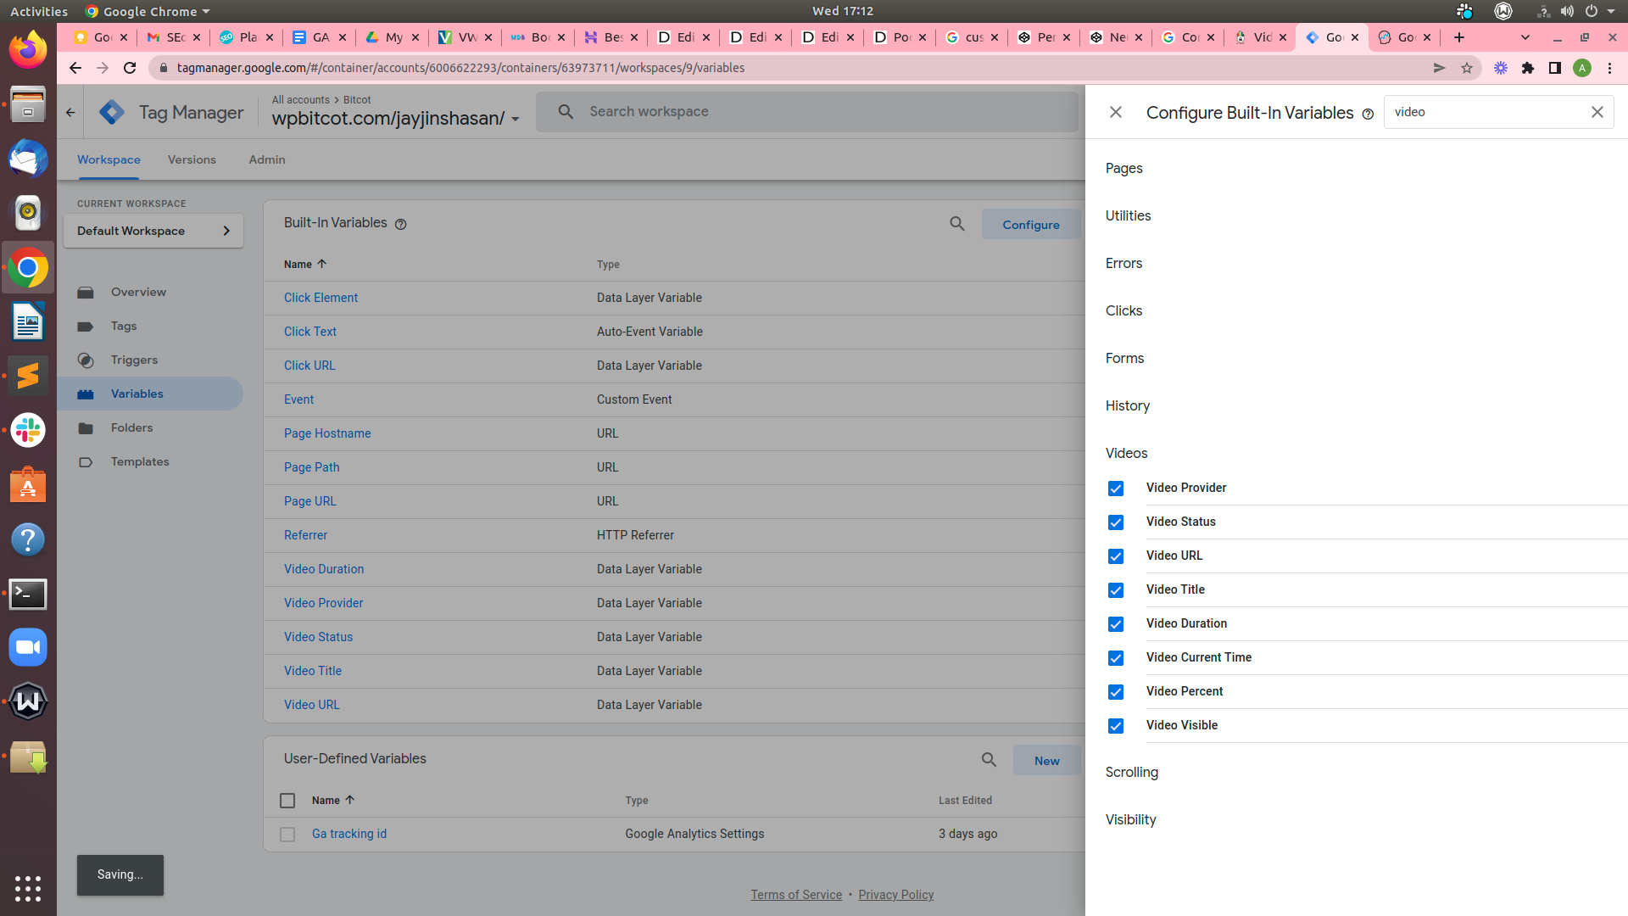

**Create a Lookup Table variable:-**

Go to Variables > New > lookup table and enter the subsequent settings:

I can create a **lookup variable table** in **GTM** so that it will return a specific output based totally on the **Youtube video interaction**

* Input Variable :- {{Video Status}}
* Input field:- progress (without quotation marks, all lowercase)
* Output field {{Video Status}} {{Video Percent}}%
* We have to allow "Set Default cost" checkbox and insert {{Video Status}} variable

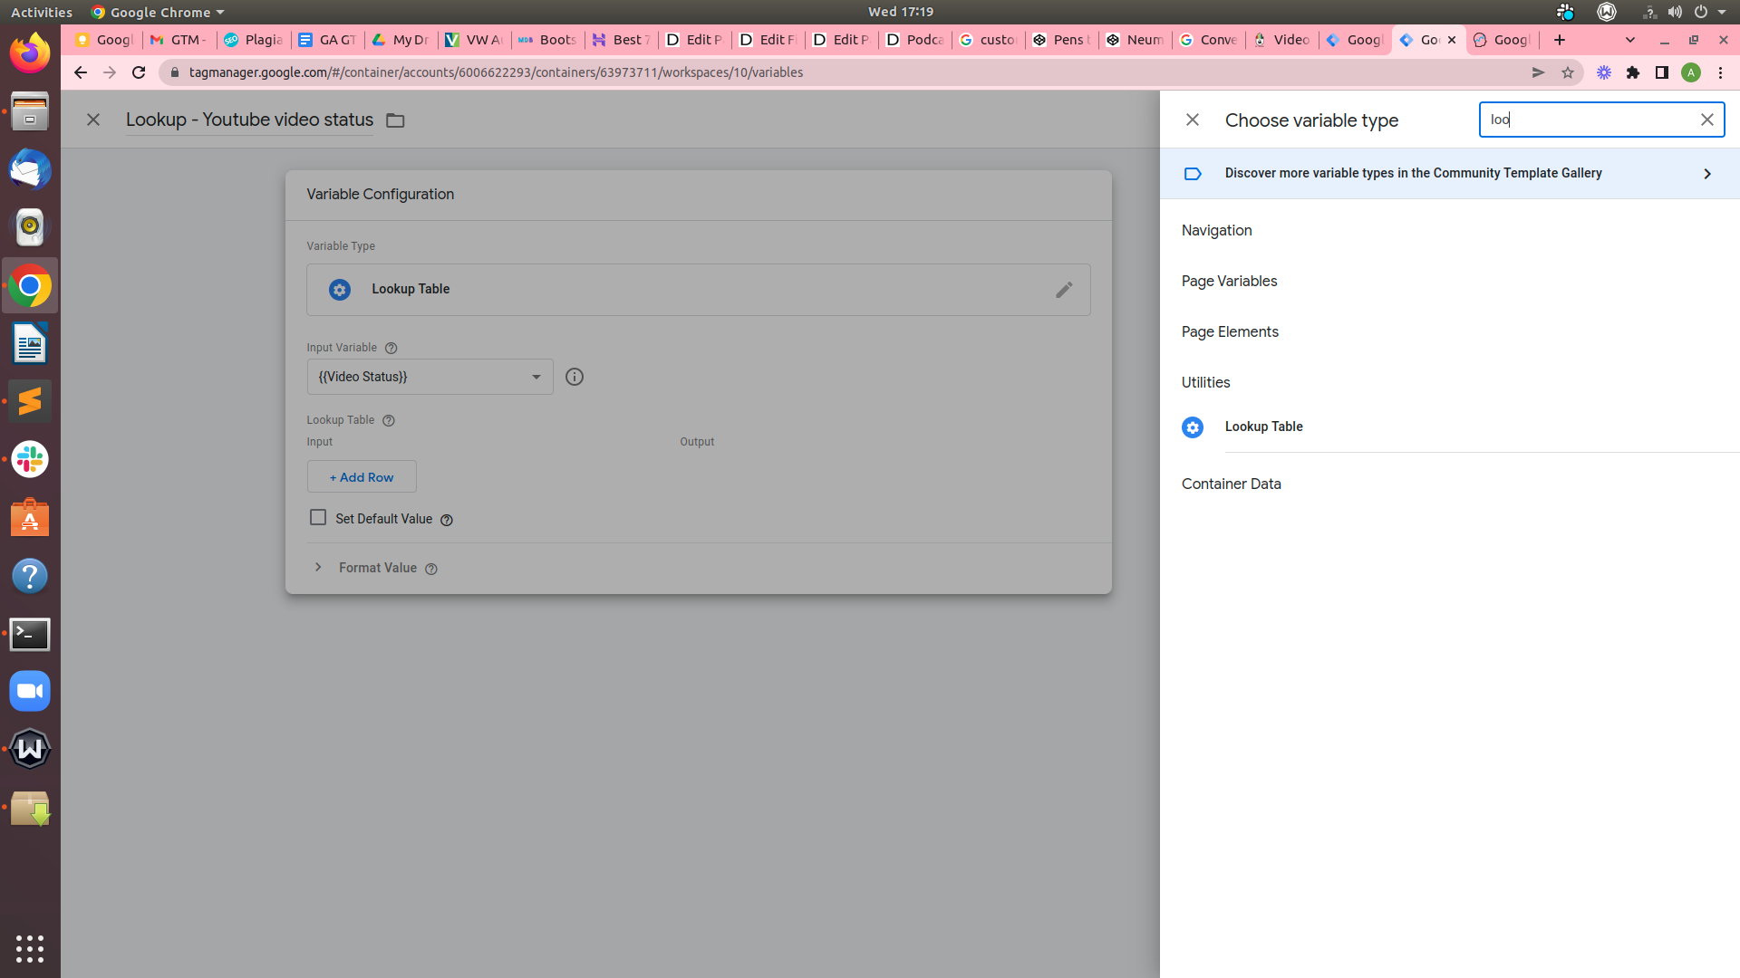

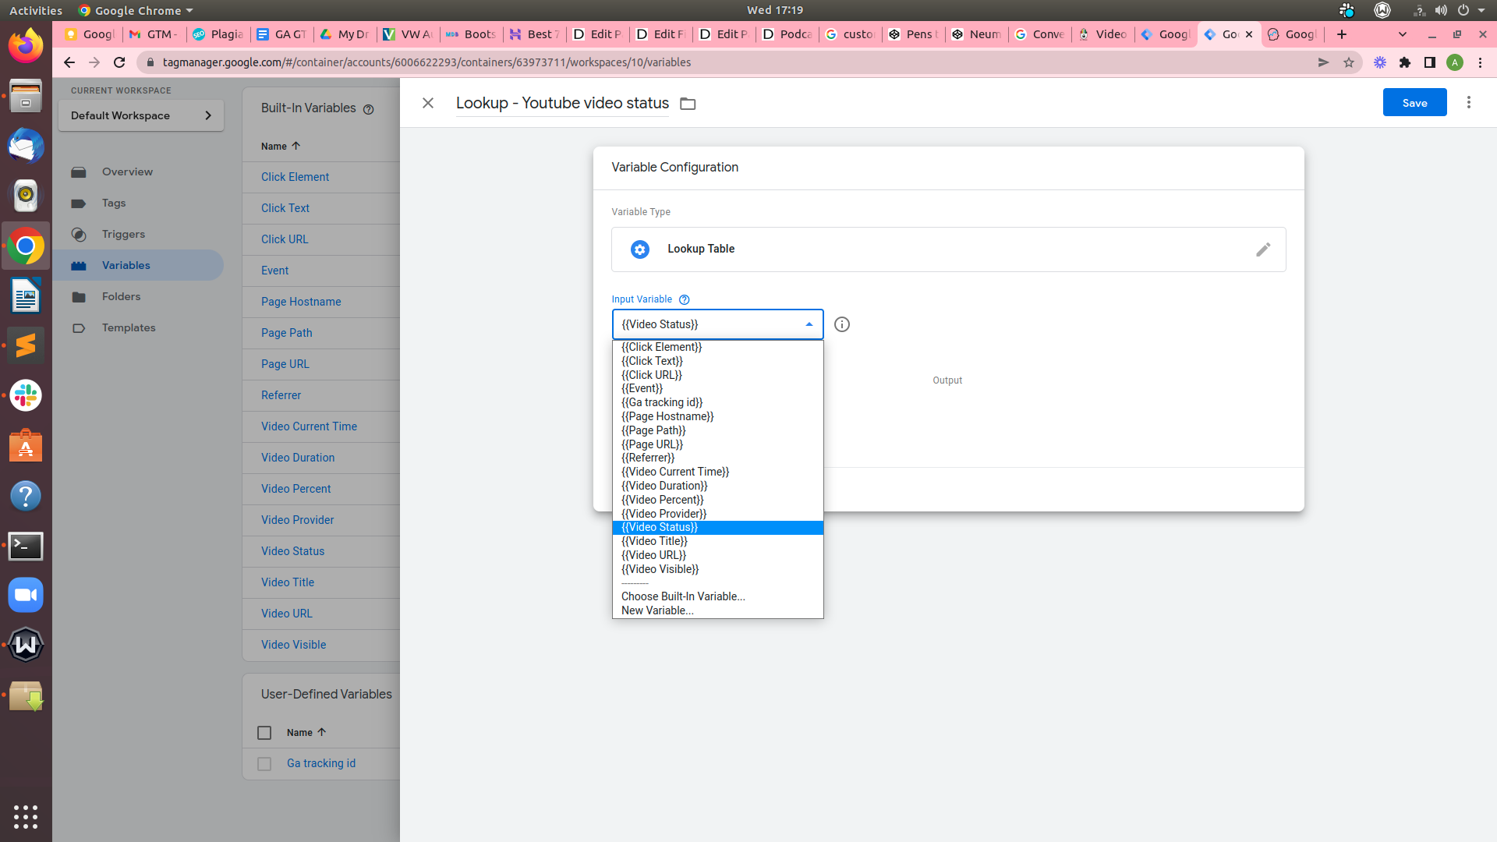

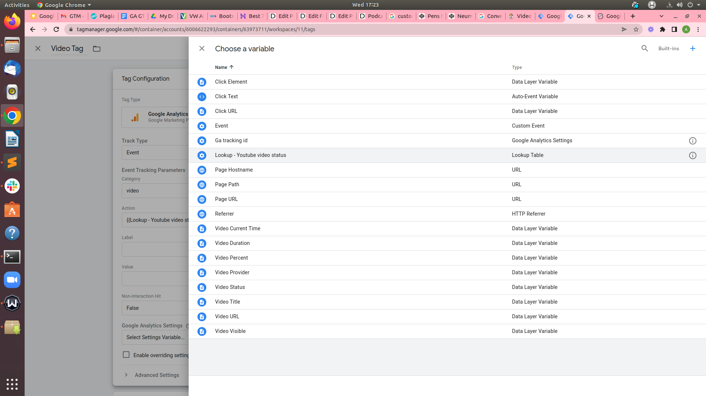

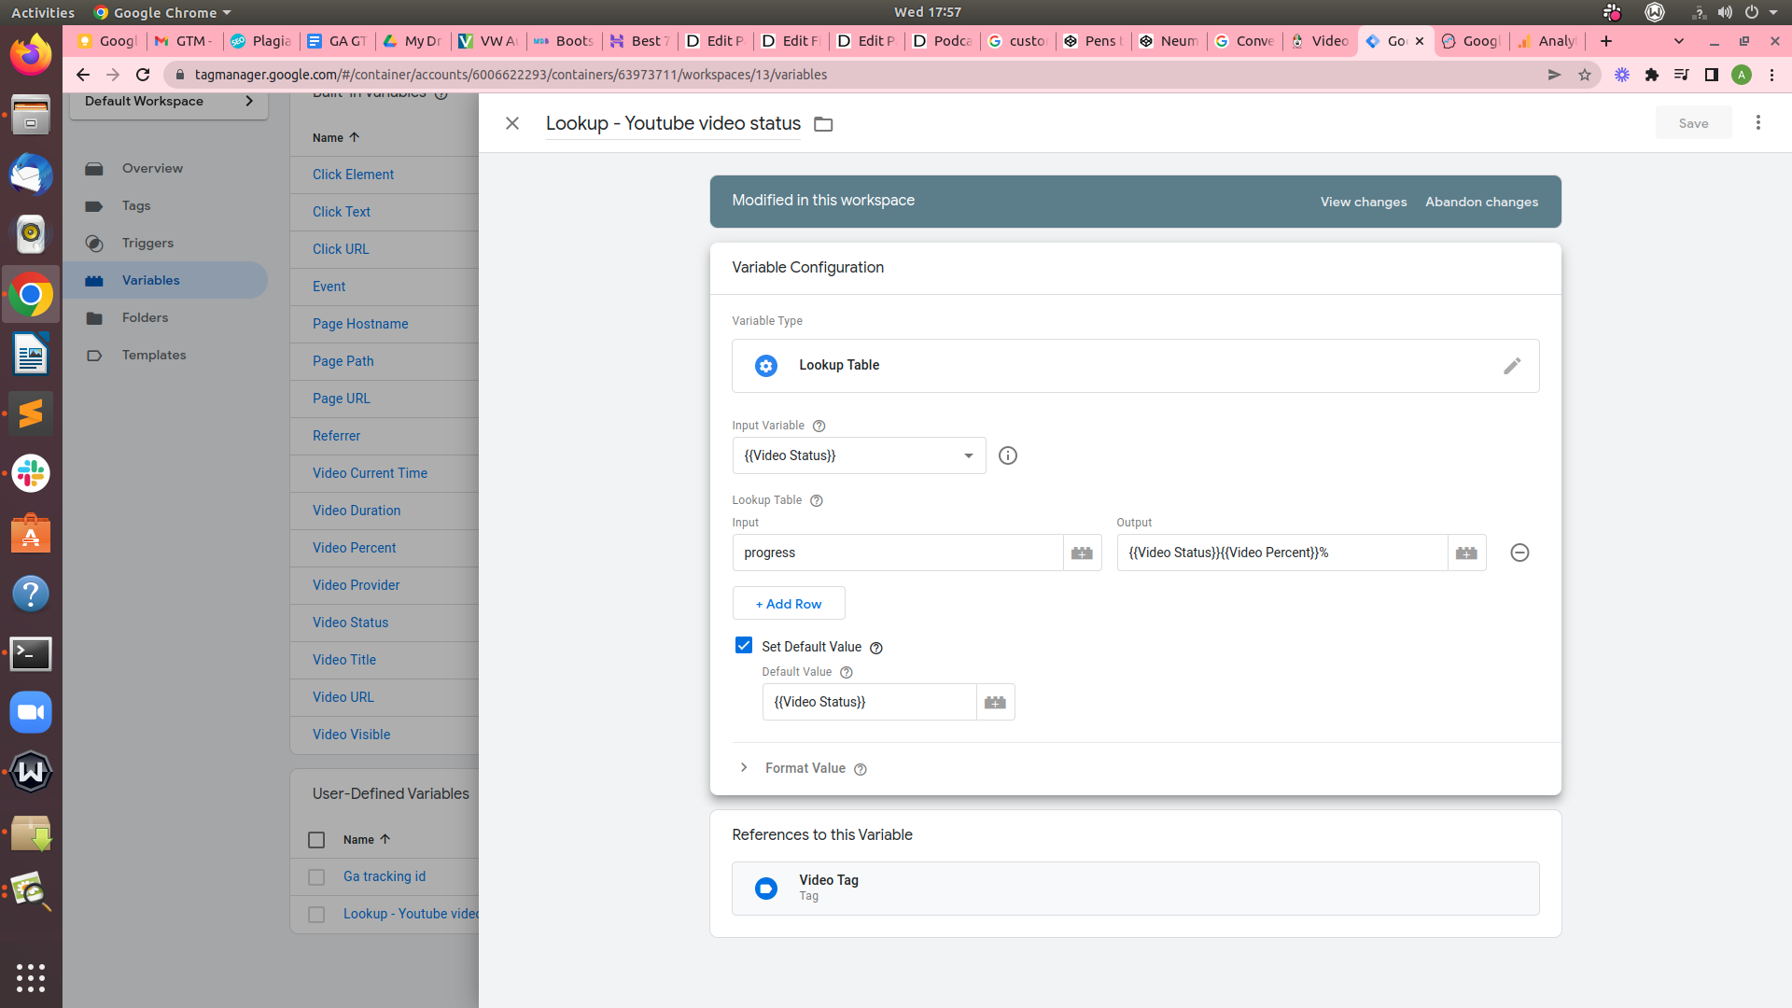

**Create a video Tag :-**

* **Go to** Tags > New > Tag Configuration
* Select **Google Analytics: Universal Analytics**
* Event Category :- video
* Action:- {{Lookup - Youtube video status}}
* Label :- {{Video Title}}
* Google Analytics Settings:- GA tracking Id
* Select trigger
* Save
* Publiash

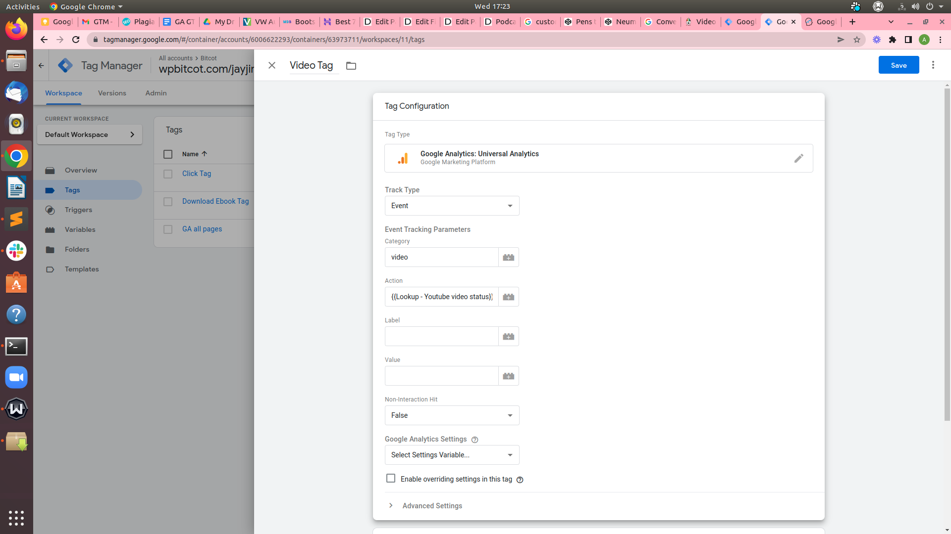

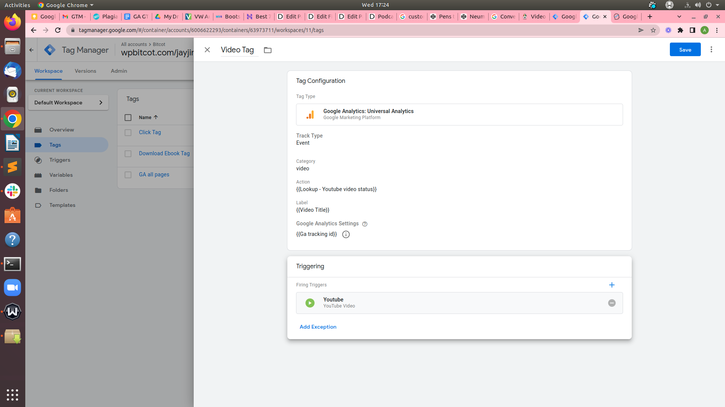

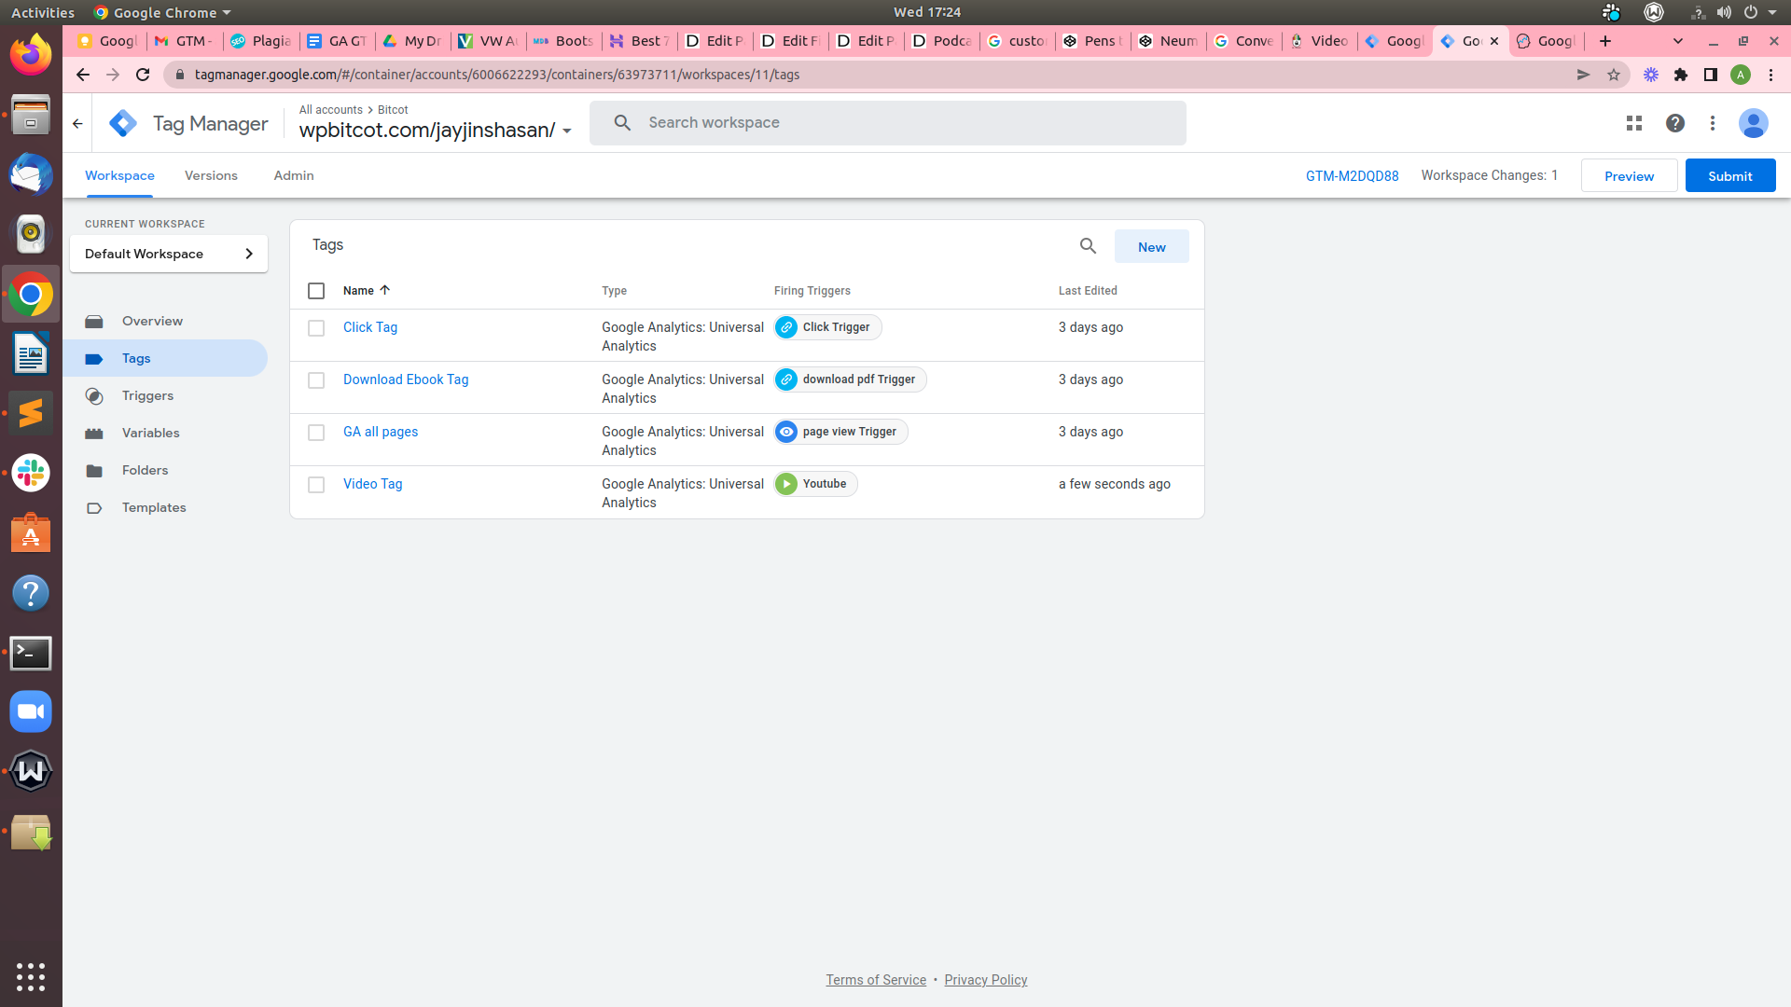

After click video in website

below mentioned result will be displayed on Google Analytics the screen

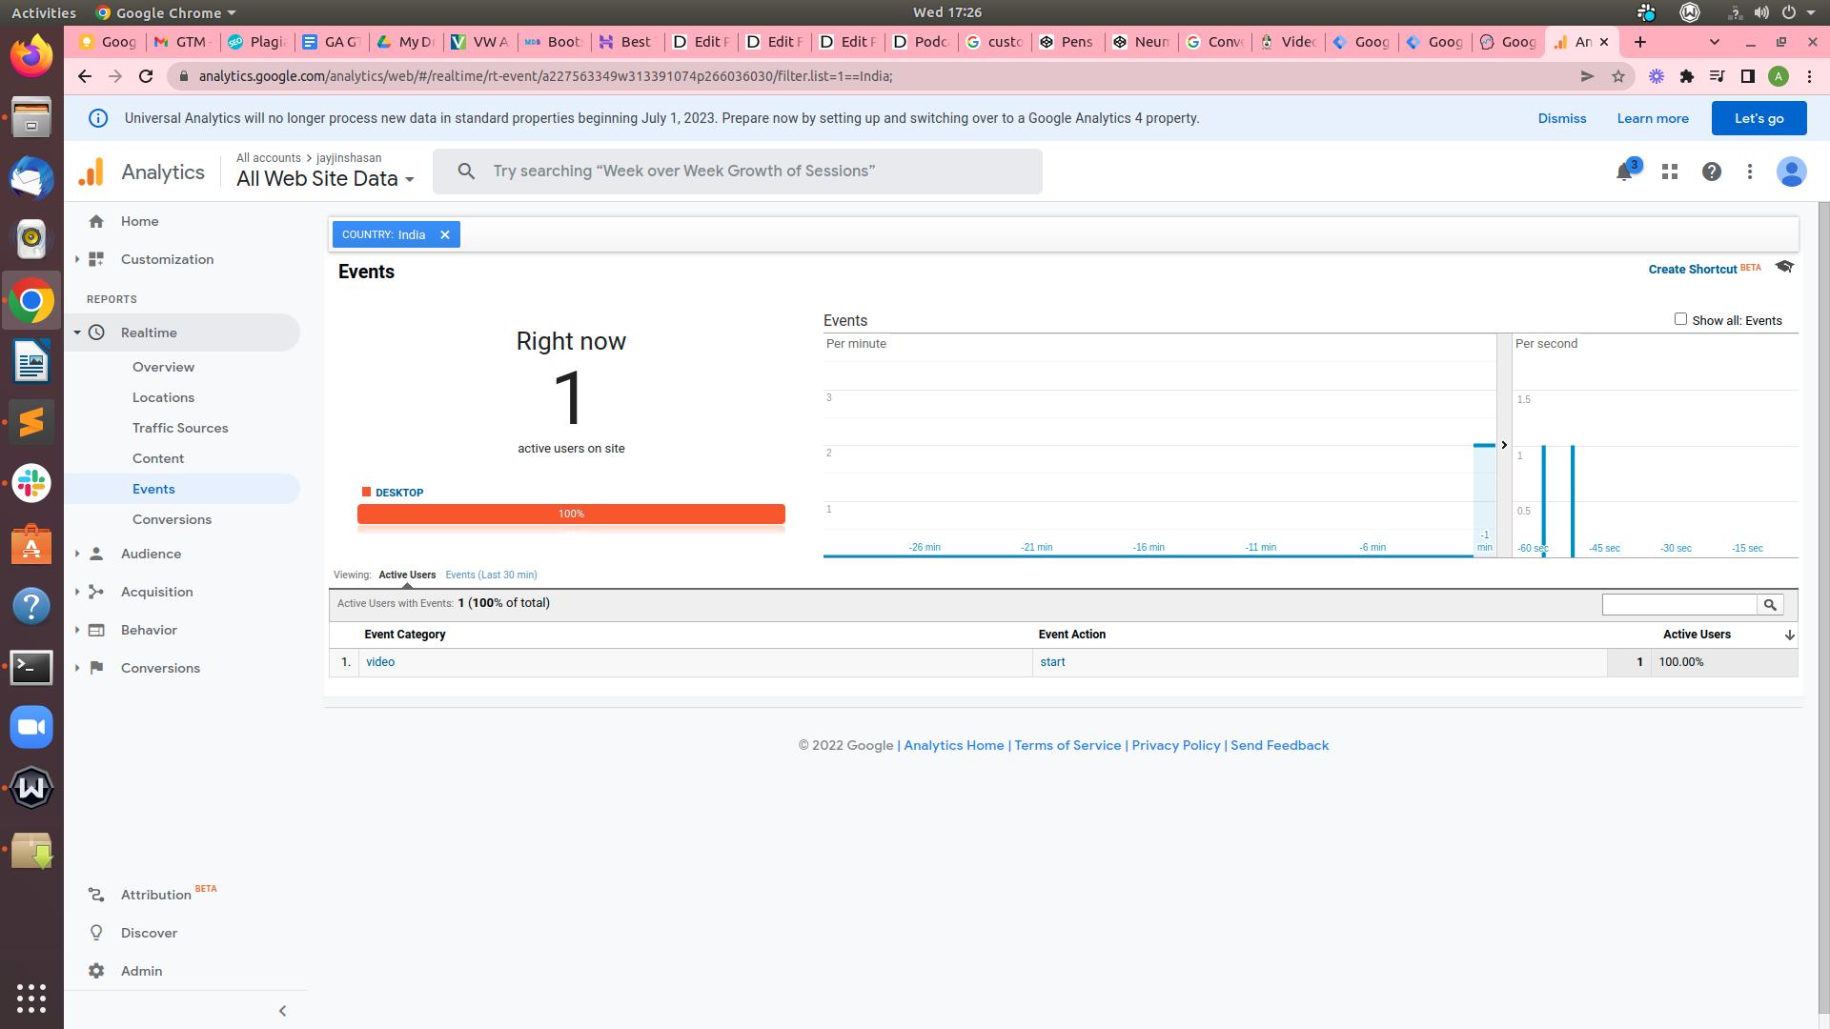

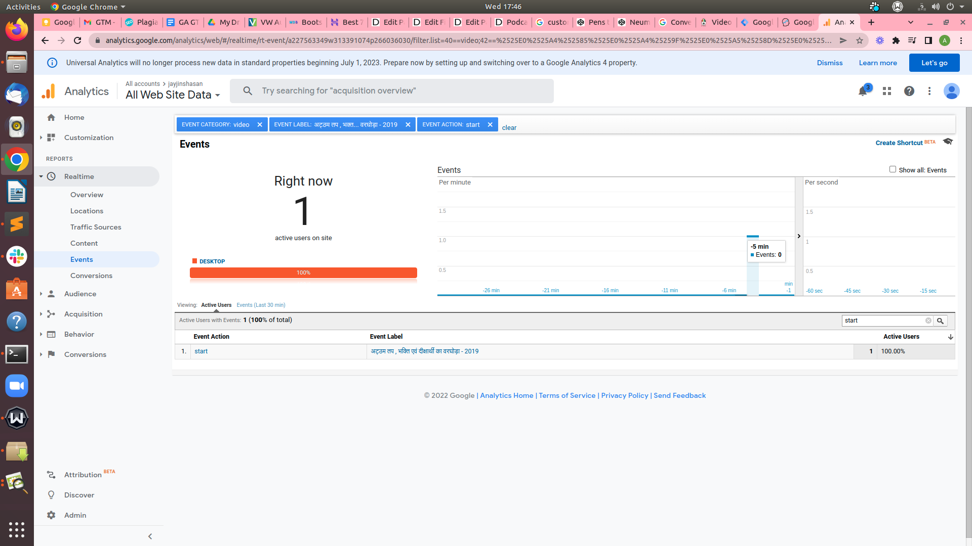

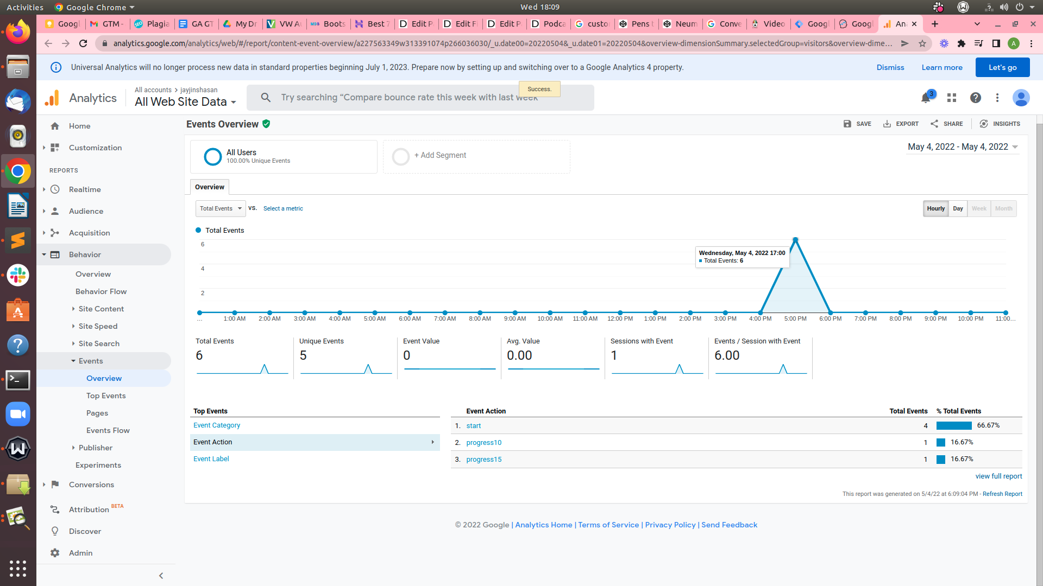

# Create a Goal in Google Analytics

**We can** classify this as a Google Analytics **goal** **so that** **each time** **anyone** **goes** to this **page**, there **will be** a conversion **inside** Google Analytics.

* Go to GA settings
* **Admin** Under the **Goals**

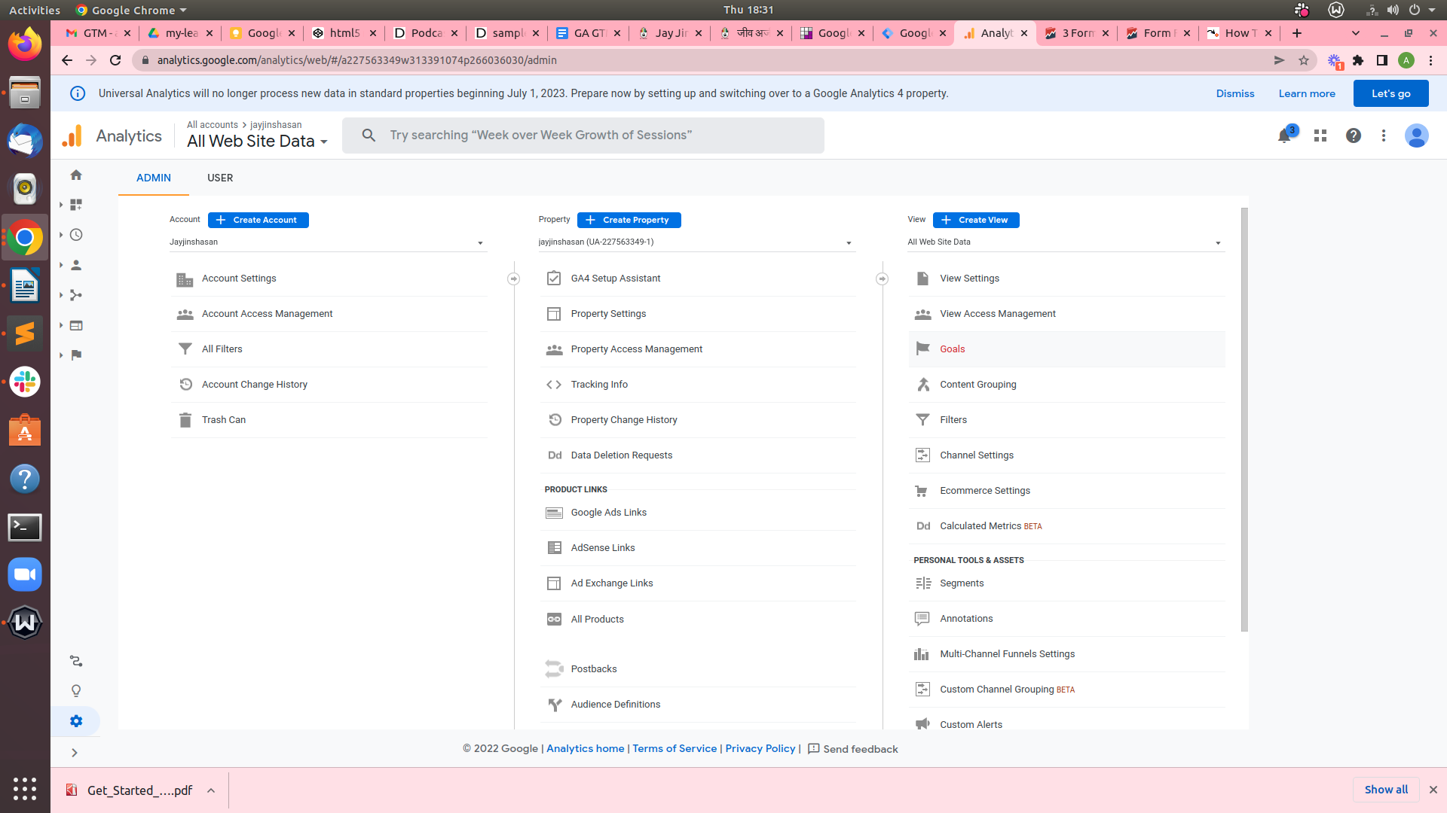

* Create **New Goal**
* Goal name

Below the goal Description, Apply your aim the proper name, including Download Ebook publish. Next, pick an aim slot identification and the sort of intention which you want to enter. In this situation, you have got a web page view that you want to classify, so pick out the destination intention here. hold to the next segment.

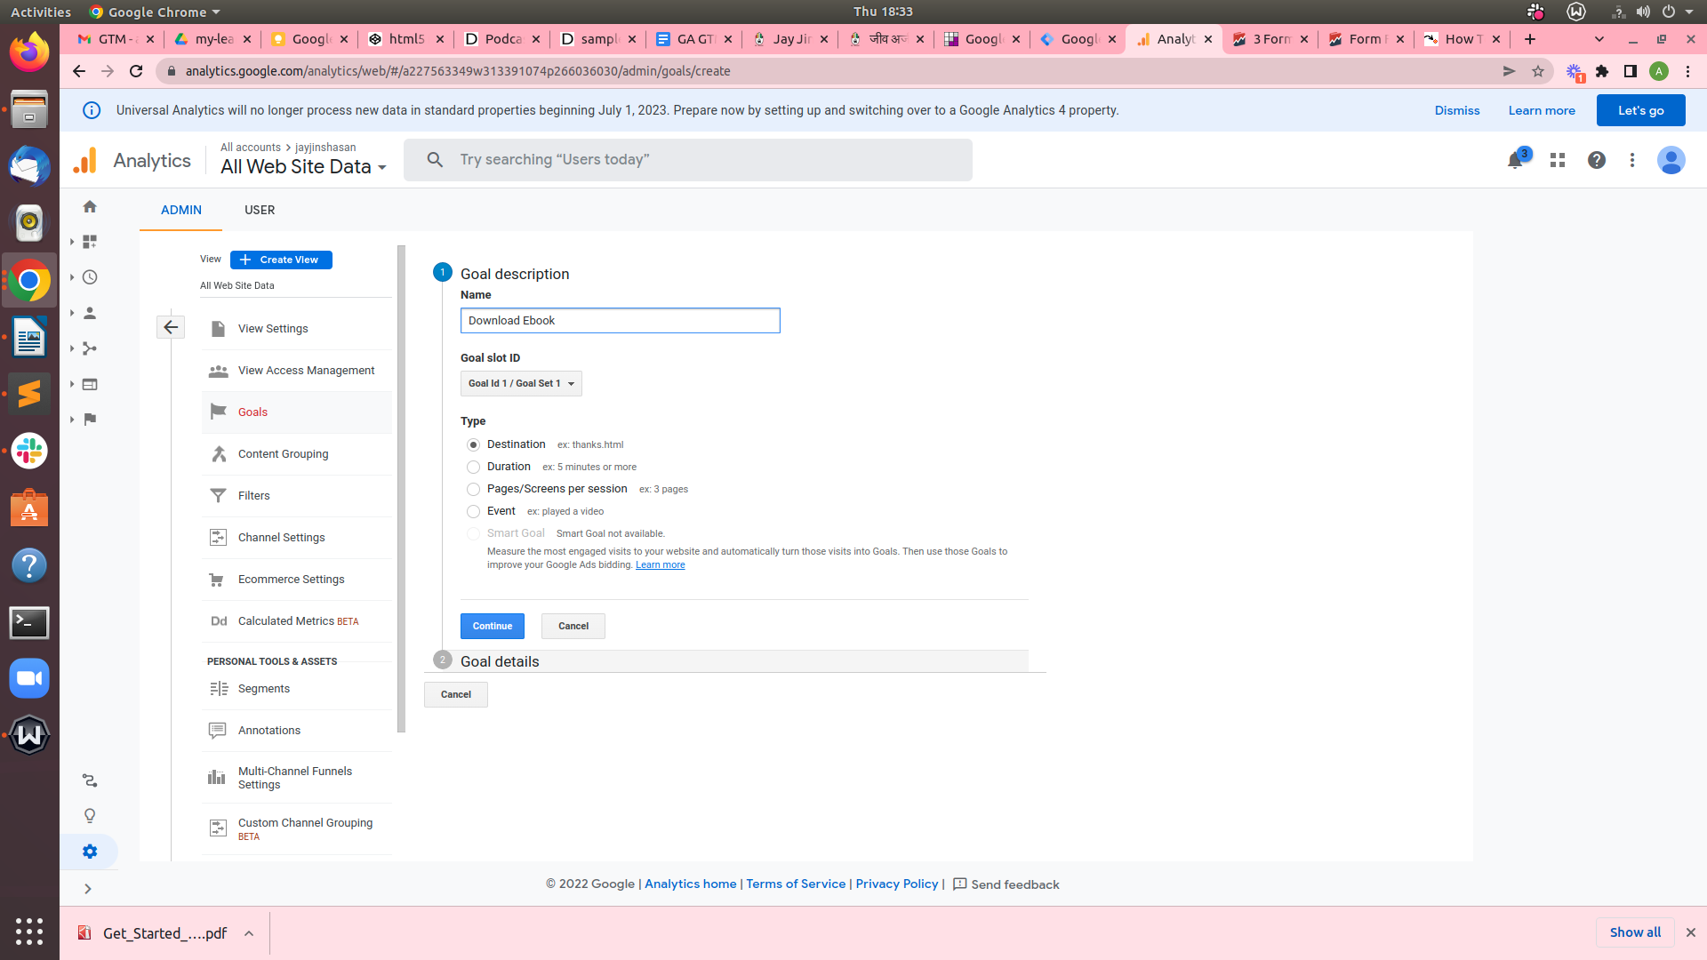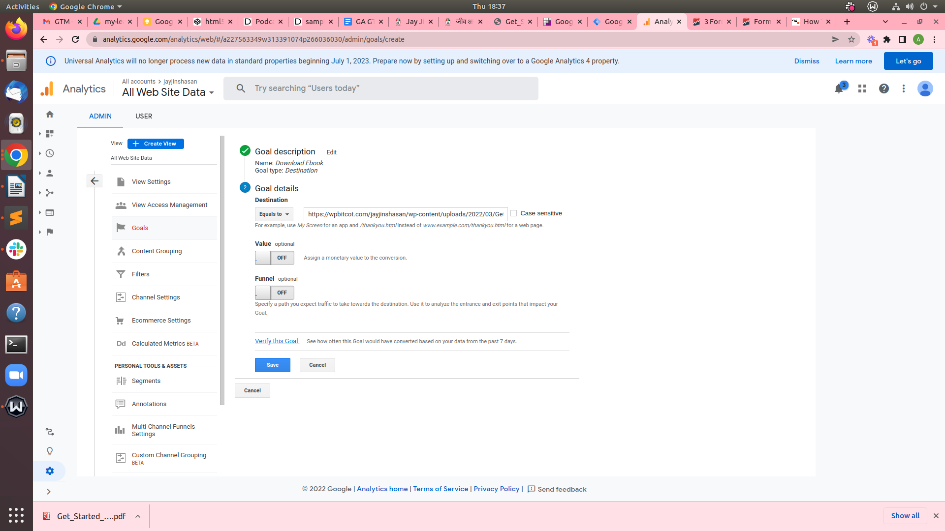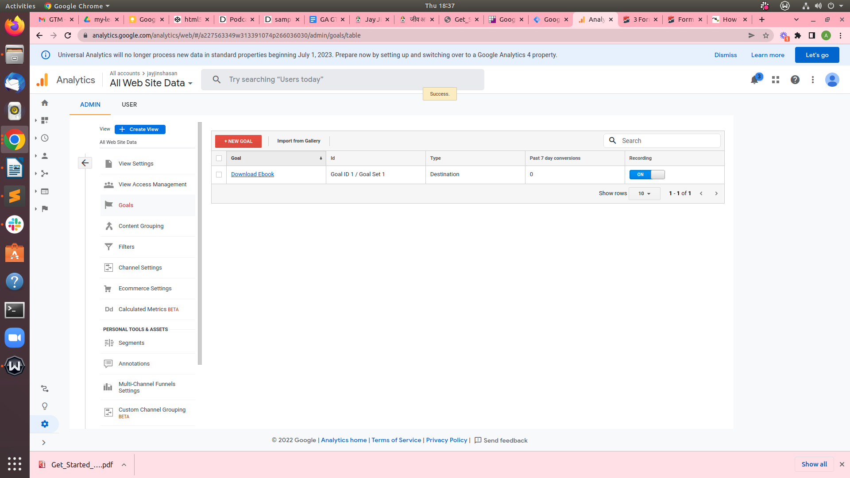

**Checking out**

To test your new goal, start by clicking Verify this goal under your Goal details. For this demo account, it says 0 percent conversion charge. this is expected for the tutorial’s demo website in view that there isn’t much data

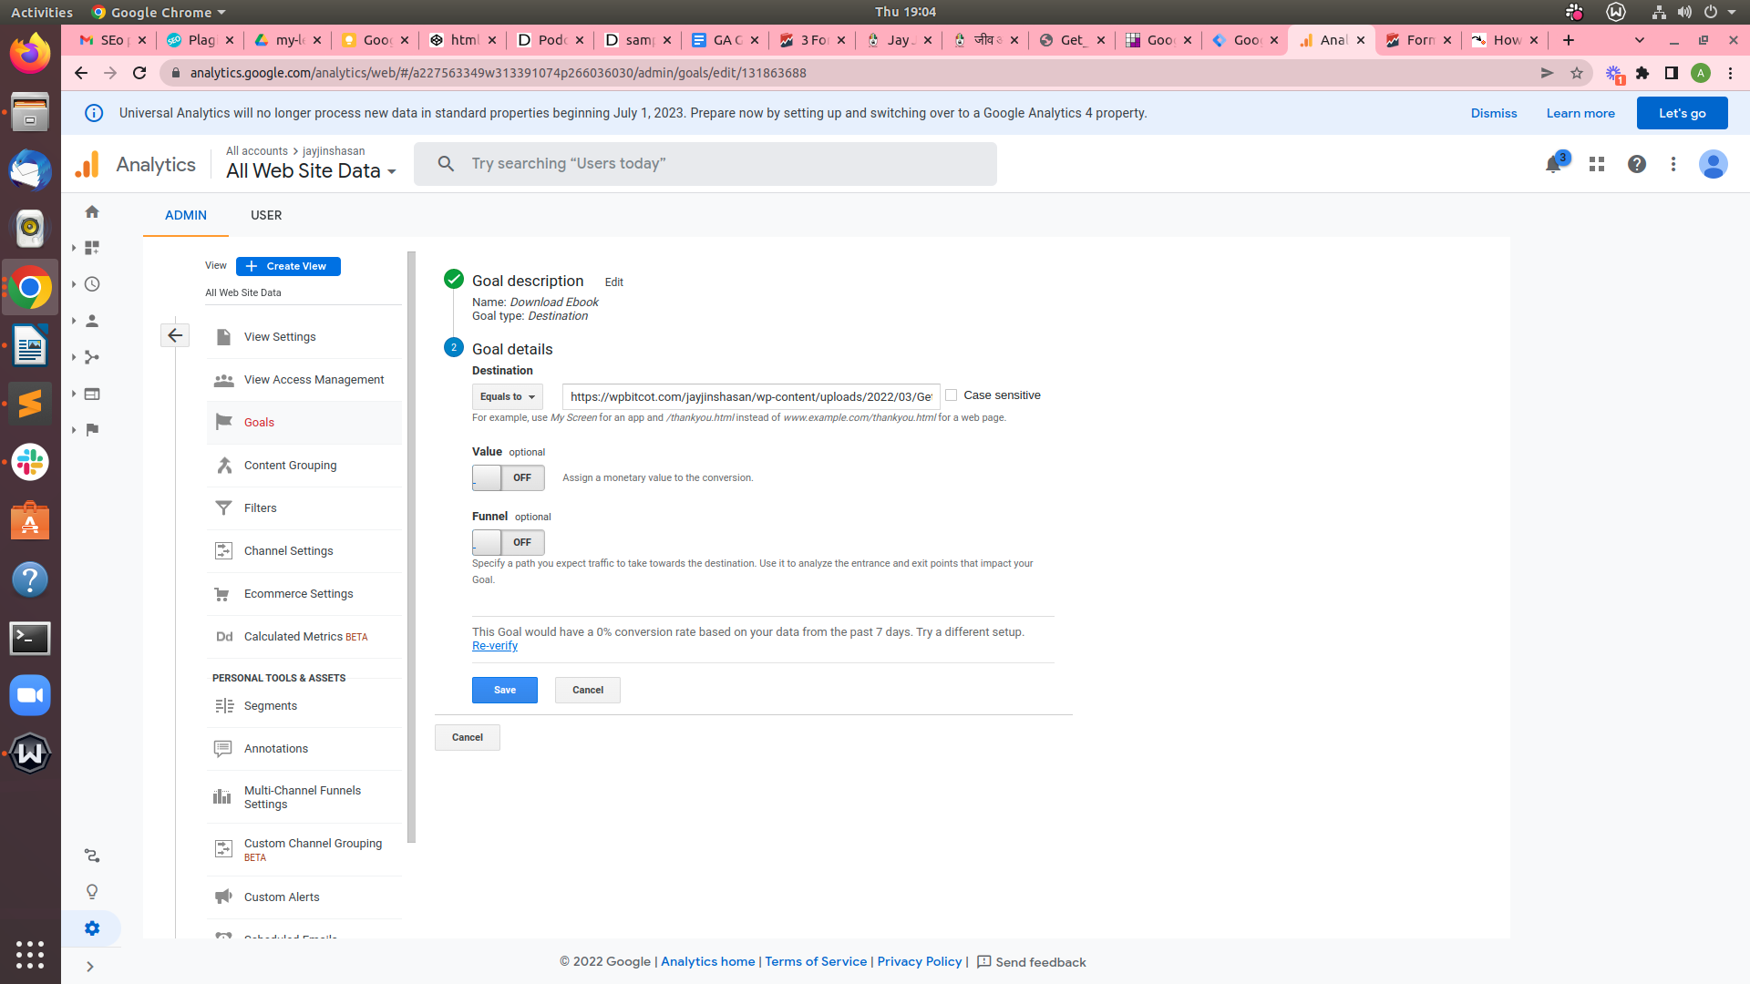

If **everything** is working, you’ll see your Goal  **on your** conversion **records**. You’ll be **capable of** viewing that and a **complete** **record** **afterward** as a Goal conversion.

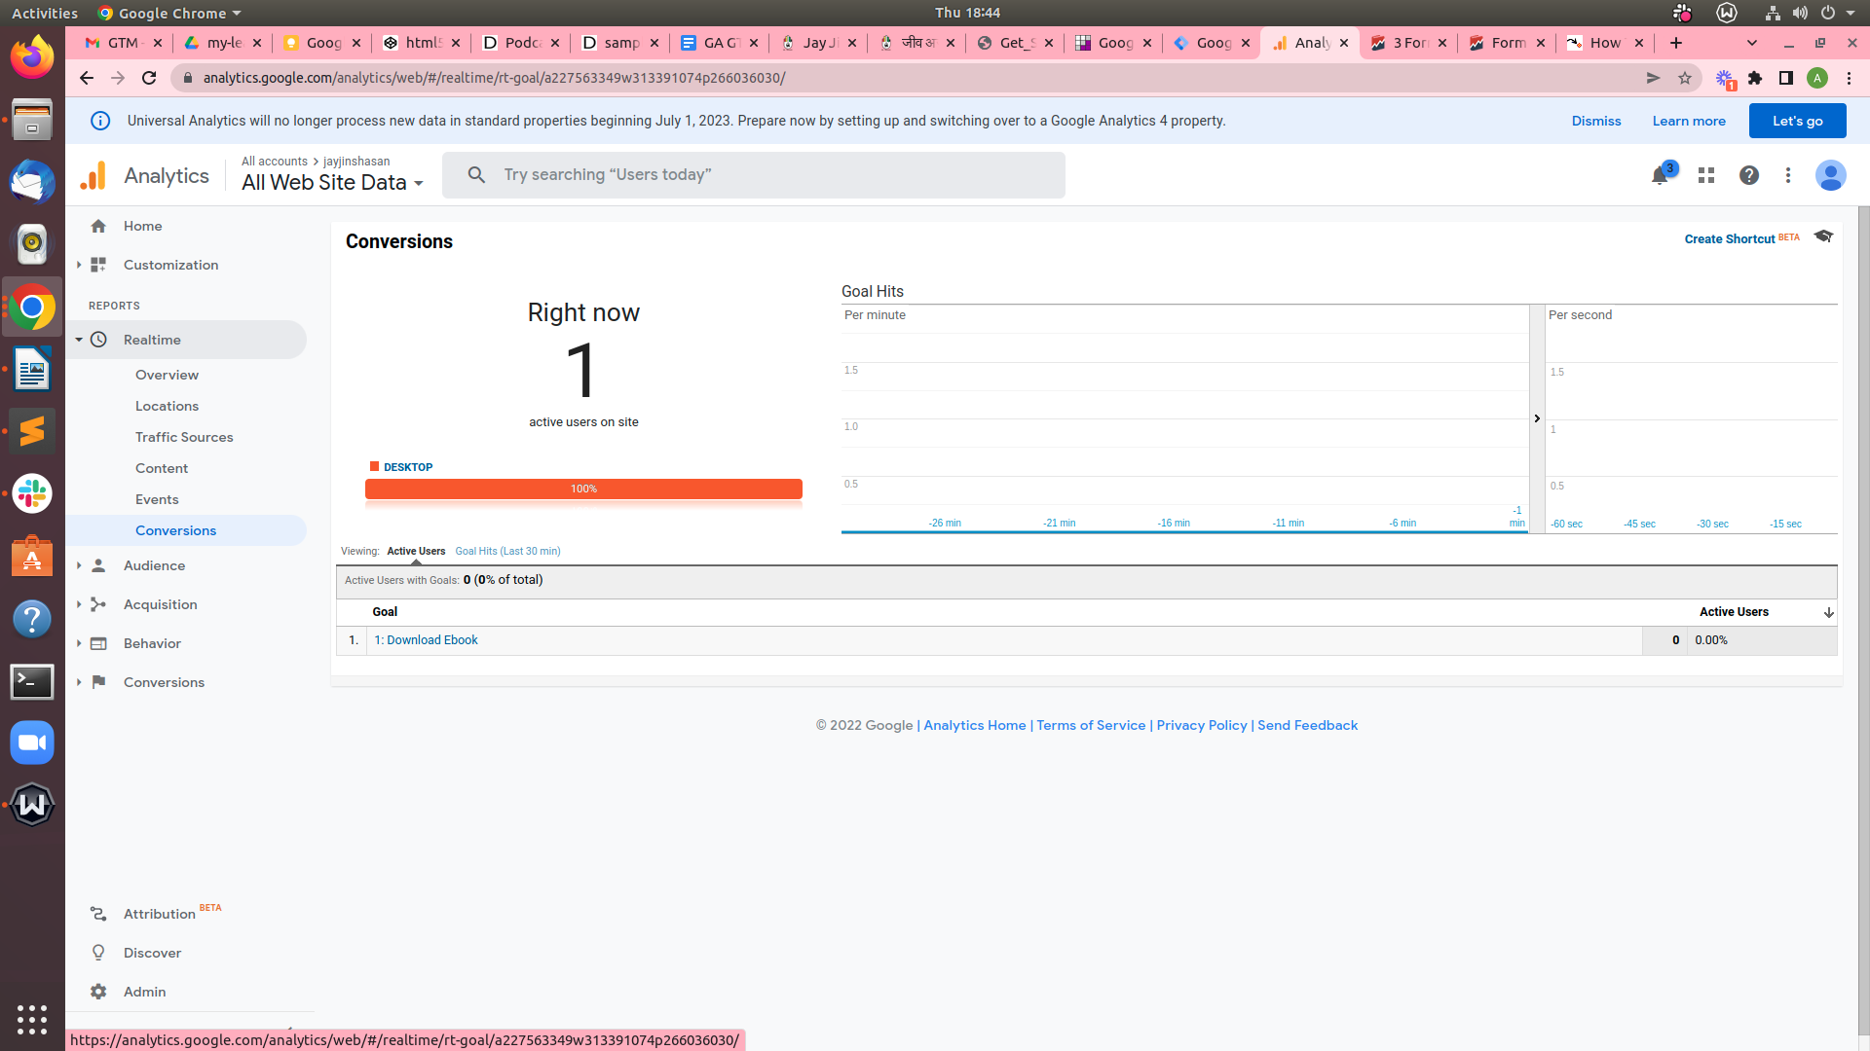

---------------------------------------------------------------------------------------------------------------------------------------------

# Contact form Submit Tracking Google Tag manager

If we are using the contact form 7 plugin on WordPress web site.

When We submit form on Contact form 7, It fires a form submission event

**Contact Form 7 DOM events:-**

DOM (**Document Object Model**) Events are a sign that something has happened, or is going on, and can be triggered by way of personal interactions or by the browser.

#### List of Contact Form 7 custom DOM events

* wpcf7invalid — Fires this DOM event when Ajax form submission has done successfully, but mail hasn’t been sent because there are fields with invalid input.
* wpcf7spam — Fires DOM event when Ajax form submission has done successfully, but mail hasn’t been sent because a possible spam activity has been detected.
* wpcf7mailsent —Fires DOM event when Ajax form submission has done successfully, and mail has been sent.
* wpcf7mailfailed —Fires DOM event when Ajax form submission has done successfully, but it has failed in sending mail.
* wpcf7submit — Fires DOM event when Ajax form submission has done successfully, regardless of other incidents.

The center one is **key : wpcf7mailsent**. As defined, this trigger fires while the form has been submitted and mail has been despatched. We’re going to apply Javascript to create a Data Layer event. Log into GTM and either pick out the “New Tag” field or navigate over to the “Tags” section and create one there. Create a brand new GTM tag (I’ve known as mine **wpcf7mailsent**) with the following configuration:

**GTM Create Tag #1** Contact form **Create a Tag :-**

* **Go to** Tags > New
* Define Tag name “**Contact form”**
* Click Tag Configuration
* Select **Custom HTML**
* Added This script

<script>

document.addEventListener( 'wpcf7mailsent', function( event ) {

dataLayer.push({

'event' : 'wpcf7successfulsubmit',

'CF7formID' : event.detail.contactFormId

});

}, false );

</script>

* Select the trigger to **All Pages**
* Save
* Publiash

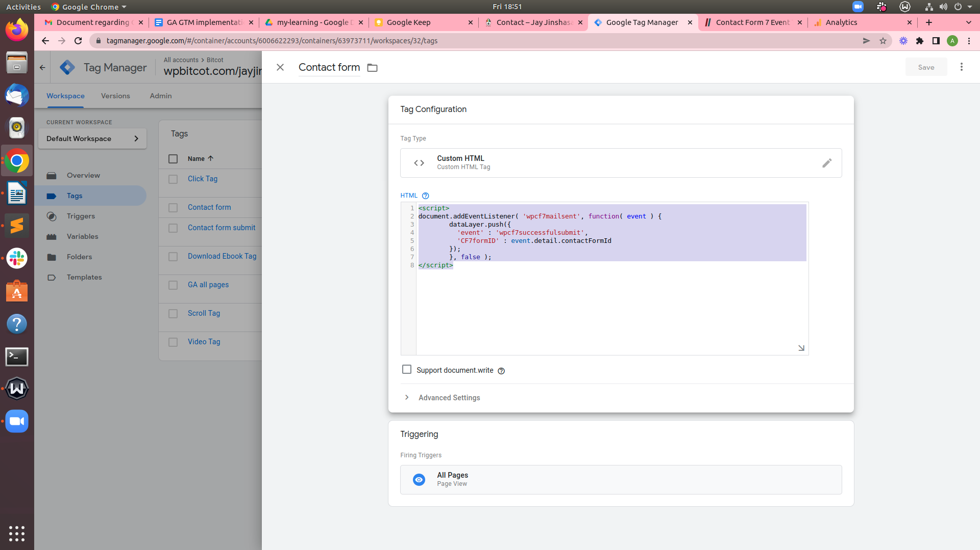

**Create a Trigger**

Click New Trigger -> Trigger name :- “**Contact Form 7 Trigger”**

Trigger Type: Custom Event   
Event name : wpcf7successfulsubmit  
This trigger fires on :- All Custom Events

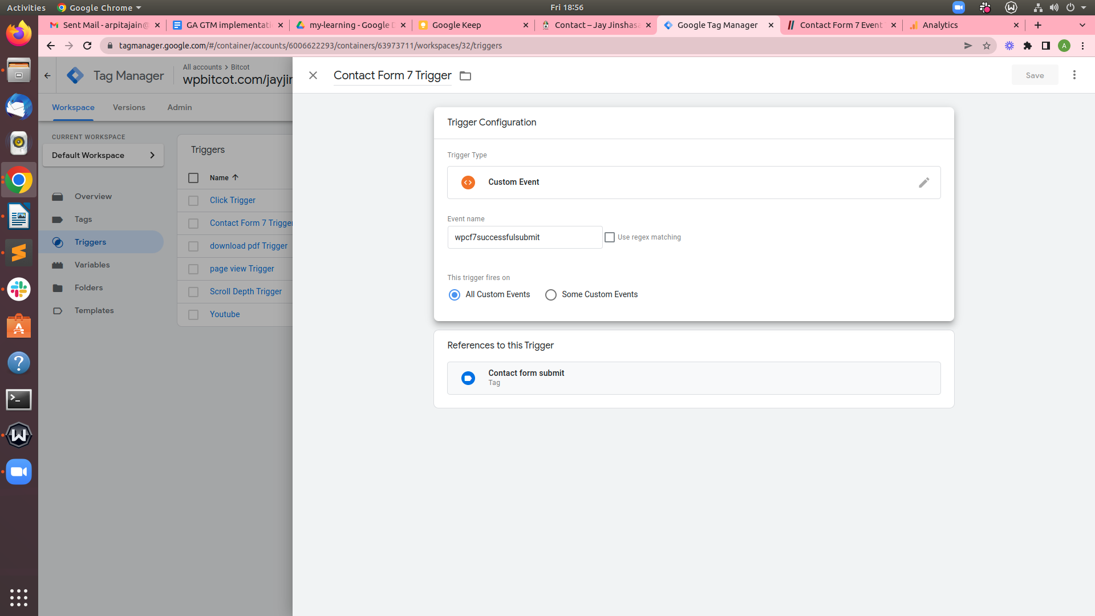

**Create Variables**

**Create a Form ID Data Layer Variable**

* Create New User-Defined Variables
* Define Name **CFformid**
* Select **Variable Type :- Data Layer Variable**
* **Data Layer Variable Name :- CFformid**
* **Data Layer Version :- Version 2**

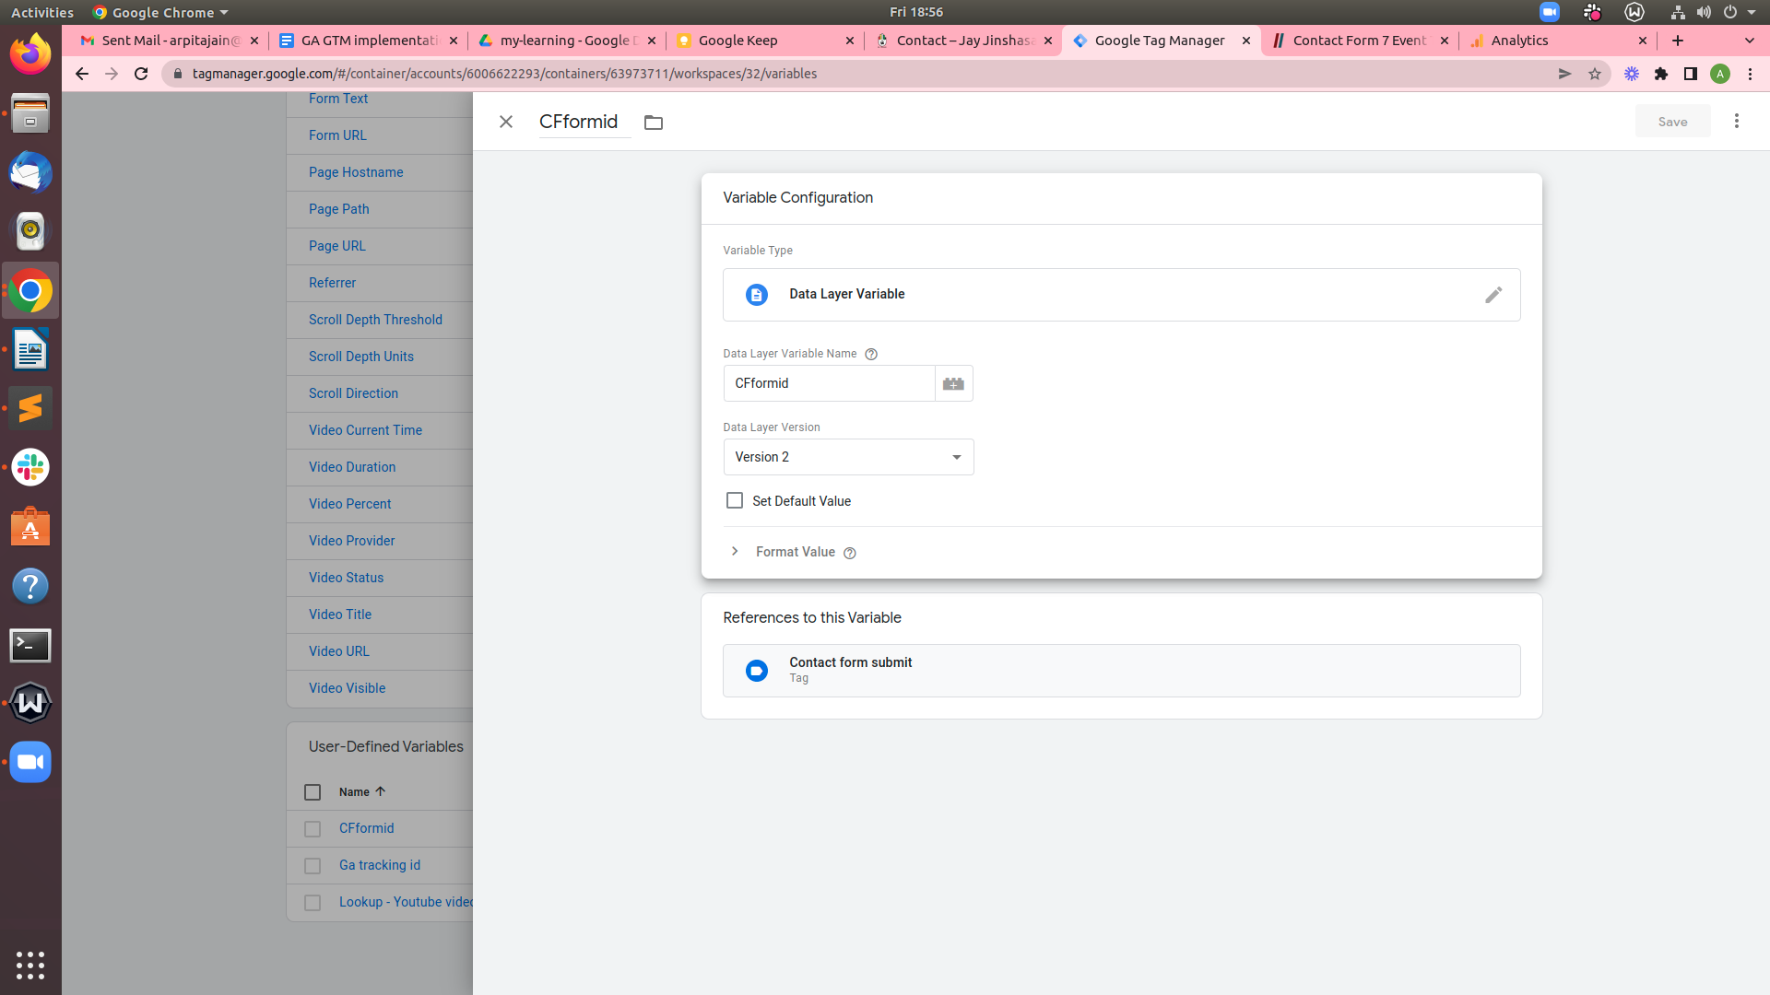

**Create GTM Create Tag #2**

* **Tag Type :** Google Analytics Universal Analytics
* **Track Type :** Event
* **Event Tracking Parameters**
* **Category :** Contact-form
* **Action :** Successful-form-submit  
  **Label : {{CFformid}}**
* **Non-Interaction Hit :** False
* **Google Analytics Settings :** {Ga tracking id}}
* Select Trigger **Contact Form 7 Trigger**
* **Save**
* **Publish**

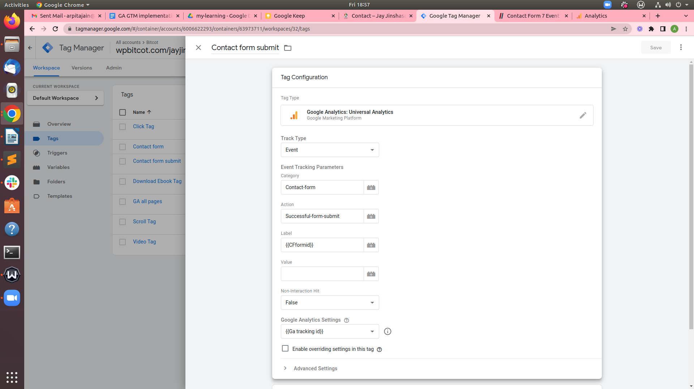

After Submit this form <https://wpbitcot.com/jayjinshasan/contact/>

Below mentioned result will be displayed on Google Analytics the screen

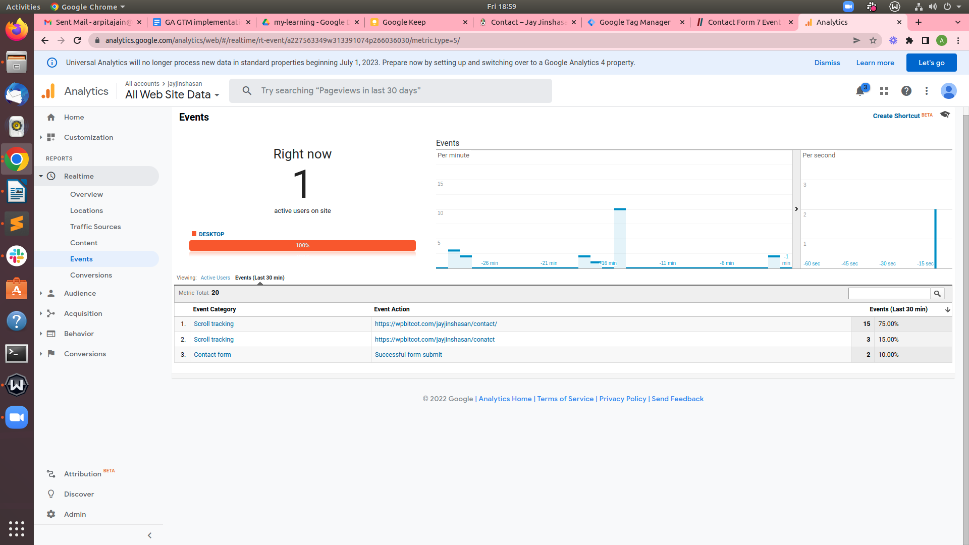

## **Set up the Goal Conversions**

* Open Google Analytics
* Click Navigate to Admin -> View -> Goals

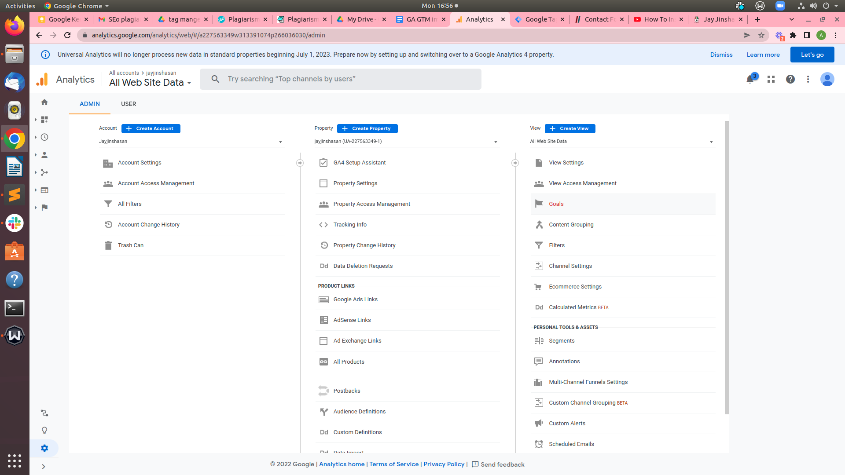

* Click New Goal
* Goal description Name :- Form submit
* **Select Type : Event**

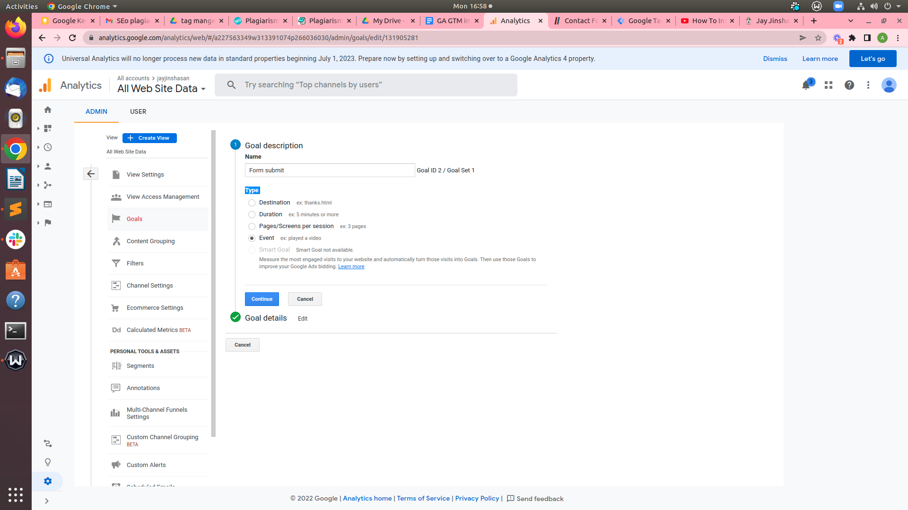

**Goal details**

* Category: **Equals to >** Form Submit(Same name which you named it in GTM)
* Action**: Equals to >** Successful-form-submit **(**Same name which you named it in GTM**)**
* **Label: 1105**Pick the form identity (ID) of the form you need to track. If you don’t need to track other forms separately, you can leave this blank
* **Value**: Set any variable here if we want, like page URL, etc.
* Use the Event value as the Goal Value for the conversion : yes
* Now **click** ‘**save**’
* 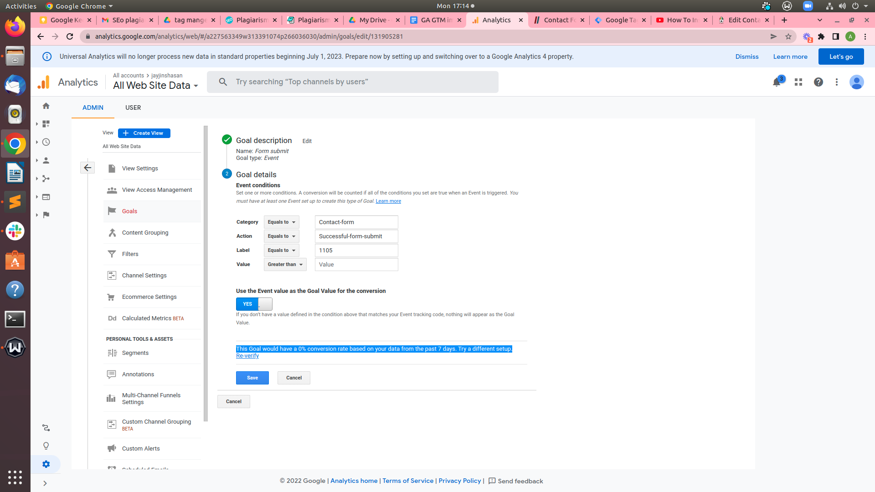
* done

**I have set up** the **Goal** Conversion and **suitable** tracking.

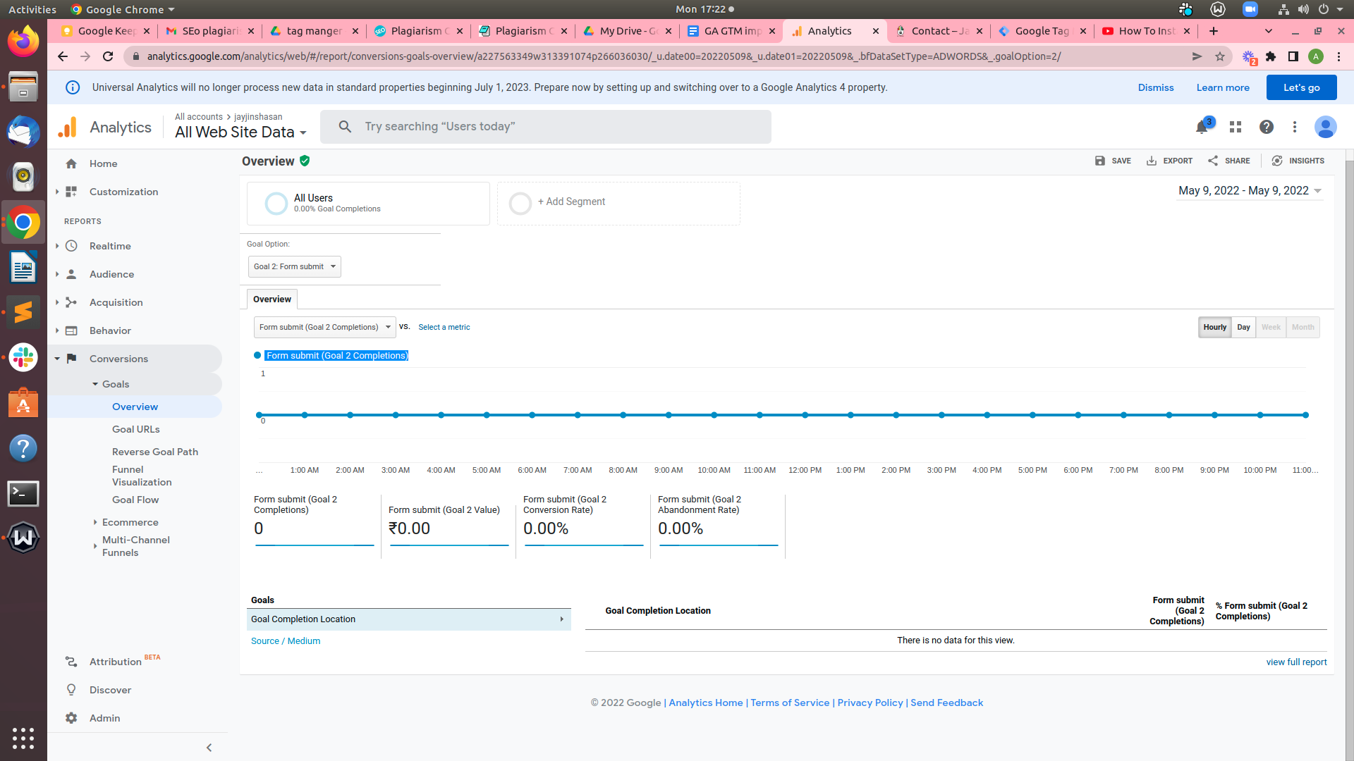

---------------------------------------------------------------------------------------------------------------------------------------------

# Scroll depth tracking in Google Tag Manager

**Why Track Scrolling?**

Tracking Scroll Depth can recognize how far readers scroll to read posts and pages on your website.

First checked all Scrolling **built-in variables** Before a form submission trigger fires:-

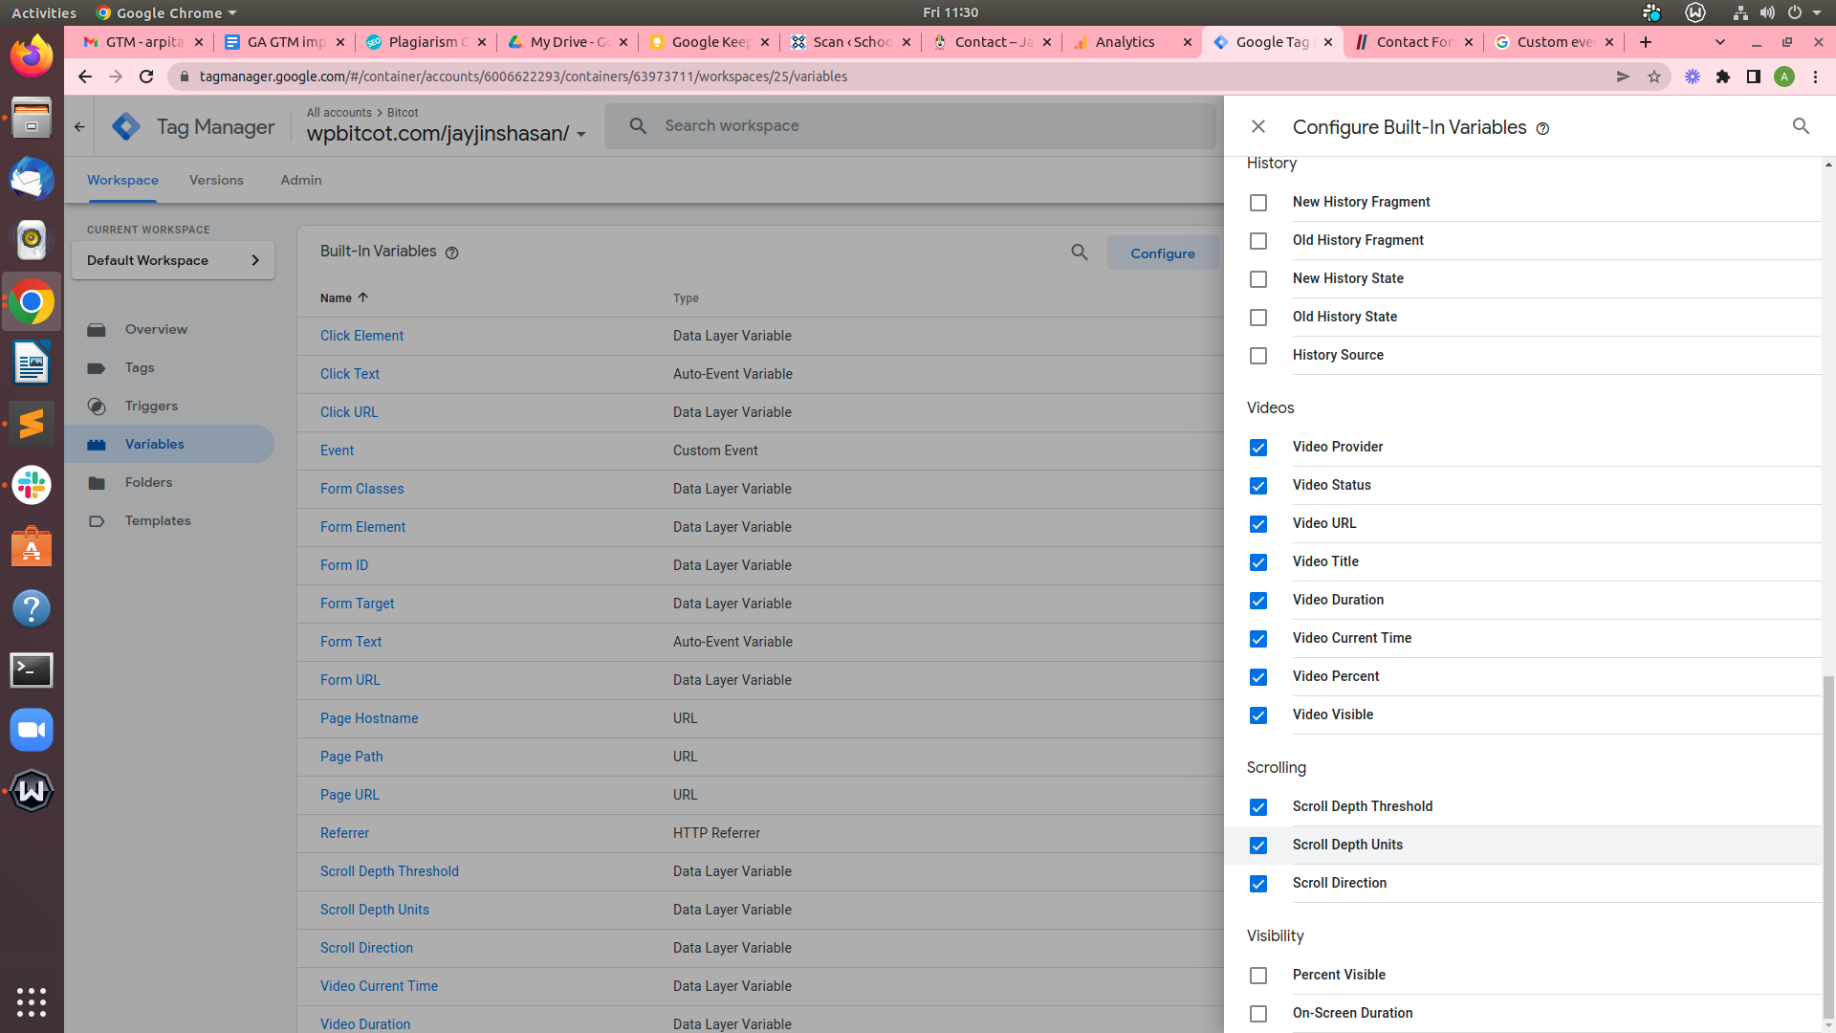

**Create a** New Trigger **‘**Scroll Depth’

Click Trigger Configuration **Scroll Depth**

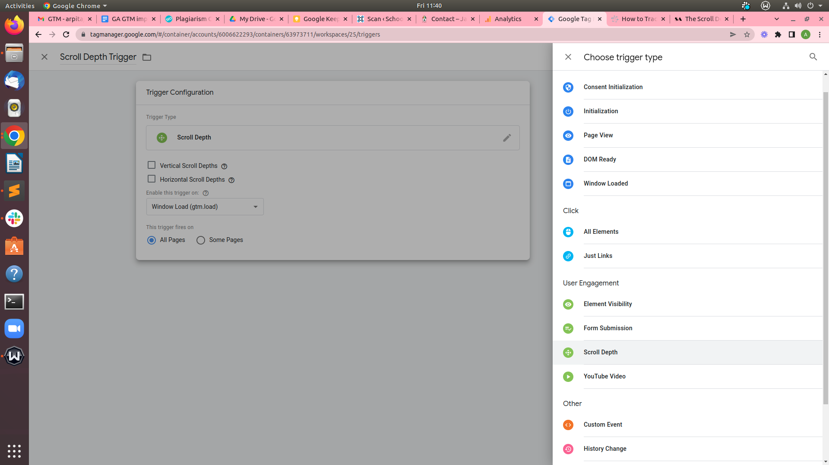

Select vertical or horizontal (or each) for scroll direction, and decide the scroll depth threshold and devices.

At the same time as pixels assist to make the cause more particular, it's far tough to pinpoint the ideal number due to differences in screen sizes throughout gadgets. while possibilities aren't absolutely infallible, it helps to give a more subjective view of scrolling behavior throughout devices.

That's Why I selected percentage set values like 25%, 50%, 75%, and one 100% were chosen to suggest users who scrolled as a minimum scroll down the web page Like 25% of web page scrolled,50% of web page scrolled , a 100% of page scrolled , 100% of web page scrolled who nearly made it to the bottom, and users who viewed the whole page.

If we want the trigger to fire on some pages (particular page), which can be configured by select '**Some Pages**' Otherwise select **All pages**

I want tohe trigger to fire **All pages that’s why I selected this :-**

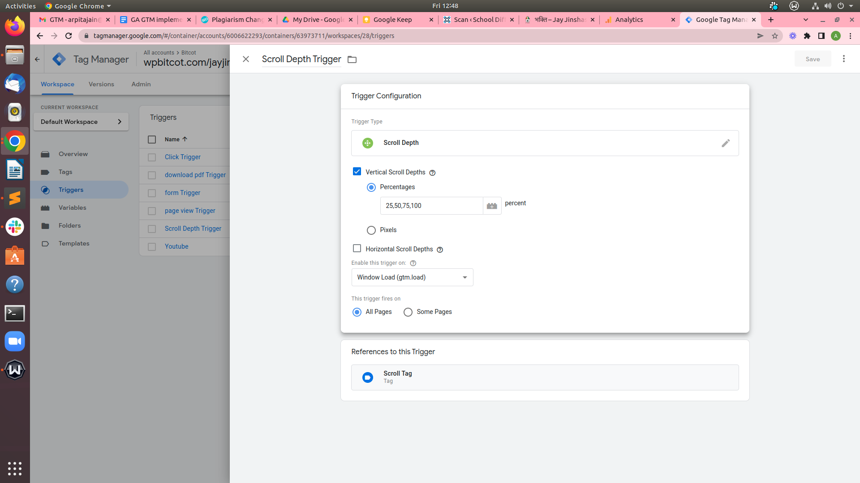

After that save this

**Create a** New Tag **Scroll Tag**

* Click Tag Configuration Select **Google Analytics Universal Analytics**
* Track Type : Event
* Category : Scroll tracking
* Action : {{Page URL}}
* Label : {{Scroll Depth Threshold}}%
* Non-Interaction Hit : True
* Google Analytics Settings : {{Ga Tracking id}}
* After add trigger **‘**Scroll Depth Trigger’
* Save and Publish

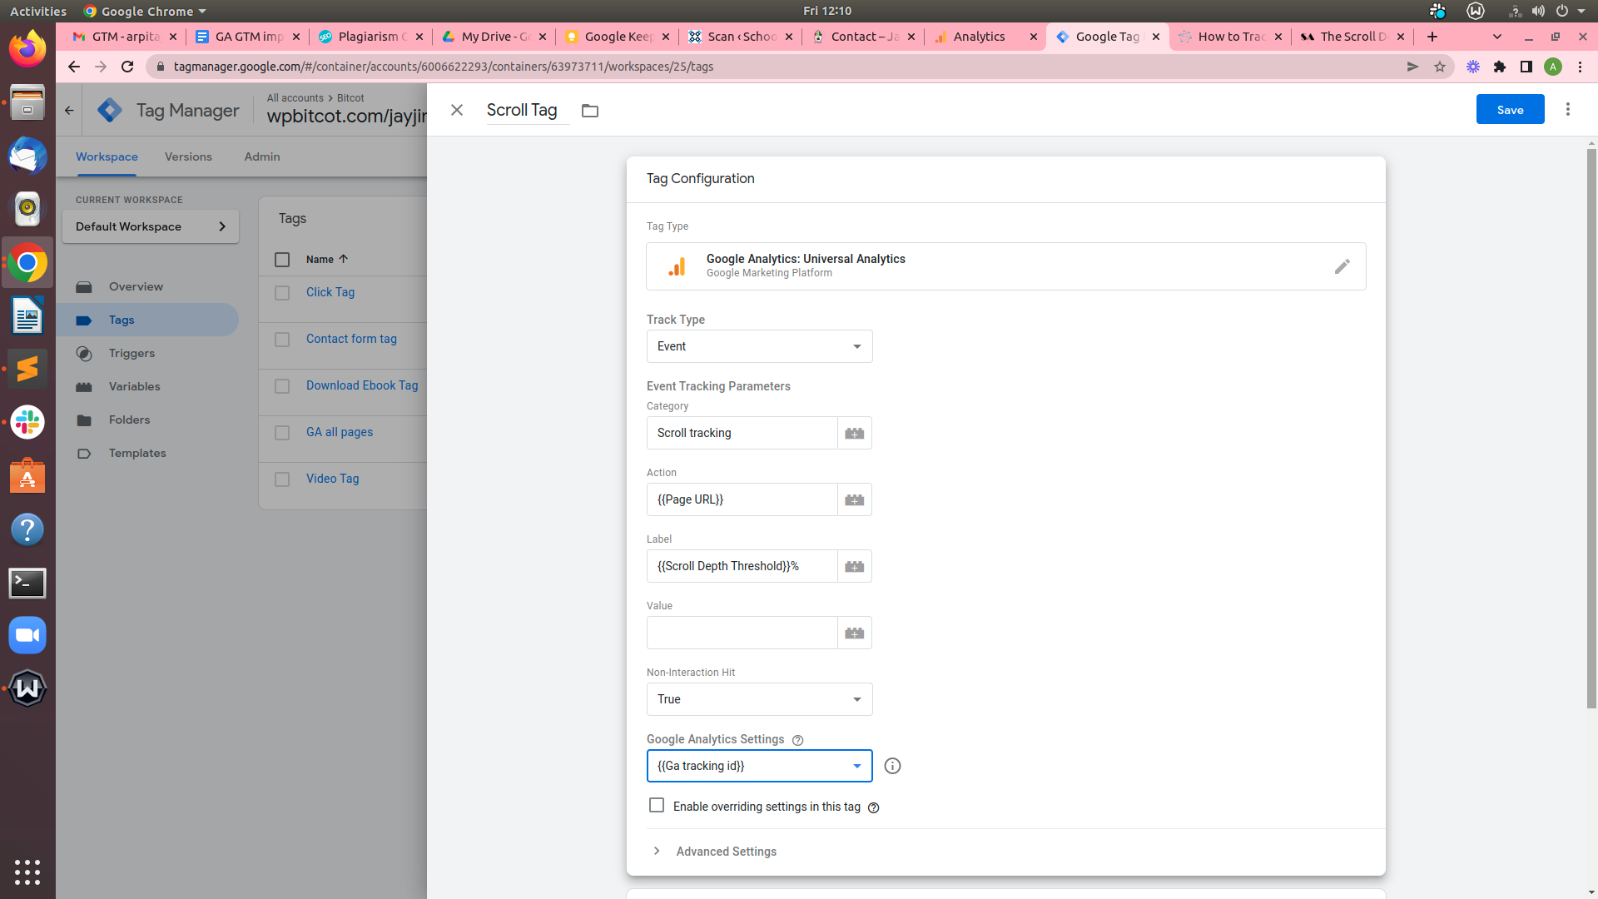

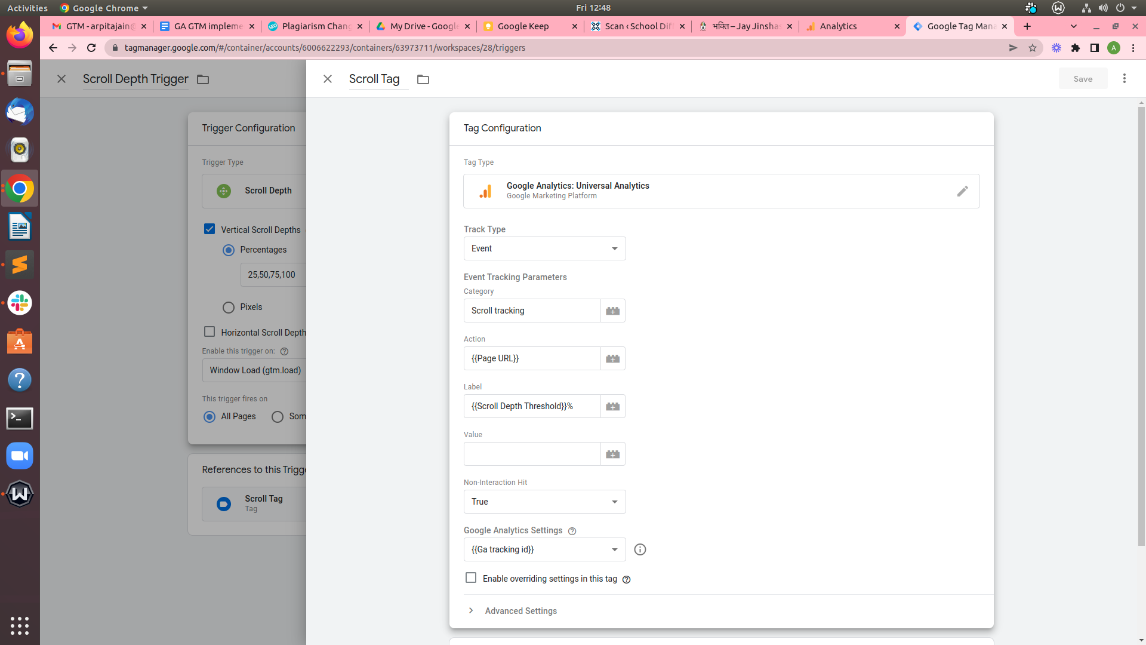

After Scroll page in website

below mentioned result will be displayed on Google Analytics the screen

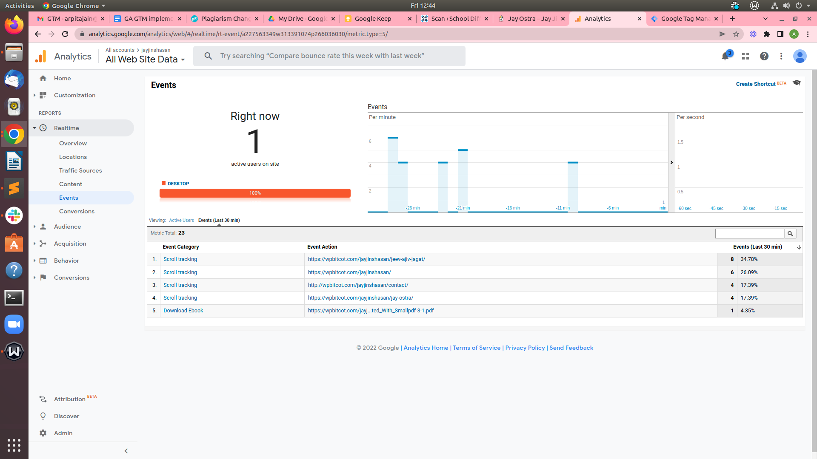

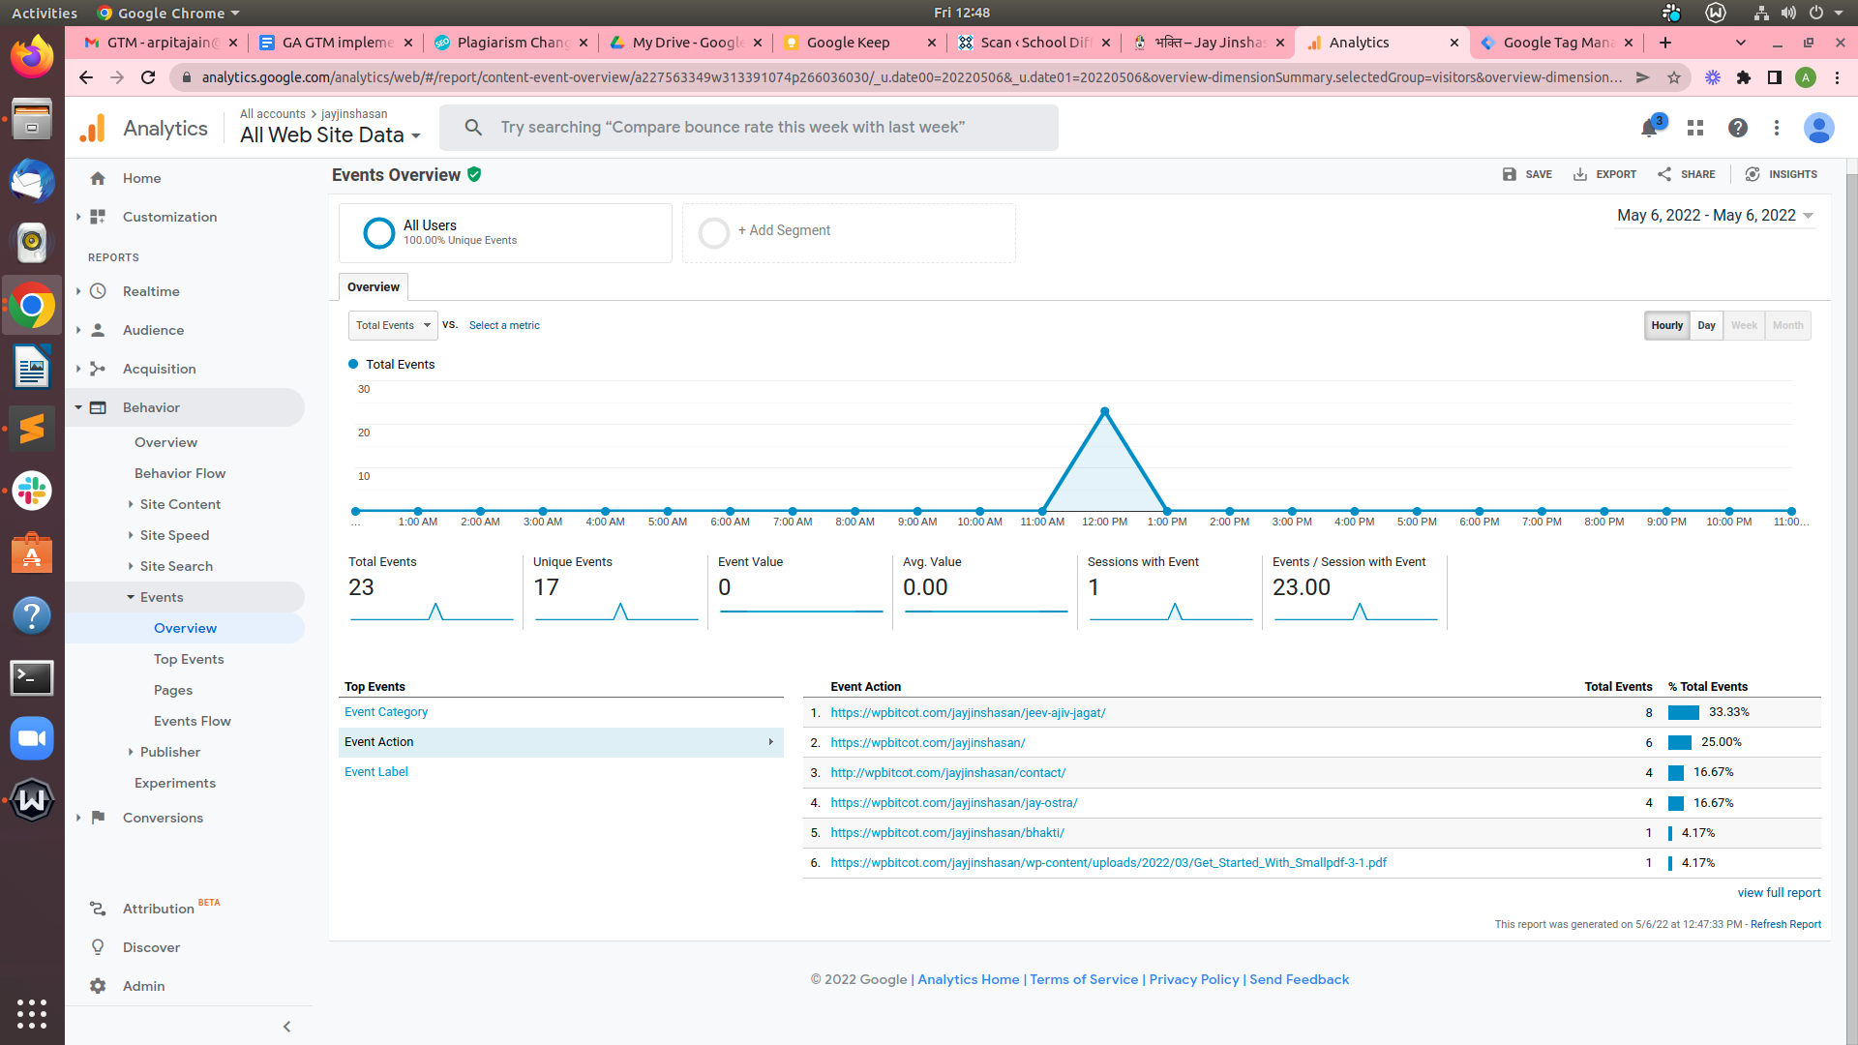

---------------------------------------------------------------------------------------------------------------------------------------------

# Google Search Console

Search Console is a free tool provided by Google that helps customers grade their web site’s traffic, see keyword performance, restoration issues, and receive messages from Google about their website.

**Setup search console aacount**

* We have to sign in **Search console** with same **Google Account (Gmail),** which we created Google Analytics and Google tag manager

<https://search.google.com/search-console/welcome>

* URL prefix ->Paste Website Url

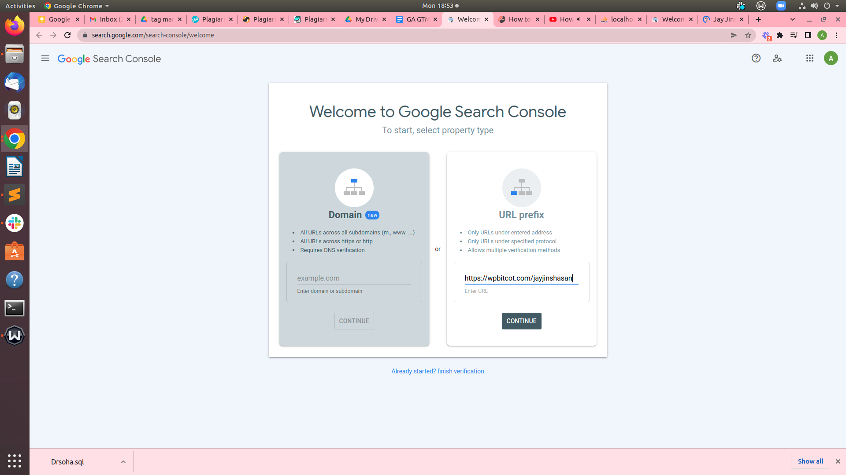

* Click Continue
* After That

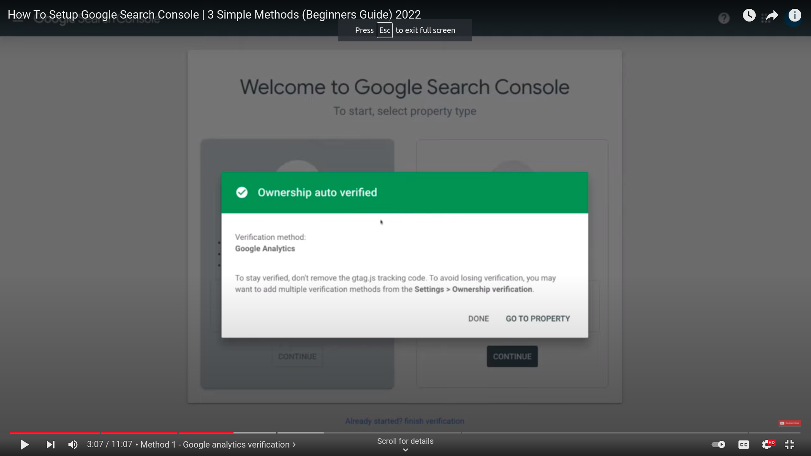

There are two type of varification method we can choose any one

**This is first verfiy methord**

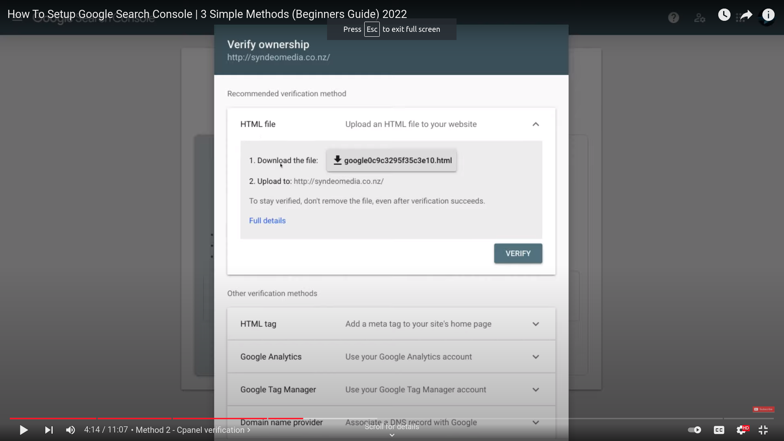

* After That we have to download below html file and uploaded this file in root directory of website
* After that click on verify

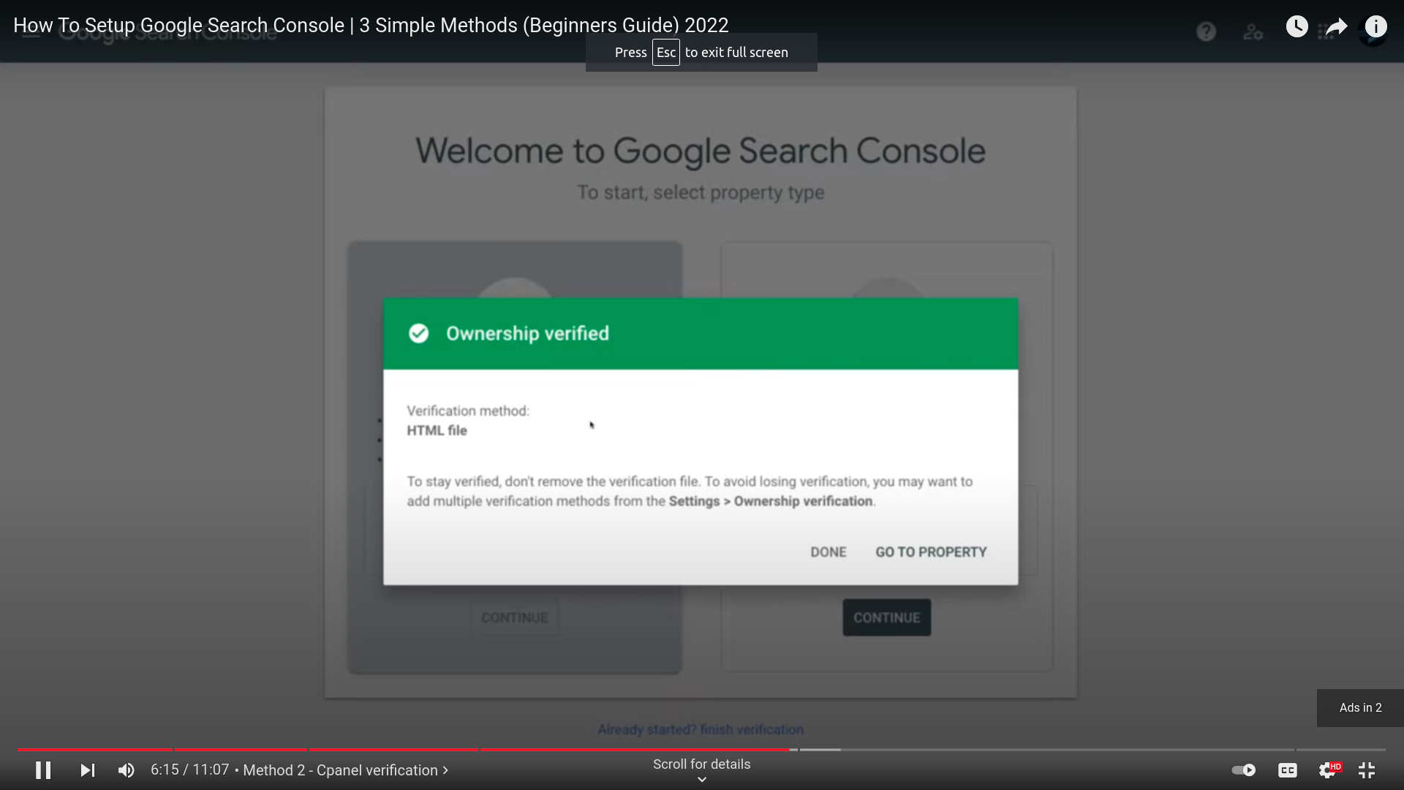

**This is second verfiy methord**

We have to copy code also paste in head section of website like below image

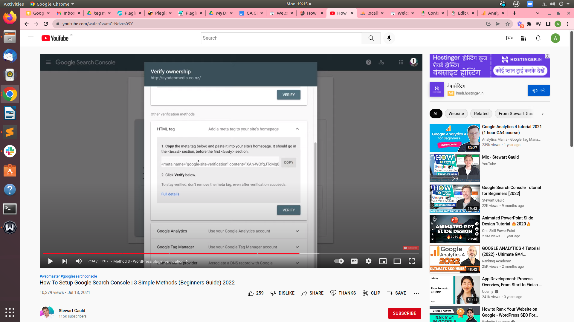

The Below enclosed image shows that the website Performance

It covered 4 points

1. Total Clicks
2. Total Impressions
3. Average CTR
4. Average Positions

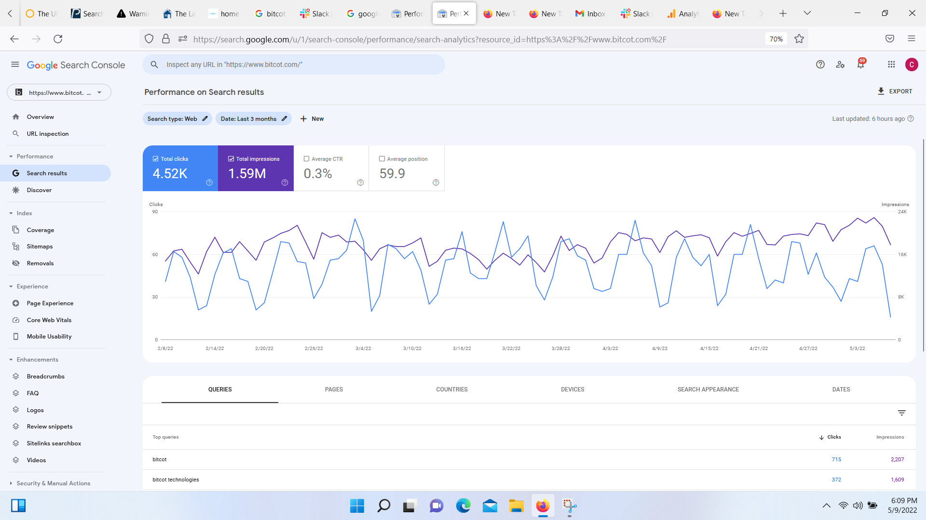

**Useful URL** :- https://raddinteractive.com/how-to-set-up-google-search-console-getting-started-easily/  
<https://www.youtube.com/watch?v=arSUE7-q41w>

https://www.youtube.com/watch?v=WFuwVKeUglU

# Configuring Search Console data in Analytics

* **Open Google Analytics**
* **Click to Admin**
* Click **PRODUCT LINKS**
* Click **All Products**

## search **Search Console**

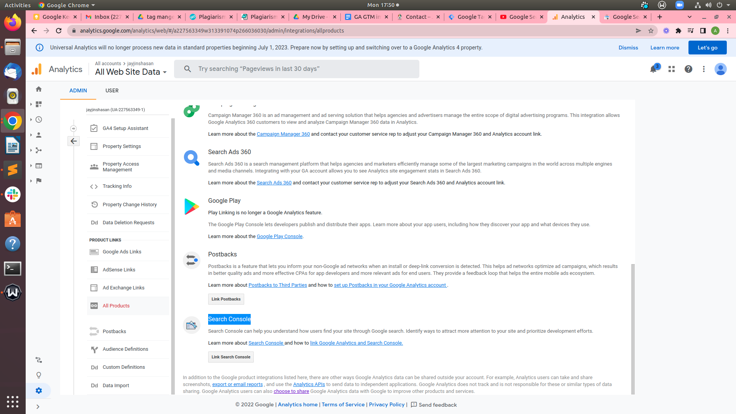

* And setup like below image to put website url

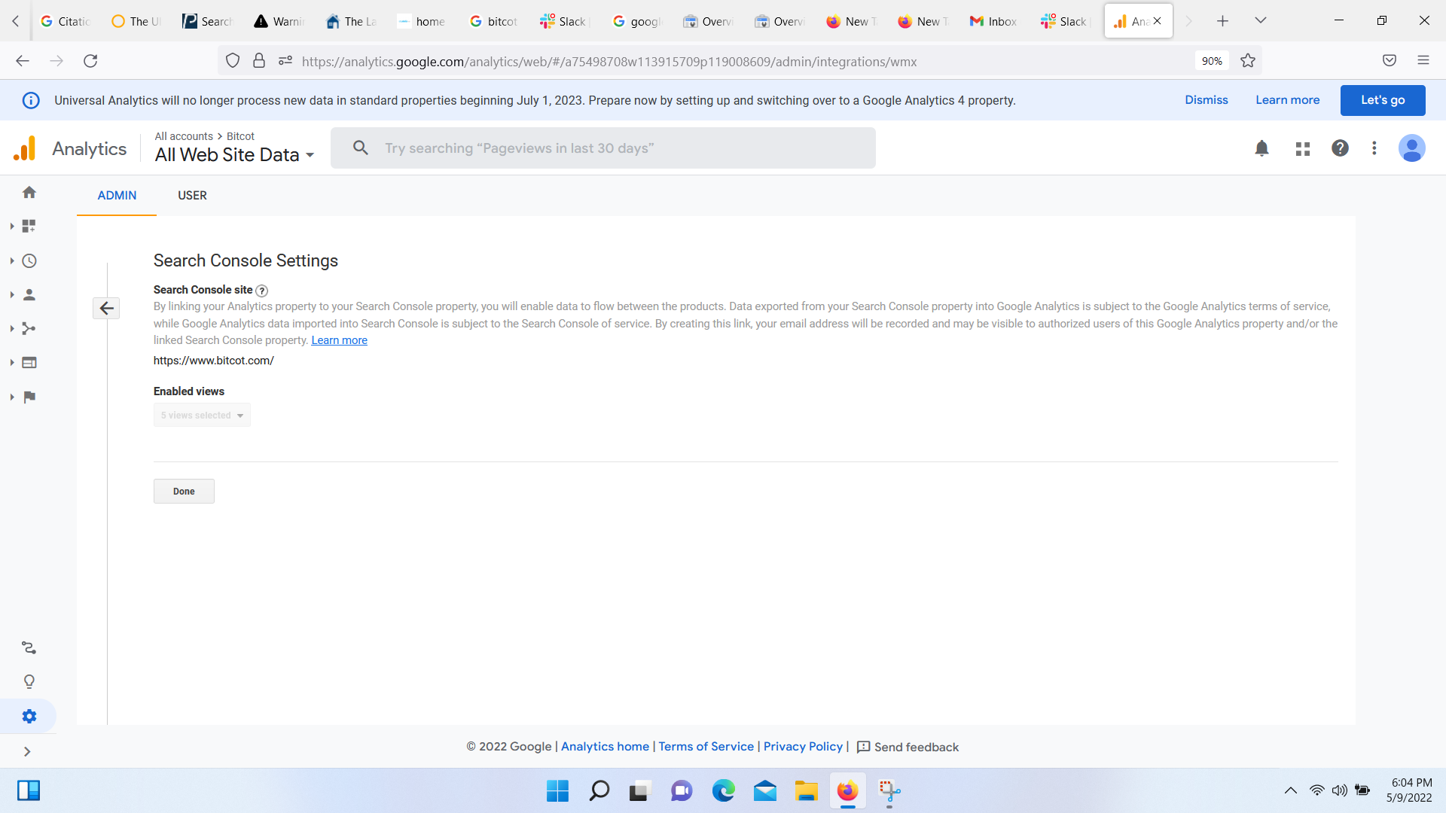

* After link
* Below image display Search console detail in Google analytics

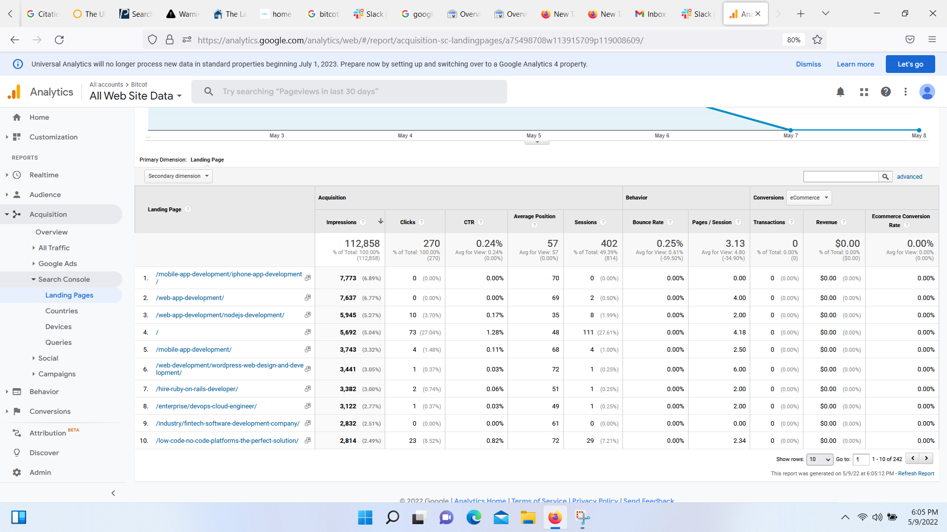

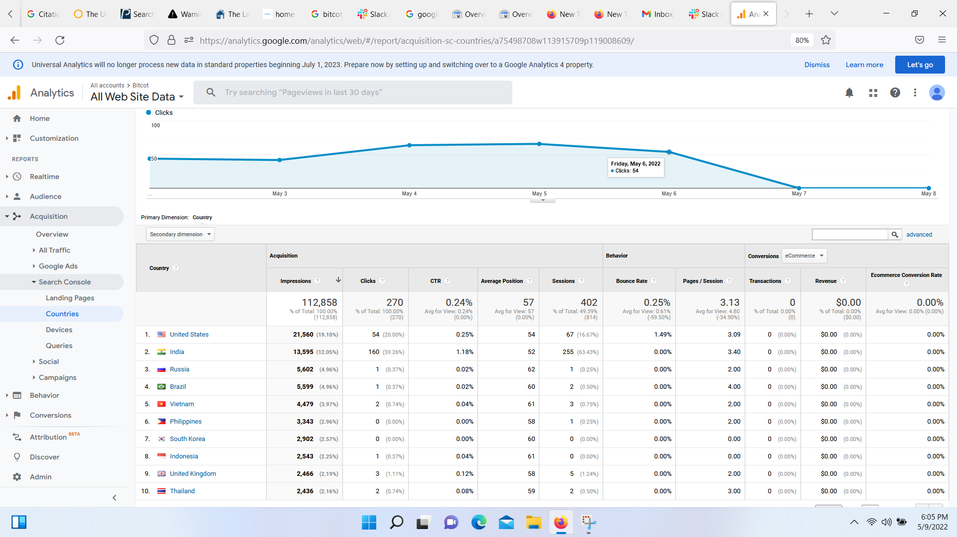

**Useful Links**: -https://support.google.com/analytics/answer/1308621?hl=en&utm_id=ad